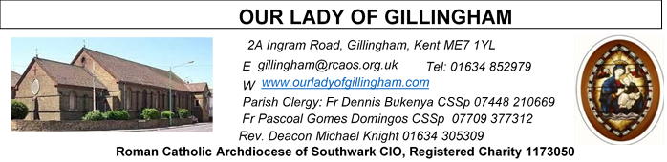Office Hours – Tuesday, Wednesday & Friday - 10.30am – 1.30pm
11th October 2026
28th Sunday in Ordinary Time - Year A
SATURDAY
Exposition of the Blessed Sacrament & Reconciliation
10.30am – 11.30am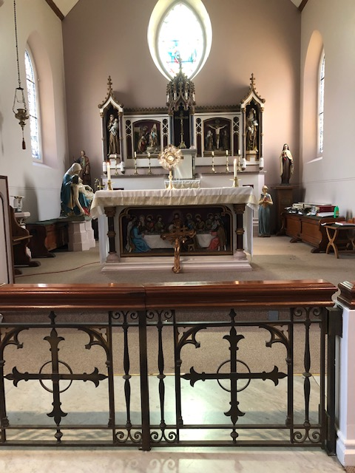
Readers next week: 17th/18th October
Sat 6.30 | Alyssa Mae Viernes; Paari Alphonse; Betty Sequeira
Sun 9.30 | Uhuegbu Sisters;  Susanna Inya
Sun 11.30 | Christabelle Nnamdi; Katalina Souza; John Quilas
Sun 6.30 | Karen Dadson;  Julia Osinachi-Okoh;  Joan Aruma

Please Pray for Elizabeth Law†, Philip Croft†, Patsy Wallace†, Pat Pullen†, Eric Fernandez†, Malcolm Scarfe†, David Prescott†, Osita Isiwu†, who have recently died. Also Pray for all those whose anniversaries occur about this time including: Sheila Ellery, Jose Fernandes, Paul Butler, John Aspey, Edward Florey, Alessandro Tizzano, Pier Cappelletti, Maria Fantetti, Christopher Carroll, David Mooney, Leslie Groombridge, John Moore, James Carroll, Edward Grainger, Charles Keane, Edward Ennis, Gaetano Marinelli, Michael Foster, Trent Hobbs, Kathleen Carroll, Sarah Brown, Angelina Fantetti, John Gethin, Margaret Scott, Arthur Dawkins, Alan O’Hara,
Archbishop Michael Bowen & Simon Julian.
May their souls, and all the souls of the faithfully departed, rest in peace.

FRIDAY
Eucharistic Adoration
6.15pm – 7.20pm
Followed by
Holy Mass at 7.30pm

Reading 1 | Isa 25:6-10 | The Lord will prepare a banquet, and will wipe away tears from every cheek.
Psalm | Ps 22 r.6 | In the Lord's own house shall I dwell for ever and ever.
Reading 2 | Phil 4:12-14, 19-20 | There is nothing I cannot master with the help of the One who gives me strength.
Gospel Acclamation | John 1:12.14 | The Word was made flesh and lived among us; to all who did accept him he gave power to become children of God.
Gospel | Matt 22:1-14 | Invite everyone you can find to the wedding.

Readers this week:
Sat 6.30 | Gabriel Concepcion; Frances Okafor;  Imelda Cervantes
Sun 9.30 | Ann Williams; Kara Iyiegbu; Akhebai Tegha
Sun 11.30 | Onyeahialam Sisters;  Laarni Fajardo
Sun 6.30 | Francisca Okeke; Victoria Shosanya; Anastasia Ibefa

Our Parish NOTICES
Collections this week:
CATEGORY | CASH (Loose) | GIFT AID | CONTACTLESS  Amount Gift Aid |  | TOTALS
Offertory | £733.72 | £151.90 | £542.00 | £52.00 | £1479.62
Second Collection - CAFOD | £236.14 | £80.00 | - | - | £316.14
Football Parking | £300.00 |  |  |  | £300.00

TODAY – there is a second collection for Prisoner Sunday, to offer care & encouragement to those facing difficult circumstances.

Next Week: SECOND COLLECTION for Missio, the Church’s official organ for the suppport of foreign missions. The entirety of the collection will go to support churches, hospitals, schools & vocations in countries where the Church is new, young or poor.

Please use the QR code for your weekly offerings & second collections
MONTHLY OFFERTORY REPORT 2026 - September
MONTH | CASH LOOSE | GIFT-AID | CONTACTLESS | GIFT-AID | STANDING ORDER | GIFT-AID | GRAND TOTAL
TOTALS | £2027.08 | £515.70 | £1709.00 | £181.25 | tbc | tbc | £4433.03
PATRICK PULLEN a Parishioner of 51 years, sadly passed away on Friday 25th September, aged 84yrs. His Funeral Service will take place, this Tuesday, 13th October 2026 at St Thomas of Canterbury Catholic Church, Rainham at 10.00am. All are welcome to attend the Church service however the cremation is for family.
ANNUAL MASS COUNT – this weekend is the final National Mass Count.
FIRST HOLY COMMUNION PROGRAMME 2027 - Application forms will be available from 10 October to 6 December 2026 and will be distributed only at Sunday Masses (not Saturday evening Mass). Applications are being accepted for children in Years 4 to 6. Separate arrangements apply to children in Year 7 and above. Completed application forms must be returned to the Parish Office, together with all required supporting documentation. Applications submitted without the necessary documentation will not be accepted. Please note that places are limited to 30. Late applications will not be considered for the 2027 programme.
PLANNED GIVING FOLLOW-UP – Thank you to everyone that very kindly put themselves forward as a Volunteer for the Parish, following the Planned Giving & Gift Aid Drive, earlier this year, in March. Please, look out for an email inviting you to attend a ‘welcome’ meeting to assess the availability & skills that you can offer.
Also, the ‘standing-order’ requests are being processed, however there have been issues with some banks not accepting the forms for various reasons. Please check your own bank statements & arrange for the standing order to be set up, as necessary. Many thanks.
DATES FOR YOUR DIARY
10/11th October | Annual Mass Count 2026
OCTOBER | Devotions to the Holy rosary will take place every day @ 9.30am
17th October | OLoG Seeds Concert practice in the McMahon Hall, 4 - 6pm
24th October | Spiritan Youth Concert at St Mellitus, Tollington Park, London, N4 3AG
24th October | Filipino Mass at 12.30pm, followed by a gathering in the McMahon Hall from 2pm. All are welcome.
31st October | Altar Server’s training in the McMahon Hall, 11am – 4pm

AROUND THE CATHOLIC COMMUNITY

YOUTH DAY AT JOHN FISHER SCHOOL PURLEY - 17TH OCTOBER 11.00AM – 5.30PM . COST £5. Free Coach transport from Dartford. For 10 – 14year olds. This great initiative of the Southwark youth service is a day of prayer, activities including sport, as well as lunch. We commend it to youth in the parish. To book a place turn to the diocesan website: https://scys.org.uk/youth-under-18/youth-days-10-14-years/ There is a free coach from St. Anselm’s Dartford, leaving at 9.30am. Please contact Fr. Stephen Boyle by email to book it: dartford@rcaos.org.uk. You may contact him for more details about the day.

FEAST OF ST JUDE, Whitefriars, Tanners Street, Faversham –
Saturday 24th, Sunday 25th & Wednesday 28th October
The programme of activities during the feast includes regular celebrations of the Eucharist; blessings with the oil of Saint Jude & other devotions. There will also be a small piety stall, a display of Carmelite books & light refreshments available.
All are welcome. Please call 01795 539214; visit www.stjudeshrine.org.uk; or email shrineoffice@stjudeshrine.org.uk for more information.

SPIRITAN YOUTH CONCERT will take place on Saturday 24th October at St Mellitus, Tollington Park, London, N4 3AG. The cost of transportation is £30 per person. Anyone interested in attending should message the OLoG Seeds Whatsapp Group or speak with Fr Pascoal. Payments should be made to Ebubechukwu Aruma; A/C no. 42132205; sort code 60-83-71 using the reference “Concert/(name of person being paid for)”

WORLD YOUTH DAY 2027 will take place in Seoul, South Korea from 3rd – 8th August 2027. Registration is now OPEN. The cost to attend is £3250 (via the Diocese). Anyone wishing to attend, should speak with Fr Pascoal.

MASS INTENTIONS FOR THE WEEK

Saturday (10th October) | 10.00am  10.30am  6.30pm | Thanksgiving Intentions for Emmanuel & Madeline’s 37years of marriage  EXPOSITION OF THE BLESSED SACRAMENT and RECONCILIATION  Repose of the soul of Jeannot Zomahoun
Sunday (11th October)  Day of Prayer for Prisoners & their families | 9.30am  11.30am  1.00pm  6.30pm | Repose of the soul of Apolonia McKenzie  Repose of the soul of Jeannot Zomahoun  Baptism of Maxmillian  Pro Populo
Monday (12th October) | 10.00am | Repose of the soul of Patsy Wallace
Tuesday (13th October)  St Edward the Confessor | 10.00am | Repose of the soul of Phil Croft
Wednesday (14th October) | 10.00am | Repose of the soul of Phil Croft
Thursday (15th October)  St Teresa of Jesus | 10.00am | God’s Blessing & Good Health for Maria Drelich
Friday (16th October) | 10.00am  6.15pm  7.30pm | Repose of the soul of Patrick Pullen  EUCHARISTIC ADORATION  Thanksgiving for the Dhis Davis Family
Saturday (17th October)  St Ignatius of Antioch  Vigil Mass | 10.00am  10.30am  6.30pm | Repose of the soul of Phil Croft  EXPOSITION OF THE BLESSED SACRAMENT and RECONCILIATION  Good Health & Thanksgiving Intentions for Hannah McIntyre
Sunday (18th October)  World Mission Sunday | 9.30am  11.30am  6.30pm | Repose of the soul of Osita Isiwu  Good Health & Wellbeing of Tommy Doyle  Pro Populo

Mass Intentions are £10. Please use a ‘Mass Intention/offering envelope’.

