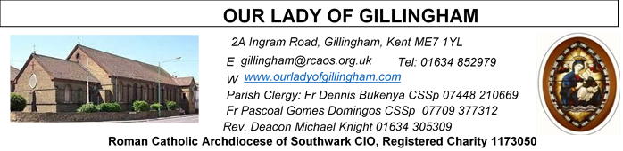Office Hours – Tuesday, Wednesday & Friday - 10.30am – 1.30pm
20th September 2026
25th Sunday in Ordinary Time - Year A
Readers next week: 26th/27th September
Sat 6.30 | Mary Sandana;  Maria Alphonse;  John Jupit Quilas
Sun 9.30 | Uhuegbu Sisters; Vincent Obi
Sun 11.30 | Shakira Kara; Olivia Gali, Samuel Robson
Sun 6.30 | Anastasia Ibefa; Julia Osinachi-Okoh; Karen Dadson

Readers this week:
Sat 6.30 | Gabriel Concepcion; Lucy Nnamdi; Kieran Shannon
Sun 9.30 | Ann Williams; Tania Jackson; Akhebai Tegha
Sun 11.30 | Onyehialam Sisters; Dinah Kansiime
Sun 6.30 | Frances Okafor; Victoria Shosanya; Daniela Ibeh

Please Pray for Eric Fernandez†, Malcolm Scarfe†, David Prescott†, Osita Isiwu†, Akinbowale Oluwole Adebiyi†, who have recently died.
Also Pray for all those whose anniversaries occur about this time including: Hugh Corr, Honora O’Hare, Peter Perfect, Magno Bottiglieri, Frederick Jackson, Lidia Tompolska, April Larkin, David Keating, Alice Burley, Valerie Gent, Margaret Sims, Joan Keohane, Robert Plummer, Samuel Scott, Thomas McKee, Linda Stroud, Catherine Keane, Martin McDonagh, Karla Benakova, Michael Kiernan, Bjorn Borg, Peter Smith and Margaret Baxter.
May their souls, and all the souls of the faithfully departed, rest in peace.

FRIDAY
Eucharistic Adoration
6.15pm – 7.20pm
Followed by
Holy Mass at 7.30pm

Reading 1 | Isa 55:6-9 | My thoughts are not your thoughts.
Psalm | Ps 144:2-3. 8-9. 17-18 r.18 | The Lord is close to all who call him.
Reading 2 | Phil 1:20-24, 27 | Life to me is Christ.
Gospel Acclamation | Luke 19: 38 | Blessings of the King who comes, in the name of the Lord! Peace be in heaven and glory in the highest heaven.
Gospel Acclamation | cf. Acts 16:14 | Open our hearts, O Lord, to accept the words of your Son
Gospel | Matt 20:1-16a | Why be envious because I am generous?

SATURDAY
Exposition of the Blessed Sacrament & Reconciliation
10.30am – 11.30am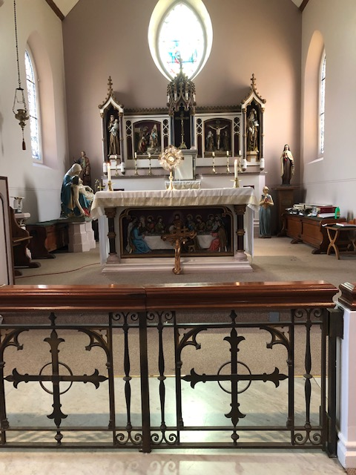
Our Parish NOTICES
Collections this week:
CATEGORY | CASH (Loose) | GIFT AID | CONTACTLESS  Amount Gift Aid |  | TOTALS
Offertory | £477.19 | £130.00 | £453.00 | £37.00 | £1097.19
Second Collection – Education Sunday | £114.88 | £48.00 | £49.00 | £6.50 | £218.38
Football | £160.00 |  |  |  | £160.00

THIS WEEK there will be a second collection for Home Mission Sunday. This collection enables the spread of the gospel in our own country.

Please use the QR code for your weekly offerings & second collections
MONTHLY OFFERTORY REPORT 2026 - August
MONTH | CASH LOOSE | GIFT-AID | CONTACTLESS | GIFT-AID | STANDING ORDER | GIFT-AID | GRAND TOTAL
TOTALS | 2,335.82 | 474.16 | 1,986.00 | 252.50 | 926.00 | 167.50 | £6141.98
FR DENNIS will be going on the HCPT Pilgrimage on Saturday 26th September, and will return to the Parish on Friday 9th October.
ANNUAL MASS COUNT – this weekend is the first National Mass Count.
HOLY HOUR WITH JESUS: A reminder to all that every Friday at 6.15pm we have the adoration of the Blessed Sacrament in the Church. All the parishioners are invited to be part of this holy devotion, spending an hour with Jesus our savior, for the spiritual nourishment. A redeeming power in the body and blood of Jesus.
EXTRA-ORDINARY MINISTERS OF HOLY COMMUNION – next training session will take place on Monday 21st September.
CHILDREN’s LITURGY – will continue on the FIRST Sunday of every month, during 9.30am Mass. Children aged 5yrs & above (until they make their First Holy Communion) are welcome to attend. Unfortunately, due to volunteer absence, there will NO Children’s Liturgy on Sunday 4th October.
DATES FOR YOUR DIARY
26th September | Filipino Mass at 12.30pm, followed by a gathering in the McMahon Hall from 2pm. All are welcome
2nd October | CAFOD Family Fast Day
19/20th Sept  26/27th Sept  3/4th October  10/11th October | Today  Annual Mass Count 2026
OCTOBER | Devotions to the Holy rosary will take place every day @ 9.30am
AROUND THE CATHOLIC COMMUNITY
CAFOD Family Fast Day Appeal this Harvest – 2nd October
Please support our Family Fast Day collection and help communities facing shortages of food and safe water. Your gift can help children like Tayla in Zimbabwe stay in school through improved access to water, nutritious school meals, and school gardens.
Donate using a CAFOD envelope in church, online at cafod.org.uk/envelope, or by calling 0303 303 3030.

ARCHDIOCESE OF SOUTHWARK – ANNUAL SERVICE – 30TH SEPTEMBER
The Archdiocese of Southwark will be holding their annual service for those that have been harmed by abuse on the 30th September 2026, at 6.30pm at St George’s Cathedral. The service will be lead by Archbishop John Wilson and is an opportunity for the archdiocese community to express their solidarity and compassion to those that have been hurt by abuse and our commitment to building safe environments for all. Please attend if you are able.

DAY FOR CATECHISTS

On behalf of the Archbishop you are invited to attend 12th annual Diocesan Day for Catechists on Saturday, 3rd October 2026 at the Amigo Hall, St Georges Cathedral, SE1 6HU. To book via the or scan the QR code https://aec.rcaos.org.uk/day-for-catechists-2026. The day is for all catechists including those involve in RCIA and Children Liturgy.

MARRIAGE & FAMILY LIFE KENT – BEREAVEMENT RETREAT
For anyone who has experienced bereavement, recently or some time ago. We grieve, remember, hope, and give thanks for our loved ones in the light of the Resurrection of Jesus.
There are still places available on the Bereavement Retreat at Aylesford Priory, 10th-11th October 2026. Cost is £280 single or £250 shared room.
For further information & to book, please contact reception@thefriars.org.uk or
telephone 01622 717272


THE EMBER PROGRAMME: FANNING THE FLAMES OF FAITH AND JUSTICE
Faith isn't just something you believe - it's something you do.
A call to action for young adults (18-25) ready to go beyond talking about justice and start living it - together. The six-month course is designed to fit round your university course or job.
Led by the Columbans and the FCJ Centre for Spirituality and EcoJustice.
The deadline for applications is 30th September. For more information and registration: tinyurl.com/Ember26

MASS INTENTIONS FOR THE WEEK
Saturday (19th September) | 10.00am  10.30am  6.30pm | Repose of the soul of Antonio DaCosta  EXPOSITION OF THE BLESSED SACRAMENT and RECONCILIATION  Repose of the soul of Mary Cade
Sunday (20th September) | 9.30am  11.30am  6.30pm | Pro Populo  Repose of the soul of Mark Opunga Makuri  For ALL the Holy Souls
Monday (21st September)  St Matthew | 10.00am | Repose of the soul of Christine Barton
Tuesday (22nd September) | 10.00am | Repose of the soul of David Keating
Wednesday (23rd September)  St Pius of Pietrelcina | 10.00am | Repose of the soul of David Mabon
Thursday (24th September)  Our Lady of Walsingham | 10.00am | Repose of the souls of Bill & Patricia Tuffin
Friday (25th September) | 10.00am  6.15pm  7.30pm | Repose of the soul of Michael Kiernan  EUCHARISTIC ADORATION  Kuriakose Chacko
Saturday (26th September)  Vigil Mass | 10.00am  10.30am  12.30 – 2pm  6.30pm | Repose of the soul of Teresa Vella  EXPOSITION OF THE BLESSED SACRAMENT and RECONCILIATION  Filipino Mass  “For God’s Blessings & Grace upon the Elderly Parishioners”
Sunday (27th September)  World Day of Prayer for Migrants & Refugees | 9.30am  11.30am  6.30pm | Repose of the souls of Mary & Aubrey Jamieson  Pro Populo  Repose of the soul of Elizabeth Buck

If you would like to book a Mass intention, please see Sue McIntyre or complete a ‘Mass Intention envelope’. Mass Intention donations are £10.00

