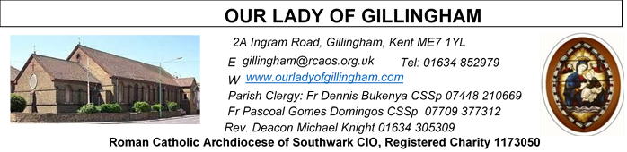Office Hours – Tuesday, Wednesday & Friday - 10.30am – 1.30pm
13th September 2026
24th Sunday in Ordinary Time - Year A
Please Pray for Eric Fernandez†, Malcolm Scarfe†, David Prescott†, Osita Isiwu†, Akinbowale Oluwole Adebiyi†, who have recently died.
Also Pray for all those whose anniversaries occur about this time including: Susan O’Connell, Christopher Gellett, Anna Holden, Cherry Burgess, William Herbert, Emily Fennell, Gerard Szalajko, Patricia Tuffin, Florencio Revil (Jnr), Julia Knell, Francis Stewart, David Baxter, Ryxzard Jecz, Farid Anthony, James (Jimmy) Sherry, Veronica (Peggy) Hardy, Rita Bannister, John Fleming, Leslie Whittell, Jane Rand, Christine Goodwin, Thomas Long, Doreen Knight, Stanley Potter, Carmine Filippone, Feliks Welke, and Maria Crozier. May their souls, and all the souls of the faithfully departed, rest in peace.

May their souls, and all the souls of the faithful departed, rest in peace.
Reading 1 | Ecclesiasticus 27:30-28:7 | Forgive your neighbour the hurt that he does you, and when you pray, your sins will be forgiven.
Psalm | Ps 102: 1-4. 9-12 r.8 | The Lord is compassion and love, slow to anger and rich in mercy.
Reading 2 | Rom 14: 7-9 | Alive or dead we belong to the Lord
Gospel Acclamation | 1 Sam 3:9; John 6:68 | Speak, Lord, your servant is listening: you have the message of eternal life.
 | John 13:34 | I give you a new commandment Love One Another, just as I have loved you.
Gospel | Matt 18:21-35 | I do not tell you to forgive seven times, but seventy-seven times.

Readers next week: 19th/20th September
Sat 6.30 | Gabriel Concepcion; Kara Iyiegbu; Kieran Shannon
Sun 9.30 | Ann Williams; Nicky Croft; Akhebai Tegha
Sun 11.30 | Onyehialam Sisters; Dinah Kansiime
Sun 6.30 | Frances Okafor; Victoria Shosanya; Daniela Ibeh

Readers this week:
Sat 6.30 | Oliver Perez; Benedict Okeke; Betty Sequiera
Sun 9.30 | Edeji Sisters
Sun 11.30 | Ellie Tetteh; Chelsea Atoe; Laarni Fajardo
Sun 6.30 | Uche Family

FRIDAY
Eucharistic Adoration
6.15pm – 7.20pm
Followed by
Holy Mass at 7.30pm

SATURDAY
Exposition of the Blessed Sacrament & Reconciliation
10.30am – 11.30am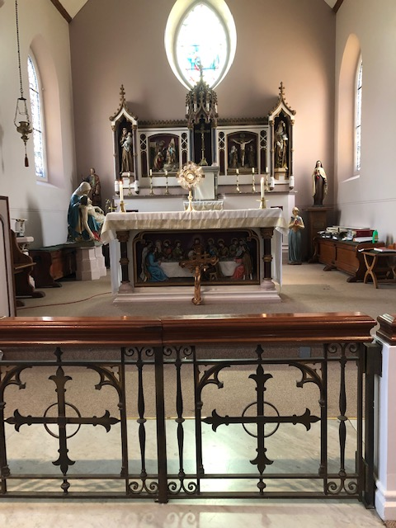
Our Parish NOTICES
Collections this week:
CATEGORY | CASH (Loose) | GIFT AID | CONTACTLESS  Amount Gift Aid |  | TOTALS
Offertory | £629.23 | £156.70 | £376.00 | £45.00 | £1206.93

THIS WEEK there will be a Second Collection for the Catholic Education Service, which works on behalf of the Catholic Bishops’ Conference to support Catholic Education. Catholic schools make up 10% of the national total of maintained schools.

NEXT WEEK there will be a second collection for Home Mission Sunday.

Please use the QR code for your weekly offerings & second collections
MONTHLY OFFERTORY REPORT 2026 - August
MONTH | CASH LOOSE | GIFT-AID | CONTACTLESS | GIFT-AID | STANDING ORDER | GIFT-AID | GRAND TOTAL
TOTALS | 2,335.82 | 474.16 | 1,986.00 | 252.50 | 926.00 | 167.50 | £6141.98
HOLY HOUR WITH JESUS: A reminder to all that every Friday at 6.15pm we have the adoration of the Blessed Sacrament in the Church. All the parishioners are invited to be part of this holy devotion, spending an hour with Jesus our savior, for the spiritual nourishment. There is a redeeming power in the body and blood of Jesus.
EXTRA-ORDINARY MINISTERS OF HOLY COMMUNION – next training session will take place on Monday 14th September @ 6pm.
CHILDREN’s LITURGY – Started on 6th September & will continue on the FIRST Sunday of every month, during 9.30am Mass. Children aged 5yrs & above (until they make their First Holy Communion) are welcome to attend. Unfortunately, due to volunteer absence, there will NO Children’s Liturgy on Sunday 4th October.
DATES FOR YOUR DIARY
12th September | Readers & Altar Servers’ Commissioning at 1pm, followed by a gathering in the McMahon Hall from 2pm-5pm
26th September | Filipino Mass at 12.30pm, followed by a gathering in the McMahon Hall from 2pm. All are welcome
2nd October | CAFOD Family Fast Day
19/20th Sept  26/27th Sept  3/4th October  10/11th October | Annual Mass Count 2026

AROUND THE CATHOLIC COMMUNITY
RECOMMENDATION by BISHOP PAUL HENDRICKS – An Experimental Programme: How do we pray? How do we build a better, more fulfilling relationship with God?
You are warmly invited to join an experiential programme called Teach Us to Pray facilitated by Southwark Diocesan Spirituality Commission. The programme will be online on Tuesdays, starting 6th October from 7pm to 8.15pm. Following 4 online sessions, there is an invitation to conclude the programme with an in-person Reflection Day in a Diocesan Retreat Centre on 5th or 12th December. There is no commitment to attend all sessions – join us whenever you can. For details/ to sign up see https://aecsouthwark.churchsuite.com/events/tnpn4hqd or email for further information spirituality@rcaos.org.uk
Archdiocese of Southwark – Annual Service – 30th September
The Archdiocese of Southwark will be holding their annual service for those that have been harmed by abuse on the 30th September 2026, at 6.30pm at St George’s Cathedral. The service will be lead by Archbishop John Wilson and is an opportunity for the archdiocese community to express their solidarity and compassion to those that have been hurt by abuse and our commitment to building safe environments for all. Please attend if you are able.
JOHN WOODHOUSE LAUDATO SI' ANIMATORS UK - SEASON OF CREATION SEPT 1 TO OCT 4 2026 LIVING WATER
The season of Creation begins on Sept 1 the World Day of prayer for the care of creation. The theme of the season is “Living water”. We learn of a river growing deeper and restoring barren land with reviving waters and sustaining flourishing ecosystems. This vision invites human responsibility: recognising ecological damage and embracing interconnectedness. We are called to immerse ourselves in the water, actively safeguarding and working for the renewal of creation so that environmental healing and human well-being may flourish together.
In the Gospel, today, Peter asks how often must I forgive my brother if he wrongs me. Jesus answered “Not seven, I tell you, but seventy-seven times”. A parable follows but how much God has forgiven us and we must forgive our fellow servants in the same way.
DAY FOR CATECHISTS

On behalf of the Archbishop you are invited to attend 12th annual Diocesan Day for Catechists on Saturday, 3rd October 2026 at the Amigo Hall, St Georges Cathedral, SE1 6HU. To book via the or scan the QR code https://aec.rcaos.org.uk/day-for-catechists-2026. The day is for all catechists including those involve in RCIA and Children Liturgy.

RETROUVAILLE - Marriage Help - Communication failure is a major cause of marital breakdown - 1,000's of couples have found Retrouvaille helped their relationship. Retrouvaille is not counselling but a programme to help married couples work through conflicts more effectively. We focus on helping restore trust and hope. Bookings close 18th Sept. www.Retrouvaille.org.uk +44 7887 296 983
MASS INTENTIONS FOR THE WEEK
Saturday (12th August) | 10.00am  10.30am  1.00pm  6.30pm | Repose of the soul of John Nicol  EXPOSITION OF THE BLESSED SACRAMENT and RECONCILIATION  Readers & Altar Servers’ Commissioning  Pro Populo
Sunday (13th August) | 9.30am  11.30am  6.30pm | Repose of the soul of Apolonia McKenzie  Thanksgiving Intention for Jacques Desire Laval  Birthday Thanksgiving for Fr Pascoal
Monday (14th August)  The Exaltation of The Holy Cross | 10.00am | Repose of the soul of Maureen Coombs
Tuesday (15th September)  Our Lady of Sorrows | 10.00am | Repose of the soul of John Gallagher
Wednesday (16th September)  Saint Cornelius | 10.00am | Birthday Intention of Clare Whiteoak
Thursday (17th September) | 10.00am | Repose of the soul of Maureen Mabon
Friday (18th September) | 9.30am  6.15pm  7.30pm | Repose of the soul of Caterina Cannavina  EUCHARISTIC ADORATION  Repose of the soul of George Norman
Saturday (19th September)  Vigil Mass | 10.00am  10.30am  6.30pm | Repose of the soul of Antonio DaCosta  EXPOSITION OF THE BLESSED SACRAMENT and RECONCILIATION  Repose of the soul of Mary Cade
Sunday (20th September) | 9.30am  11.30am  6.30pm | Pro Populo  Repose of the soul of Mark Opunga Makuri  For ALL the Holy Souls

If you would like to book a Mass intention, please see Sue McIntyre or complete a ‘Mass Intention envelope’. Mass Intention donations are £10.00

