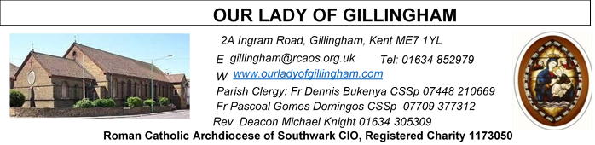Office Hours – Tuesday, Wednesday & Friday - 10.30am – 1.30pm
6th September 2026
23rd Sunday in Ordinary Time - Year A
Readers next week: 12th/13th September
Sat 6.30 | Oliver Perez; Benedict Okeke; Betty Sequiera
Sun 9.30 | Edeji Sisters
Sun 11.30 | Ellie Tetteh; Chelsea Atoe; Laarni Fajardo
Sun 6.30 | Uche Family

Readers this week:
Sat 6.30 | Janette Alfayad; Gillian Knight; Yolanda Danday
Sun 9.30 | Nnamdi Eke; Chizoba Okeke; Gillian Knight
Sun 11.30 | Dominic Gali; Katalina Souza; Laarni Fajardo
Sun 6.30 | Charbel Tsagli; Francisca Okeke; Joan Aruma

Please Pray for Eric Fernandez, Malcolm Scarfe†, David Prescott†, Osita Isiwu†, Akinbowale Oluwole Adebiyi†, who have recently died.
Also Pray for all those whose anniversaries occur about this time including: Salvatore Formosa, Davina Colgan, Ernest Cragon, Michael Dooner, Kenneth Almond, Matteo Rocco, Betty O’Connell, Rita Keating, Colm Crowley, Alice Wills, Iris Appleton, Fedor Yarmak, Stuart Hills, George Norman, Mareen Coombs, Philip Dunfold, Tony Collins, Marjorie Shea, Joyce Guscott, Hilda Mason, Lisette Cathan & Gerald Bunce.
May their souls, and all the souls of the faithful departed, rest in peace.
Reading 1 | Ezek 33:7-9 | If you do not speak to the wicked man, I will hold you responsible for his death.
Psalm | Ps 94: 1-2. 6-9 r.7-8 | O that today you would listen to his voice! Harden not your hearts.
Reading 2 | Rom 13:8-10 | Love is the answer to every one of the commandments.
Gospel Acclamation | John 17:17 | Your word is truth, O Lord, consecrate us in the truth.
 | 2 Cor 5:19 | God in Christ was reconciling the world to himself, and he has entrusted to us that they are reconciled.
Gospel | Matt 18:15-20 | If he listens to you, you have won back your brother.

FRIDAY
Eucharistic Adoration
6.15pm – 7.20pm
Followed by
Holy Mass at 7.30pm

SATURDAY
Exposition of the Blessed Sacrament & Reconciliation
10.30am – 11.30am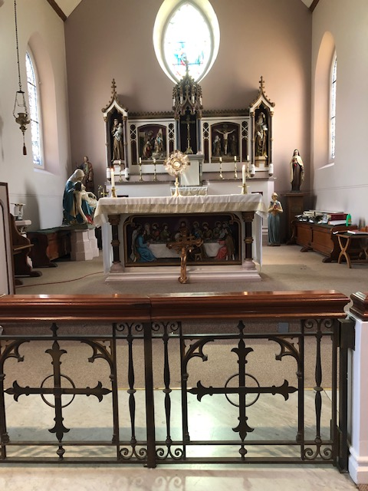
Our Parish NOTICES
Collections this week:
CATEGORY | CASH (Loose) | GIFT AID | CONTACTLESS  Amount Gift Aid |  | TOTALS
Offertory | £500.26 | £111.50 | £477.00 | £58.75 | £1147.51
Football Parking | £262.50 |  |  |  | £262.50

NEXT WEEK there will be a Second Collection for the Catholic Education Service

Please use the QR code for your weekly offerings & second collections
MONTHLY OFFERTORY REPORT 2026 - August
MONTH | CASH LOOSE | GIFT-AID | CONTACTLESS | GIFT-AID | STANDING ORDER | GIFT-AID | GRAND TOTAL
TOTALS | 2,335.82 | 474.16 | 1,986.00 | 252.50 | 926.00 | 167.50 | £6141.98
READER’s & ALTAR SERVERS’ COMMISSIONING – will take place, next weekend, Saturday 12th September @ 1pm in Church, followed by a gathering in the McMahon Hall from 2pm until 5pm. Bishop Paul Hendricks will be attending.
1st Reader | Gabriel Concepcion
Responsorial Psalm | Julia Osinachi-Okoh
2nd Reader | Ann Williams
Bidding Prayers | Tania Jackson; Betty Sequiera; Alyssa Mae Viernes; Kieran Shannon; Akhebai Tegha; Ugochi Uche
PARISH THANKSGIVING – Thank you for your ‘thanksgiving’ donations which NOW total £5206.78 for the renovation of Frs. dining room. The carpet has now been fitted & the project is complete. Thank you for your generosity.
FOOD BANK – We are still collecting unperishable food items for the local food bank. Please leave any donations in the box at the back of the Church.
HOLY HOUR WITH JESUS: A reminder to all that every Friday at 6.15pm we have the adoration of the Blessed Sacrament in the Church. All the parishioners are invited to be part of this holy devotion, spending an hour with Jesus our savior, for the spiritual nourishment. There is a redeeming power in the body and blood of Jesus.
DATES FOR YOUR DIARY

12th September | Readers & Altar Servers’ Commissioning at 1pm, followed by a gathering in the McMahon Hall from 2pm-5pm
26th September | Filipino Mass at 12.30pm, followed by a gathering in the McMahon Hall from 2pm. All are welcome
AROUND THE CATHOLIC COMMUNITY
RECOMMENDATION by BISHOP PAUL HENDRICKS – An Experimental Programme: How do
we pray? How do we build a better, more fulfilling relationship with God?
You are warmly invited to join an experiential programme called Teach Us to Pray facilitated by Southwark Diocesan Spirituality Commission. The programme will be online on Tuesdays, starting 6th October from 7pm to 8.15pm. Following 4 online sessions, there is an invitation to conclude the programme with an in-person Reflection Day in a Diocesan Retreat Centre on 5th or 12th December. There is no commitment to attend all sessions – join us whenever you can. For details/ to sign up see https://aecsouthwark.churchsuite.com/events/tnpn4hqd or email for further information spirituality@rcaos.org.uk

Archdiocese of Southwark – Annual Service – 30th September
The Archdiocese of Southwark will be holding their annual service for those that have been harmed by abuse on the 30th September 2026, at 6.30pm at St George’s Cathedral. The service will be lead by Archbishop John Wilson and is an opportunity for the archdiocese community to express their solidarity and compassion to those that have been hurt by abuse and our commitment to building safe environments for all. Please attend if you are able.

MARRIAGE & FAMILY LIFE KENT - SycamOre – Growing in Faith –
8th; 15th; 22nd; 29th September
The Growing in Faith Together for married and engaged couples is an ONLINE course, which has been developed in collaboration with the Southwark Marriage and Family Life team, the Agency for Evangelisation and Sycamore, a programme about the Catholic faith by Fr Stephen Wang,(Bishop-elect Arundel and Brighton)
Growing in Faith Together consists of four one hour-long sessions via Zoom and is a wonderful opportunity for:
· married couples to enrich their friendship and love.
· engaged couples who want to continue exploring their faith together
The next course begins on Tuesday Sept 8th and continues on Sept 15th, 22nd and 29th at 8.30pm – 9.30pm. For further information and to book a place, please contact Carole on mflkent@rcaos.org.uk

DAY FOR CATECHISTS

On behalf of the Archbishop you are invited to attend 12th annual Diocesan Day for Catechists on Saturday, 3rd October 2026 at the Amigo Hall, St Georges Cathedral, SE1 6HU. To book via the or scan the QR code https://aec.rcaos.org.uk/day-for-catechists-2026. The day is for all catechists including those involve in RCIA and Children Liturgy.

RETROUVAILLE - Marriage Help - Communication failure is a major cause of marital breakdown - 1,000's of couples have found Retrouvaille helped their relationship. Retrouvaille is not counselling but a programme to help married couples work through conflicts more effectively. We focus on helping restore trust and hope. Bookings close 18th Sept. www.Retrouvaille.org.uk +44 7887 296 983
MASS INTENTIONS FOR THE WEEK
Saturday (5th August) | 10.00am  10.30am  3.00pm  6.30pm | Repose of the soul of Malcolm Scarfe  EXPOSITION OF THE BLESSED SACRAMENT and RECONCILIATION  Young Adult Mass  Intentions of Immaculate Sserebe
Sunday (6th August) | 9.30am  11.30am  6.30pm | Repose of the soul of Davina Colgan  For All the Holy Souls  Pro Populo
Monday (7th August) | 10.00am | Repose of the soul of Fr Gerald Quinn
Tuesday (8th September)  The Nativity of the Blessed Virgin Mary | 10.00am | Good Health & Wellbeing of Philip Croft
Wednesday (9th September) | 10.00am | Thanksgiving Intentions for Pere Laual
Thursday (10th September) | 10.00am | Repose of the soul of Mary Shodimeji
Friday (11th September) | 9.30am  6.15pm  7.30pm | Repose of the soul of Eric Fernandez  EUCHARISTIC ADORATION  For All the Holy Souls
Saturday (12th September)  Vigil Mass | 10.00am  10.30am  1.00pm  6.30pm | Repose of the soul of John Nicol  EXPOSITION OF THE BLESSED SACRAMENT and RECONCILIATION  Readers & Altar Servers’ Commissioning  Pro Populo
Sunday (13th September) | 9.30am  11.30am  6.30pm | Repose of the soul of Apolonia McKenzie  Thanksgiving Intention for Pere Laual  For All the Holy Souls

If you would like to book a Mass intention, please see Sue McIntyre or complete a ‘Mass Intention envelope’. Mass Intention donations are £10.00

