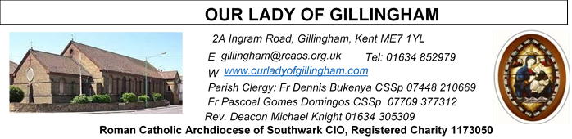Office Hours – Tuesday, Wednesday & Friday - 10.30am – 1.30pm
30th August 2026
22nd Sunday in Ordinary Time - Year A
FRIDAY
Eucharistic Adoration
6.15pm – 7.20pm
Followed by
Holy Mass at 7.30pm

Please Pray for Eric Fernandes, Malcolm Scarfe†, David Prescott†, Osita Isiwu†, Akinbowale Oluwole Adebiyi†, Mary Shirley†, and Chris Milne†, who have recently died.
Also Pray for all those whose anniversaries occur about this time including: Jack Deere, Maurice O’Connell, Pasquale Simone, Reginald Flannery, John Slevin, Ruth Ireland, Royston Lewis, Ellen Almond, Edward Obasuyi, Cosimo Larini, William O’Grady, Teresa Vella, Nancy Buckley, John Fleming and Walter Hardy.
May their souls, and all the souls of the faithful departed,
rest in peace.
Reading 1 | Jer 20:7-9 | The word of the Lord has meant insult for me.
Psalm | Ps 62:2-6. 8-9 r. 2 | For you my soul is thirsting, O Lord my God.
Reading 2 | Rom 12:1-2 | Offer your bodies as a living sacrifice.
Gospel Acclamation | cf. Eph 1:17.18 | May the Father of our Lord Jesus Christ enlighten the eyes of our mind, so that we can see what hope his call holds for us.
Gospel | Matt 16:21-27 | If anyone wants to be a follower of mine, let him renounce himself.

Readers next week: 5th/6th September
Sat 6.30 | Janette Alfayad; Francisca Okeke; Imelda Cervantes
Sun 9.30 | Nnamdi Eke; Chizoba Okeke; Gillian Knight
Sun 11.30 | Dominic Gali; Katalina Souza; Laarni Fajardo
Sun 6.30 | Charbei Tsagli; Shakira Kara; Joan Aruma

Readers this week:
Sat 6.30 | Lucy,Crystabelle;  Yolanda Danday
Sun 9.30 | Ann Williams; Nnamdi Eke;  Akhebai Tegha
Sun 11.30 | Kara Family;  Samuel Robson
Sun 6.30 | Charbel Tsagli;  Julia Joan Aruma

SATURDAY
Exposition of the Blessed Sacrament & Reconciliation
10.30am – 11.30am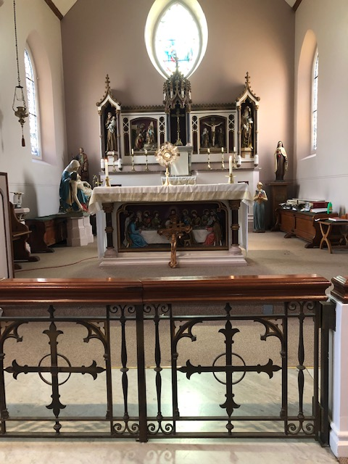
Our Parish NOTICES
Collections this week:
CATEGORY | CASH (Loose) | GIFT AID | CONTACTLESS  Amount Gift Aid |  | TOTALS
Offertory | £334.00 | £81.00 | £421.00 | £65.00 | £901.00


Please use the QR code for your weekly offerings & second collections
WE NEED YOU - EXTRA-ORDINARY MINISTERS OF THE EUCHARIST
Training is ongoing. The next meeting is on Wednesday 2nd September 2026, at 6.30pm, in the McMahon Hall.
PARISH THANKSGIVING – Thank you for your ‘thanksgiving’ donations which NOW total £5185.78 for the renovation of Frs. dining room. Donations are still being accepted and can be made by bank transfer to RCAS Gillingham; 60-08-37; 55153119 or via the contactless machine, using the ‘THANKSGIVING’ option. There are also ‘Thanksgiving’ envelopes available at the back of the Church. Thank you all for your generosity. The carpet is due to be fitted next week.
FOOD BANK – We are still collecting unperishable food items for the local food bank. Please leave any donations in the box at the back of the Church.
CHURCH CLEANLINESS – our volunteer cleaners work very hard to keep the Church presentable for everyone. We are encouraging Parishioners and/or their children to refrain from eating during Mass, Thank You.
HOLY HOUR WITH JESUS: A reminder to all that every Friday at 6.15pm we have the adoration of the Blessed Sacrament in the Church. All the parishioners are invited to be part of this holy devotion, spending an hour with Jesus our savior, for the spiritual nourishment. There is a redeeming power in the body and blood of Jesus.
DATES FOR YOUR DIARY

5th September | Reader’s Training & Formation in the McMahon Hall. 2pm-4pm
5th September | Young Adult Mass at 3pm
12th September | Reader’s Commissioning at 1pm
26th September | Filipino Mass at 12.30pm, followed by a gathering in the McMahon Hall from 2pm. All are welcome

AROUND THE CATHOLIC COMMUNITY

IGBO CATHOLIC COMMUNITY MASS – THIS SUNDAY, 30 AUGUST 2026
The Igbo Catholic Community, under the Nigerian Catholic Chaplaincy in England and Wales, warmly invites everyone to join us for a joyful celebration of our Catholic faith, culture and community. Sunday, 30 August 2026 at 1.00 pm
St Thomas of Canterbury Church, Rainham, Kent, ME8 7RH. Families and friends are all warmly welcome.
RIGHT TO LIFE - Stop assisted suicide - postcards available
The vote on assisted suicide is on 11 September.
Not Dead Yet UK have provided postcards you can send to your MP to ask them to vote NO to assisted suicide in the vote in the House of Commons on 11 September.
Please take action now - collect a red and white postcard, fill out your details, and return it to Fr Dennis or the Parish Office by Friday 4th September latest. We will post them to your MP.
MARRIAGE & FAMILY LIFE KENT - SycamOre – Growing in Faith
The Growing in Faith Together for married and engaged couples is an ONLINE course, which has been developed in collaboration with the Southwark Marriage and Family Life team, the Agency for Evangelisation and Sycamore, a programme about the Catholic faith by Fr Stephen Wang,(Bishop-elect Arundel and Brighton)
Growing in Faith Together consists of four one hour-long sessions via Zoom and is a wonderful opportunity for:
· married couples to enrich their friendship and love.
· engaged couples who want to continue exploring their faith together
The next course begins on Tuesday Sept 8th and continues on Sept 15th, 22nd and 29th at 8.30pm – 9.30pm. For further information and to book a place, please contact Carole on mflkent@rcaos.org.uk
DAY FOR CATECHISTS

On behalf of the Archbishop you are invited to attend 12th annual Diocesan Day for Catechists on Saturday, 3rd October 2026 at the Amigo Hall, St Georges Cathedral, SE1 6HU. To book via the or scan the QR code https://aec.rcaos.org.uk/day-for-catechists-2026. The day is for all catechists including those involve in RCIA and Children Liturgy.

PILGRIMAGE TO FATIMA - Monday 28th September – Thursday 1st October. Cost £419 (includes flights, half board accommodation and transfer to Lisbon) contact Fr Stephen via email dartford@rcaos.org.uk or 07504518262 for more details. Closing date is 13 September.

DIVINE MERCY PILGRIMAGE
The Divine Mercy Apostolate, London is holding a Celebration of St Faustina Birthday at Aylesford Priory, Aylesford, Kent on Bank Holiday Monday 31 August 2025 from 10:30 am to 4pm. The reflection day will include teachings on the Message of Divine Mercy, Holy Mass, Hour of Mercy with Adoration and Benediction and Veneration of the Image of Merciful Jesus. All welcome. Call Millie on WhatsApp 07957594646 for more information.
MASS INTENTIONS FOR THE WEEK
Saturday (29th August) | 10.00am  10.30am  12.30pm  6.30pm | Repose of the soul of Gerald Odi Osakine  EXPOSITION OF THE BLESSED SACRAMENT and RECONCILIATION  Baptism of Alexander Leon Odjocea  God’s Blessings and Grace upon the Elderly Parishioners
Sunday (30th August)  22nd Sunday of Ordinary Time | 9.30am  11.30am  6.30pm | Intentions for Claire Whiteoak  Pro Populo  For all the Holy Souls
Monday (31st August) | 10.00am | Repose of the soul of Helen Wigley
Tuesday (1st September) | 10.00am | Health & Wellbeing of Philip Croft
Wednesday (2nd September) | 10.00am | Requiem Mass for Kaleekal Mathew Varkey
Thursday (3rd September)  St Gregory the Great | 10.00am | Thanksgiving for Matthew Qurku
First Friday (4th September) | 9.30am  6.15pm  7.30pm | Requiem Mass for Eric Fernandes  EUCHARISTIC ADORATION  For All the Holy Souls
First Saturday (5th September)  Vigil Mass | 10.00am  10.30am  3.00pm  6.30pm | Repose of the soul of Malcolm Scarfe  EXPOSITION OF THE BLESSED SACRAMENT and RECONCILIATION  Young Adult Mass  Intentions of Immaculate Sserebe
Sunday (6th September)  23rd Sunday of Ordinary Time | 9.30am  11.30am  6.30pm | Repose of the soul of Davina Colgan  For All the Holy Souls  Pro Populo

If you would like to book a Mass intention, please see Sue McIntyre or complete a ‘Mass Intention envelope’. Mass Intention donations are £10.00

