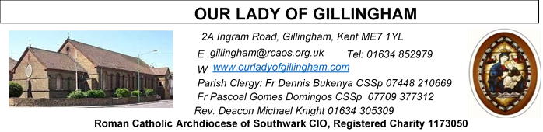Office Hours – Tuesday, Wednesday & Friday - 10.30am – 1.30pm
23rd August 2026
21st Sunday in Ordinary Time - Year A
Reading 1 | Isa 22:19-23 | I place the key of the House of David upon his shoulder.
Psalm | Ps 137: 1-3. 6-8 r.8 | Your love, O Lord, is eternal, discard not the work of your hands.
Reading 2 | Rom 11:33-36 | All that exists comes from him; all is by him and for him.
Gospel Acclamation | 2 Cor 5:19 | God in Christ was reconciling the world to himself, and he has entrusted to us that they are reconciled.
 | Matt 16:18 | You are Peter and on this rock I will build my Church. And the gates of the underworld can never hold out against it.
Gospel | Matt 16:13-20 | You are Peter, and I will give you the keys of the kingdom of heaven.

Readers next week: 29th/30th Aug
Sat 6.30 | Lucy,Crystabelle,Yday Danday
Sun 9.30 | Ann Williams  Nnamdi Eke  Akhebai Tegha
Sun 11.30 | Kara Family  Samuel Robson
Sun 6.30 | Charbel Tsagli  Julia  Joan Aruma

Readers this week:
Sat 6.30 | Gabriel Concepcion;  Alyssa Mae Viernes;  Kieran Shannon
Sun 9.30 | Chimaka Eke; Chizoba Okeke; Gillian Knight
Sun 11.30 | Dinah Kansiime;  Onyehialam Sisters
Sun 6.30 | Frances Okafor; Victoria Shosanya; Daniela Ibeh

Please Pray for Malcolm Scarfe†, David Prescott†, Osita Isiwu†, Akinbowale Oluwole Adebiyi†, Mary Shirley†, and Chris Milne†, who have recently died.
Also Pray for all those whose anniversaries occur about this time including:Jack Deere, Maurice Fraser O’Connell, Pasquale Simone, Reginald Kevin Flannery, John Slevin, Ruth Ireland, Royston Herbert Lewis, Ellen Almond, Edward Oghomwen Obasuyi,Cosimo Damiano Carmine Larini, William John O’Grady, Teresa Vella, Nancy Buckley, John Fleming, Walter Joseph Hardy.

May their souls, and all the souls of the faithful departed,
rest in peace.
SATURDAY
Exposition of the Blessed Sacrament & Reconciliation
10.30am – 11.30am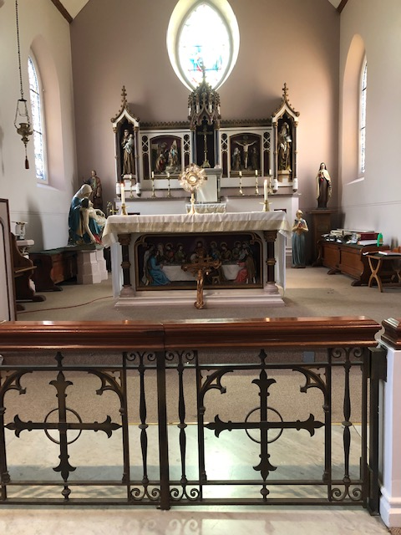
FRIDAY
Eucharistic Adoration
6.15pm – 7.20pm
Followed by
Holy Mass at 7.30pm

Our Parish NOTICES
Collections this week:
CATEGORY | CASH (Loose) | GIFT AID | CONTACTLESS  Amount Gift Aid |  | TOTALS
Offertory | £696.32 | £93.10 | £347.00 | £38.75 | £1,175.17
Football Parking | £377.00 | - | - | - | £377.00


Please use the QR code for your weekly offerings & second collections
WE NEED YOU - EXTRA-ORDINARY MINISTERS OF THE EUCHARIST
The Parish needs more Eucharistic Ministers to assist Fr Dennis with visiting the ‘sick and/or housebound’. If you would like to assist Fr Dennis; join the Eucharistic Ministry; & become a valuable member of the Parish Volunteer Community, please complete a registration form, which are available at the back of the Church, & return the completed form with the evidence requested to Fr Dennis or the Parish Office. Training will commence on Monday 24th August 2026, time to be confirmed but probably 6.30pm or 7.00pm (whichever time is the most popular)
PARISH THANKSGIVING – Thank you for your ‘thanksgiving’ donations which NOW total £4948.78 for the renovation of Frs. dining room. Donations are still being accepted and can be made by bank transfer to RCAS Gillingham; 60-08-37; 55153119 or via the contactless machine, using the ‘THANKSGIVING’ option. There are also ‘Thanksgiving’ envelopes available at the back of the Church. Thank you all for your generosity. The decorating & electrical work is now complete. We await the quote for new carpet.
CHURCH CLEANLINESS – our volunteer cleaners work very hard to keep the Church presentable for everyone. We are encouraging Parishioners and/or their children to refrain from eating during Mass, Thank You.
Monthly Offertory Report - July
MONTH | CASH LOOSE | GIFT-AID | CONTACTLESS | GIFT-AID | STANDING ORDER | GIFT-AID | GRAND TOTAL
TOTAL | £1,642.49 | £559.88 | £1,357.00 | £185.00 | £1023.00 | £196.25 | £4,963.62
DATES FOR YOUR DIARY
24th August | Extra-Ordinary Minister of the Eucharist in McMahon Hall.6.30pm for 7pm.
29th August | Reader’s Training & Formation in the McMahon Hall. 2pm-4pm
5th September | Reader’s Training & Formation in the McMahon Hall. 2pm-4pm
12th September | Reader’s Commissioning at 1pm.
AROUND THE CATHOLIC COMMUNITY
COULD YOU BE A GOVERNOR AT A LOCAL CATHOLIC SCHOOL OR A DIRECTOR AT A CATHOLIC ACADEMY TRUST? Please use the link:
www.rcaoseducation.org.uk/could-you-become-a-governor-or-directoror.uk/couldcomer/
FUNDRAISING FOR DIOCESAN LOURDES PILGRIMAGE - From Bishop Paul. One of the trustees of our Lourdes pilgrimage has been doing a sponsored walk to raise money to help disabled pilgrims to go to Lourdes. He will be in parts of Kent and SE London this week. If you would be willing to contribute, he has a fundraising page at www.justgiving.com/page/calourdes125sw
IGBO CATHOLIC COMMUNITY MASS – SUNDAY, 30 AUGUST 2026
The Igbo Catholic Community, under the Nigerian Catholic Chaplaincy in England and Wales, warmly invites everyone to join us for a joyful celebration of our Catholic faith, culture and community.Sunday, 30 August 2026 at 1.00 pm
St Thomas of Canterbury Church, Rainham, Kent, ME8 7RH. Families and friends are all warmly welcome.
SUMMER FAITH RESOURCES
I am delighted to share the CELEBRATE summer family faith resources, created to equip and encourage families in sharing faith with their children.
Revised Summer family activity pack - Summer Psalm Walk - designed to help families explore Psalm 139 whilst they walk Contact Claire Fernandes clairefernandes@celebratetrust.org for more information.

DAY FOR CATECHISTS

On behalf of the Archbishop you are invited to attend 12th annual Diocesan Day for Catechists on Saturday, 3rd October 2026 at the Amigo Hall, St Georges Cathedral, SE1 6HU. To book via the or scan the QR code https://aec.rcaos.org.uk/day-for-catechists-2026. The day is for all catechists including those involve in RCIA and Children Liturgy.

PILGRIMAGE TO FATIMA - Monday 28th September – Thursday 1st October. Cost £419 (includes flights, half board accommodation and transfer to Lisbon) contact Fr Stephen via email dartford@rcaos.org.uk or 07504518262 for more details. Closing date is 13 September.

DIVINE MERCY PILGRIMAGE
The Divine Mercy Apostolate, London is holding a Celebration of St Faustina Birthday at Aylesford Priory, Aylesford, Kent on Bank Holiday Monday 31 August 2025 from 10:30 am to 4pm. The reflection day will include teachings on the Message of Divine Mercy, Holy Mass, Hour of Mercy with Adoration and Benediction and Veneration of the Image of Merciful Jesus. All welcome. Call Millie on WhatsApp 07957594646 for more information.

MASS INTENTIONS FOR THE WEEK
Saturday (22nd August)  The Queenship of the Blessed Virgin Mary | 10.00am  10.30am  1.00pm  12noon  6.30pm | Birthday Thanksgiving for Kenechukwu Benedict Okeke  EXPOSITION OF THE BLESSED SACRAMENT and RECONCILIATION  Filipino Mass  Baptism of Raymone Andrew Perez  For All the Holy Souls
Sunday (23rd August) | 9.30am  11.30am  6.30pm | Pro Populo  For All the Holy Souls  Repose of the soul of Frank Hanham
Monday (24th August)  St Bartholomew Apostle | 10.00am | Pro Populo
Tuesday (25th August) | 10.00am | 54th Wedding Anniversary and Birthday
Wednesday  (26th August) | 10.00am | Repose of the soul of Sylvia Azubuine
Thursday (27th August)  St Monica | 10.00am | For All the Holy Souls
Friday (28th August)  St Augustine | 10.00am  6.15pm  7.30pm | For All the Holy Souls  EUCHARISTIC ADORATION  For All the Holy Souls
Saturday (29th August)  The Passion of St John the Baptist  Vigil Mass | 10.00am  10.30am  12.30pm  6.30pm | Repose of the soul of Gerald Odi Osakine  EXPOSITION OF THE BLESSED SACRAMENT and RECONCILIATION  Baptism of Alexander Leon Odjocea  God’s Blessings and Grace upon the Elderly Parishioners
Sunday (30th August)  22nd Sunday of Ordinary Time | 9.30am  11.30am  6.30pm | Intentions for Claire Whiteoak  Pro Populo  For all the Holy Souls

If you would like to book a Mass intention, please see Sue McIntyre or complete a ‘Mass Intention envelope’. Mass Intention donations are £10.00

