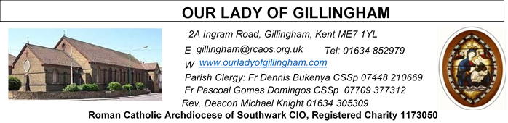Office Hours – Tuesday, Wednesday & Friday - 10.30am – 1.30pm
16th August 2026
THE ASSUMPTION OF THE BLESSED VIRGIN MARY - Year A
Reading 1 | 1 Chr 15:3-4,  15-16; 16:1-2 | They brought in the ark of God and set  it inside the tent which David had  pitched for it.
Psalm | Ps 131:6-7,  9-10, 13-14 r.8 | Go up, Lord, to the place of rest, you  and the ark of your strength.
Reading 2 | 1 Cor 15:54-57 | He gave us victory through our Lord  Jesus Christ.
Gospel Acclamation | Luke 11:28 | Happy are those who hear the word of  God, and keep it.
Gospel | Luke 11:27-28 | Happy the womb that bore you!

Readers next week: 22nd/23rd Aug
Sat 6.30 | Gabriel Concepcion;  Alyssa Mae Viernes;  Kieran Shannon
Sun 9.30 | Chimaka Eke; Chizoba Okeke; Gillian Knight
Sun 11.30 | Dinah Kansiime;  Onyehialam Sisters
Sun 6.30 | Frances Okafor; Victoria Shosanya; Daniela Ibeh

Readers this week:
Sat 6.30 | Oliver Perez;  Benedict Okeke;  Laarni Fajardo
Sun 9.30 | Ann Williams; Nicky Croft; Vincent Obi
Sun 11.30 | Ellie Tetteh;  Chelsea Atoe;  Alyssa Mae Viernes
Sun 6.30 | Uche Family

Please Pray for Malcolm Scarfe†, David Prescott†, Osita Isiwu†, Akinbowale Oluwole Adebiyi†, Mary Shirley†, and Chris Milne†, who have recently died.
Also Pray for all those whose anniversaries occur about this time including: Rose Fisher, John O’Neill, Joseph Ryan, Phyllis Gabriel, Peter Jordan, Edward Kirwan, Joan Kinnear, Blanche French,
Ethel Wimsey, Anne Lodge, Winifred Hogg, Jo Fewkes, Edith Gully,
John Smith, Annie (Veronica) Dolan, Edwin Proctor, Keegan Garlinge, Alan Culverhouse, Ernest Savage, Christine Barton, Pasquale Fantetti, Maria Gilbert, and Juliane Bohnhoft.
May their souls, and all the souls of the faithful departed,
rest in peace.
SATURDAY
Exposition of the Blessed Sacrament & Reconciliation
10.30am – 11.30am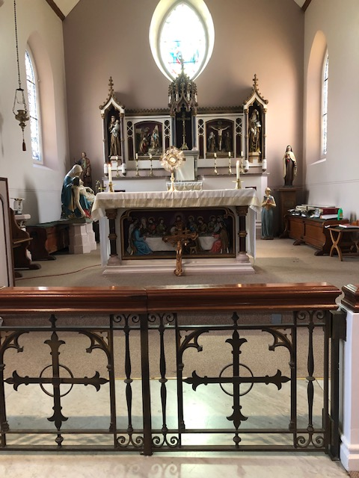
FRIDAY
Eucharistic Adoration
6.15pm – 7.20pm
Followed by
Holy Mass at 7.30pm
Our Parish NOTICES
Please use the QR code for your weekly offerings & second collections
Collections this week:
CATEGORY | CASH (Loose) | GIFT AID | CONTACTLESS  Amount Gift Aid |  | TOTALS
Offertory | £562.16 | £72.00 | £433.00 | £61.25 | £1128.41
Football Parking | £277.00 | - | - | - | £277.00


STELLA MARIS (formerly Apostleship of the Sea) have sent a Thank You letter for the Parish’s donation of £256.19.
PARISH SECRETARY (Sue McIntyre) is on annual leave for the week commencing 17th August until 21st August, therefore, the Parish Office will not be available as usual. A restricted service will be offered by volunteers.
WE NEED YOU - EXTRA-ORDINARY MINISTERS OF THE EUCHARIST
The Parish needs more Eucharistic Ministers to assist Fr Dennis with visiting the ‘sick and/or housebound’. If you would like to assist Fr Dennis; join the Eucharistic Ministry; & become a valuable member of the Parish Volunteer Community, please complete a registration form, which are available at the back of the Church, & return the completed form with the evidence requested to Fr Dennis or the Parish Office. Training will commence on Monday 24th August 2026, time to be confirmed but probably 6.30pm or 7.00pm (whichever time is the most popular)
PARISH THANKSGIVING – Thank you for your ‘thanksgiving’ donations which NOW total £4948.78 for the renovation of Frs. dining room. Donations are still being accepted and can be made by bank transfer to RCAS Gillingham; 60-08-37; 55153119 or via the contactless machine, using the ‘THANKSGIVING’ option. There are also ‘Thanksgiving’ envelopes available at the back of the Church. Thank you all for your generosity. The decorating & electrical work is now complete. We await the quote for new carpet.
CHURCH CLEANLINESS – our volunteer cleaners work very hard to keep the Church presentable for everyone. We are encouraging Parishioners and/or their children to refrain from eating during Mass, Thank You.

Monthly Offertory Report - July
MONTH | CASH LOOSE | GIFT-AID | CONTACTLESS | GIFT-AID | STANDING ORDER | GIFT-AID | GRAND TOTAL
TOTAL | £1,642.49 | £559.88 | £1,357.00 | £185.00 | £1023.00 | £196.25 | £4,963.62

DATES FOR YOUR DIARY
22nd August | Filipino Mass at 1pm, followed by a Gathering in the McMahon Hall.
29th August | Reader’s Training & Formation in the McMahon Hall. 2pm-4pm
5th September | Reader’s Training & Formation in the McMahon Hall. 2pm-4pm
12th September | Reader’s Commissioning at 1pm.
AROUND THE CATHOLIC COMMUNITY
COULD YOU BE A GOVERNOR AT A LOCAL CATHOLIC SCHOOL OR A DIRECTOR AT A CATHOLIC ACADEMY TRUST? Please use the link:
www.rcaoseducation.org.uk/could-you-become-a-governor-or-directoror.uk/couldcomer/
FUNDRAISING FOR DIOCESAN LOURDES PILGRIMAGE - From Bishop Paul. One of the trustees of our Lourdes pilgrimage has been doing a sponsored walk to raise money to help disabled pilgrims to go to Lourdes. He will be in parts of Kent and SE London this week. If you would be willing to contribute, he has a fundraising page at www.justgiving.com/page/calourdes125sw
SUMMER FAITH RESOURCES
I am delighted to share the CELEBRATE summer family faith resources, created to equip and encourage families in sharing faith with their children.
Revised Summer family activity pack -
Summer Psalm Walk - designed to help families explore Psalm 139 whilst they walk
Contact Claire Fernandes clairefernandes@celebratetrust.org for more information.
DIVINE MERCY PILGRIMAGE
The Divine Mercy Apostolate, London is holding a Celebration of St Faustina Birthday at Aylesford Priory, Aylesford, Kent on Bank Holiday Monday 31 August 2025 from 10:30 am to 4pm. The reflection day will include teachings on the Message of Divine Mercy, Holy Mass, Hour of Mercy with Adoration and Benediction and Veneration of the Image of Merciful Jesus. All welcome. Call Millie on WhatsApp 07957594646 for more information.
Thought for the Soul on the Solemnity of the Assumption
Along this pilgrim way Mary never leaves us alone. When our journey becomes weighed down by shadows and struggle; when trials grow so overwhelming that they seem to dim even the sure hope of our final victory; she steps forward to intercede. Our struggle toward victory does not require great strength or earthly weapons. Rather, each of us is called to fight according to our own human gifts and the grace God bestows upon us. As young David once stood before Goliath, relying not on heavy armour or weapons, but on five simple stones, so too may we take up the humble beads of the Rosary. These small, simple grains become our stones of faith; through them, with trust like David’s, we too shall overcome every foe and reach the eternal victory that Christ has already won for us.

MASS INTENTIONS FOR THE WEEK
Saturday  (15th August)  Vigil Mass | 10.00am  10.30am  12noon  6.30pm | Conversion of Kathy George  EXPOSITION OF THE BLESSED SACRAMENT and RECONCILIATION  Baptism of Jaden Eryx Pacumio  Pro Populo
Sunday (16th August)  The Assumption of the Blessed Virgin Mary  (Holy Day of Obligation) | 9.30am  11.30am  6.30pm | Conversion of Bev Bright  Repose of the souls of Mary & Peter Nash  Repose of the soul of Elizabeth Hooper
Monday (17th August) | 10.00am | Repose of the soul of Marie-Rose Essissima
Tuesday (18th August) | 10.00am | Birthday Thanksgiving for Betty Edeji
Wednesday  (19th August) | 10.00am | Repose of the soul of Malcolm Scarfe
Thursday (20th August)  St Bernard | 10.00am | Repose of the soul of Harry Aruma
Friday (21st August)  St Pius X | 10.00am  6.15pm  7.30pm | For All the Holy Souls  EUCHARISTIC ADORATION  Birthday Thanksgiving for Keon
Saturday (22nd August)  The Queenship of the Blessed Virgin Mary  Vigil Mass | 10.00am  10.30am  12noon  1pm  6.30pm | Birthday Thanksgiving for Kenechukwu Benedict Okeke  EXPOSITION OF THE BLESSED SACRAMENT and RECONCILIATION  Baptism of Raymone Andrew Perez  Filipino Mass  For All the Holy Souls
Sunday (23rd August) | 9.30am  11.30am  6.30pm | Pro Populo  For All The Holy Souls  Repose of the soul of Frank Hanham

If you would like to book a Mass intention, please see Sue McIntyre or complete a ‘Mass Intention envelope’. Mass Intention donations are £10.00

