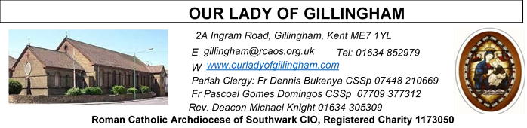 Office Hours – Tuesday, Wednesday & Friday - 10.30am – 1.30pm
9th August 2026
NINETEENTH SUNDAY – Year A
Readers next week: 16th/17th Aug
Sat 6.30 | Oliver Perez; Benedict Okeke; Laarni Fajardo
Sun 9.30 | Ann Williams; Nicky Croft; Vincent Obi
Sun 11.30 | Ellie Tetteh; Chelsea Atoe; Alyssa Mae Viernes
Sun 6.30 | Uche Family

Readers this week:
Sat 6.30 | Francisca Okeke; Imelda Cervantes; Janette Alfayad
Sun 9.30 | Edeji Sisters
Sun 11.30 | John Jupit Quilas; Katalina Souza; Laarni Fajardo
Sun 6.30 | Charbel Tsagli; Shakira Kara;  Joan Aruma

Please Pray for Malcolm Scarfe†, David Prescott†, Osita Isiwu†, Akinbowale Oluwole Adebiyi†, Mary Shirley†, and Chris Milne†, who have recently died.
Also Pray for all those whose anniversaries occur about this time including: Marie Smith, Bridget (Bridie) Hockley, John Smith,
Mary Jones, Ian Bell, Anthony Veale, Ann Brunt, Angela Dididonato, Zdnek Conke, George Perry, Fr. Ryszard Serafin, Ross Venables, Stella Turner, Edmond Hubbert & Mary Keogh.
May their souls, and all the souls of the faithful departed,
rest in peace.
Reading 1 | 1 Kgs 19:9, 11-13 | Stand on the mountain before the Lord.
Psalm | Ps 84: 9-14 r.8 | Let us see, O Lord, your mercy and give  us your saving help.
Reading 2 | Rom 9:1-5 | I would willingly be condemned if it  Could help my brothers.
Gospel Acclamation | Luke 19: 38 | Blessings of the King who comes, in the  name of the Lord! Peace be in heaven  and glory in the highest heaven.
 | Ps 129:5 | My soul is waiting for the Lord.
Gospel | Matt 14:22-33 | Tell me to come to you across the water.

FRIDAY
Eucharistic Adoration
6.15pm – 7.20pm
Followed by
Holy Mass at 7.30pm
SATURDAY
Exposition of the Blessed Sacrament & Reconciliation
10.30am – 11.30am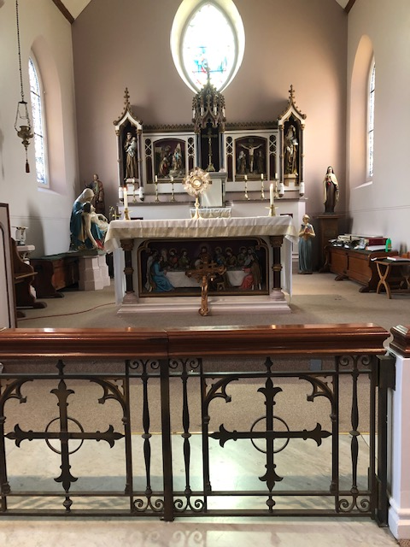
Our Parish NOTICES
Collections this week:
CATEGORY | CASH (Loose) | GIFT AID | CONTACTLESS  Amount Gift Aid |  | TOTALS
Offertory | £465.33 | £97.00 | £457.00 | £42.50 | £1061.83


Please use the QR code for your weekly offerings & second collections
WE NEED YOU - EXTRA-ORDINARY MINISTERS OF THE EUCHARIST
The Parish needs more Eucharistic Ministers to assist Fr Dennis with visiting the ‘sick and/or housebound’. If you would like to assist Fr Dennis; join the Eucharistic Ministry; & become a valuable member of the Parish Volunteer Community, please complete a registration form, which are available at the back of the Church, & return the completed form with the evidence requested to Fr Dennis or the Parish Office. Training will commence on Monday 17th August 2026, time to be confirmed but probably 6.30pm or 7.00pm (whichever time is the most popular)
FR DENNIS – will be travelling to Lourdes with the HCPT Hosanna House Pilgrimage on 26th September. Anyone wishing to travel with him, should come & speak with Fr Dennis or the Parish Office, for further details.
PARISH THANKSGIVING – Thank you for your ‘thanksgiving’ donations which NOW total £4582.03, plus £326.75 gift aid, totaling £4908.78 for the renovation of Frs. dining room. Donations are still being accepted and can be made by bank transfer to RCAS Gillingham; 60-08-37; 55153119 or via the contactless machine, using the ‘THANKSGIVING’ option. There are also ‘Thanksgiving’ envelopes available at the back of the Church. Thank you all for your generosity.
Work on the Priest’s dining room has begun.
CHURCH CLEANLINESS – our volunteer cleaners work very hard to keep the Church presentable for everyone. We are encouraging Parishioners and/or their children to refrain from eating during Mass, Thank You.
FR STAN CHUKWUBE has moved to St Michael the Archangel, Chatham but will be returning on Sunday’s to assist Fr Dennis.

Monthly Offertory Report - July
MONTH | CASH LOOSE | GIFT-AID | CONTACTLESS | GIFT-AID | STANDING ORDER | GIFT-AID | GRAND TOTAL
TOTAL | £1,642.49 | £559.88 | £1,357.00 | £185.00 | £630.00 |  | £4,374.37

DATES FOR YOUR DIARY
8th August | Reader’s Training & Formation in the McMahon Hall. 2pm – 4pm
22nd August | Filipino Mass at 1pm, followed by a Gathering in the McMahon Hall.
29th August | Reader’s Training & Formation in the McMahon Hall. 2pm – 4pm
29th August | OLoG Seeds Youth Sports Day, followed with a BBQ in the Parish garden.
AROUND THE CATHOLIC COMMUNITY
FUNDRAISING FOR DIOCESAN LOURDES PILGRIMAGE - From Bishop Paul. One of the trustees of our Lourdes pilgrimage has been doing a sponsored walk to raise money to help disabled pilgrims to go to Lourdes. He will be in parts of Kent and SE London this week. If you would be willing to contribute, he has a fundraising page at www.justgiving.com/page/calourdes125sw
MARRIAGE & FAMILY LIFE KENT - CELEBRATE festival - a faith-filled event for all the family. Runs from 15-19 August, at Worth School, West Sussex.
Hear inspiring speakers such as Fr Roberto Pasolini (Preacher to the Pope), David Wells and Johannes Hartl, experience beautiful masses, pray in Worth Abbey, fun and formation for children and young people aged 3-24 each day of the festival, and relax in the beautiful Sussex countryside. Camp in our festival field or stay in school accommodation. Weekend tickets also available.
For more information visit www.celebratefestival.org
SUMMER FAITH RESOURCES
I am delighted to share the CELEBRATE summer family faith resources, created to equip and encourage families in sharing faith with their children. Please could I ask you to share this with parishes and families in your diocese?
Revised Summer family activity pack - families can choose from faith filled activities, support for family prayer, books for different ages and film suggestions.
Summer Psalm Walk - designed to help families explore Psalm 139 whilst they walk in their local park or on holiday.
Contact Claire Fernandes clairefernandes@celebratetrust.org for more information.
DIVINE MERCY PILGRIMAGE
The Divine Mercy Apostolate, London is holding a Celebration of St Faustina Birthday at Aylesford Priory, Aylesford, Kent on Bank Holiday Monday 31 August 2025 from 10:30 am to 4pm. The reflection day will include teachings on the Message of Divine Mercy, Holy Mass, Hour of Mercy with Adoration and Benediction and Veneration of the Image of Merciful Jesus. All welcome. Call Millie on WhatsApp 07957594646 for more information.

MASS INTENTIONS FOR THE WEEK

Saturday  (8th August)  Vigil Mass | 10.00am  10.30am  6.30pm | Antonio Simone  EXPOSITION OF THE BLESSED SACRAMENT and RECONCILIATION  Repose of the souls of John & April Larkin
Sunday (9th August) | 9.30am  11.30am  6.30pm | Repose of the soul of Beryl & Clive Brooker  Repose of the soul of Bridie Hockley  Pro Populo
Monday (10th August)  St Lawrence | 10.00am | Repose of the soul of Cenny Cannavina
Tuesday (11th August)  St Clare | 10.00am | Birthday Intentions of Jane Handford
Wednesday  (12th August) | 10.00am | Repose of the soul of James Kuriakose
Thursday (13th August) | 10.00am | Needs of Ashley & Nicki
Friday (14th August)  St Maximilian Mary Kolbe | 10.00am  6.15pm  7.30pm | Repose of the soul of Rosaria Carbonara  EUCHARISTIC ADORATION  Repose of the soul of Tony Phillips
Saturday  (15th August)  Vigil Mass | 10.00am  10.30am  12noon  6.30pm | Conversion of Kathy George  EXPOSITION OF THE BLESSED SACRAMENT and RECONCILIATION  Baptism of Jaden Eryx Pacumio  Pro Populo
Sunday (16th August)  The Assumption of the Blessed Virgin Mary  (Holy Day of Obligation) | 9.30am  11.30am  6.30pm | Conversion of Bev Bright  Repose of the souls of Mary & Peter Nash  Repose of the soul of Elizabeth Hooper

If you would like to book a Mass intention, please see Sue McIntyre or complete a ‘Mass Intention envelope’. Mass Intention donations are £10.00

