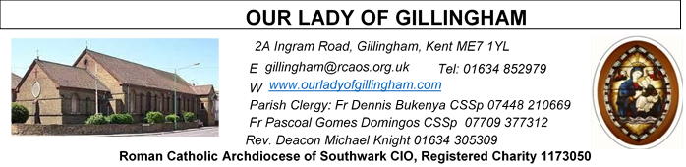 Office Hours – Tuesday, Wednesday & Friday - 10.30am – 1.30pm
2nd August 2026
EIGHTEENTH SUNDAY – Year A
FRIDAY
Eucharistic Adoration
6.15pm – 7.20pm
Followed by
Holy Mass at 7.30pm
SATURDAY
Exposition of the Blessed Sacrament & Reconciliation
10.30am – 11.30am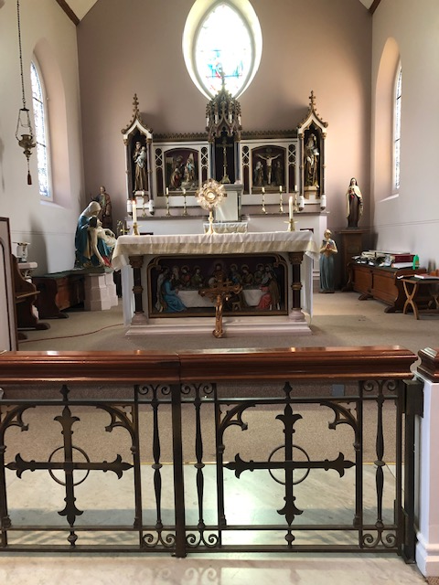
Please Pray for Malcolm Scarfe†, David Prescott†, Osita Isiwu†, Akinbowale Oluwole Adebiyi†, Mary Shirley†, and Chris Milne†, who have recently died. Also Pray for all those whose anniversaries occur about this time including: James Colgan, Paul Appleton, Eileen Sanderson, Theresa Allen, Gladys Wood, Martin Longland, Philip Malone, Milena Cinesi, Lillian D’Souza, James McCartney, Cyril Hamon, Thelma Perris, Bernadette Southern, Angela Dine, Cassandra Eden, Manuela Hernandez, Bridget Fletcher, Mary Biggs and Antonio Simone.
May their souls, and all the souls of the faithful departed,
rest in peace.
Readers this week:
Sat 6.30 | Sandaña Family
Sun 9.30 | Uhuegbu Sisters;  Anastasia Ebifa
Sun 11.30 | Dominic Gali; Olivia Gali; Samuel Robson
Sun 6.30 | Archi Macwan; Daniela Ibeh; Anastasia Ebifa

Reading 1 | Isa 55:1-3 | Come and eat.
Psalm | Ps 144: 8-9. 15-18 r.16 | You open wide your hand, O Lord, and  grant our desires.
Reading 2 | Rom 8:35,  37-39 | No created thing can ever come between  us and the love of God made visible in  Christ.
Gospel Acclamation | Luke 19: 38 | Blessings of the King who comes, in the  name of the Lord! Peace be in heaven  and glory in the highest heaven.
 | Matt 4:4 | Man does not live on bread alone, but on  every word that comes from the mouth  of God.
Gospel | Matt 14:13-21 | They all ate as much as they wanted.

Readers next week: 8th/9th August
Sat 6.30 | Francisca Okeke; Imelda Cervantes; Janette Alfayad
Sun 9.30 | Edeji Sisters
Sun 11.30 | John Jupit Quilas; Katalina Souza; Laarni Fajardo
Sun 6.30 | Charbel Tsagli; Shakira Kara; Joan Aruma

Our Parish NOTICES
Collections this week:
CATEGORY | CASH (Loose) | GIFT AID | CONTACTLESS  Amount Gift Aid |  | TOTALS
Offertory | £278.01 | £131.06 | £328.00 | £45.00 | £782.07
Monthly Standing Order Collections – June 2026 |  |  |  |  | £870.00
Football Parking | £304.00 |  |  |  | £304.00


Please use the QR code for your weekly offerings & second collections
FR DENNIS – will be travelling to Lourdes with the HCPT Hosanna House Pilgrimage on 26th September. Anyone wishing to travel with him, should come & speak with Fr Dennis or the Parish Office, for further details.
PARISH THANKSGIVING – Thank you for your ‘thanksgiving’ donations which NOW total £4232.03, plus £289.25 gift aid, totaling £4521.28 for the renovation of Frs. dining room. Donations are still being accepted and can be made by bank transfer to RCAS Gillingham; 60-08-37; 55153119 or via the contactless machine, using the ‘THANKSGIVING’ option. There are also ‘Thanksgiving’ envelopes available at the back of the Church. Thank you all for your generosity.
Work on the Priest’s dining room will commence on Monday 3rd August.
CHILDREN’S LITURGY – VOLUNTEERS NEEDED. Children’s Liturgy will resume in September 2026 and more volunteers are needed to help with these sessions. If you are interested in joining the team, please email the parish office at gillingham@rcaos.org.uk. Please note that all volunteers will be subject to a satisfactory Disclosure and Barring Service (DBS) check.
CHURCH CLEANLINESS – our volunteer cleaners work very hard to keep the Church presentable for everyone. We are encouraging Parishioners and/or their children to refrain from eating during Mass, especially biscuits/crisps or food that creates a lot of crumbs, so that the Church remains tidy for every Mass. Thank You.
THOUGHTS FOR YOUR SOUL
What Is Expected of A Good Parent During The Holidays
♥Pray with your kids ♥Vocational skills are better ♥Promote their dreams
♥Monitor what they watch & how much time is spent on TV ♥ Be a role model
♥Make sure they do their holiday packing ♥Encourage bible recitation at home
♥Boys & Girls should have separate bedrooms ♥Be a regular provider
♥Regular counselling meetings are vital for your kids ♥Avoid domestic violence
♥Listen to them in case of challenges ♥Train them to do domestic work
♥Have meals together ♥Get a holiday school with bible teaching program
♥Encourage kids to greet ♥Teach them to appreciate ♥Mind the kid’s dress code
♥Train kids to respect All, irrespective of age ♥Tell them ‘money is worked for’
♥Avoid bad talk about Teachers ♥Help your kids avoid unnecessary visitations.
SHOW LOVE & CARE

DATES FOR YOUR DIARY
8th August | Reader’s Training & Formation in the McMahon Hall. 2pm – 4pm
22nd August | Filipino Mass at 1pm, followed by a Gathering in the McMahon Hall.
29th August | Reader’s Training & Formation in the McMahon Hall. 2pm – 4pm
29th August | OLoG Seeds Youth Sports Day, followed with a BBQ in the Parish garden.
AROUND THE CATHOLIC COMMUNITY
Summertime 2026: 11th August – 14th August: Altar Servers Trip to Westminster Pastoral Centre, £199. For aged 11-15. An excellent residential trip for altar servers and those who regularly attend mass on the weekend. It is a few days for deepening one’s catholic faith, in a great social atmosphere, including football, sports and visit to Thorpe Park. For more details of how to get to the venue, with a coach laid on at St. Anselm’s Dartford, see your Parish Priest for a form, or contact Fr. Stephen Boyle, Dartford@rcaos.org.uk, Tel:01322 220075.
FUNDRAISING FOR DIOCESAN LOURDES PILGRIMAGE - From Bishop Paul. One of the trustees of our Lourdes pilgrimage has been doing a sponsored walk to raise money to help disabled pilgrims to go to Lourdes. He will be in parts of Kent and SE London this week. If you would be willing to contribute, he has a fundraising page at www.justgiving.com/page/calourdes125sw
MARRIAGE & FAMILY LIFE KENT - CELEBRATE festival - a faith-filled event for all the family. Runs from 15-19 August, at Worth School, West Sussex.
Hear inspiring speakers such as Fr Roberto Pasolini (Preacher to the Pope), David Wells and Johannes Hartl, experience beautiful masses, pray in Worth Abbey, fun and formation for children and young people aged 3-24 each day of the festival, and relax in the beautiful Sussex countryside. Camp in our festival field or stay in school accommodation. Weekend tickets also available.
For more information visit www.celebratefestival.org
SUMMER FAITH RESOURCES
I am delighted to share the CELEBRATE summer family faith resources, created to equip and encourage families in sharing faith with their children. Please could I ask you to share this with parishes and families in your diocese?
Revised Summer family activity pack - families can choose from faith filled activities, support for family prayer, books for different ages and film suggestions.
Summer Psalm Walk - designed to help families explore Psalm 139 whilst they walk in their local park or on holiday.
Contact Claire Fernandes clairefernandes@celebratetrust.org for more information.
DIVINE MERCY PILGRIMAGE
The Divine Mercy Apostolate, London is holding a Celebration of St Faustina Birthday at Aylesford Priory, Aylesford, Kent on Bank Holiday Monday 31 August 2025 from 10:30 am to 4pm. The reflection day will include teachings on the Message of Divine Mercy, Holy Mass, Hour of Mercy with Adoration and Benediction and Veneration of the Image of Merciful Jesus. All welcome. Call millie on WhatsApp 07957594646 for more information.
MASS INTENTIONS FOR THE WEEK

First Saturday  (1st August)  St Alphonsus Liguori  Vigil Mass | 10.00am  10.30am  3.00pm  6.30pm | Repose of the soul of Jimmy Brown  EXPOSITION OF THE BLESSED SACRAMENT and RECONCILIATION  OLoG Seeds Young Adult Mass  Pro Populo
Sunday (2nd August) | 9.30am  11.30am  6.30pm | 40th Birthday Thanksgiving for Grace Croft  Thanksgiving Intentions for the Newton Family  Repose of the souls of John & Elizabeth Buck
Monday (3rd August) | 10.00am | Repose of the soul of Teresa Carroll Snr
Tuesday (4th August)  St John Vianney | 10.00am | Repose of the souls of Mary & Aubrey Jamieson
Wednesday  (5th August) | 10.00am | Repose of the souls of Peter & Mary Gallagher
Thursday (6th August)  The Transfiguration of the Lord | 10.00am | Repose of the soul of Stephen Regan
First Friday  (7th August) | 10.00am  6.15pm  7.30pm | Health & Wellbeing of Teresa Cottam  EUCHARISTIC ADORATION  Intentions of Elaine Keating
Saturday  (8th August)  St Dominic  Vigil Mass | 10.00am  10.30am  6.30pm | Antonio Simone  EXPOSITION OF THE BLESSED SACRAMENT and RECONCILIATION  Repose of the souls of John & April Larkin
Sunday (9th August) | 9.30am  11.30am  6.30pm | Repose of the soul of Tony Phillips  Repose of the soul of Bridie Hockley  Pro Populo

If you would like to book a Mass intention, please see Sue McIntyre or complete a ‘Mass Intention envelope’. Mass Intention donations are £10.00

