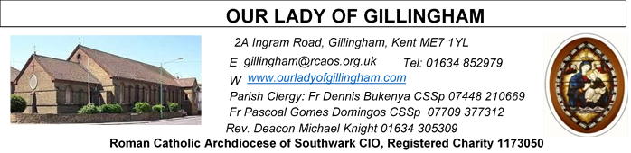 Office Hours – Tuesday, Wednesday & Friday - 10.30am – 1.30pm
26th July 2026
SEVENTEENTH SUNDAY – Year A
Readers next week: 1st/2nd August
Sat 6.30 | Sandaña Family
Sun 9.30 | Uhuegbu Sisters;  Anastasia Ebifa
Sun 11.30 | Dominic Gali; Olivia Gali; Samuel Robson
Sun 6.30 | Archi Macwan; Daniela Ibeh; Anastasia Ebifa

Please Pray for Malcolm Scarfe†, David Prescott†, Osita Isiwu†, Akinbowale Oluwole Adebiyi†, Mary Shirley†, and Chris Milne†, who have recently died. Also Pray for all those whose anniversaries occur about this time including: Giovanni De Fazio, Margaret Finlayson, Nora Percival, Edward Dann, Agnes Starck, Alma Wilkie, William Lawson, James Fertnig, Thomas Brennan, Peter John, Sarah Southey, William Owen, Partrick Murphy, Norah Harris, Maureen Drake, Nuala Hanley, Rita Bailey and Maureen Parry.

May their souls, and all the souls of the faithful departed,
rest in peace.
FRIDAY
Eucharistic Adoration
6.15pm – 7.20pm
Followed by
Holy Mass at 7.30pm
Reading 1 | 1 Kgs 3:5, 7-12 | You have asked for a discerning  judgment for yourself.
Psalm | Ps 118: 57. 72 76-77. 127-130 r.97 | Lord, how I love your law!
Reading 2 | Rom 8:28-30 | God intended us to become true  images of his Son.
Gospel Acclamation | John 15:15 | I call you friends, says the Lord,  because I have made known to you everything I have learnt from my Father.
Gospel | Matt 13:44-52 | He sells everything he owns and buys  the field.

SATURDAY
Exposition of the Blessed Sacrament & Reconciliation
10.30am – 11.30am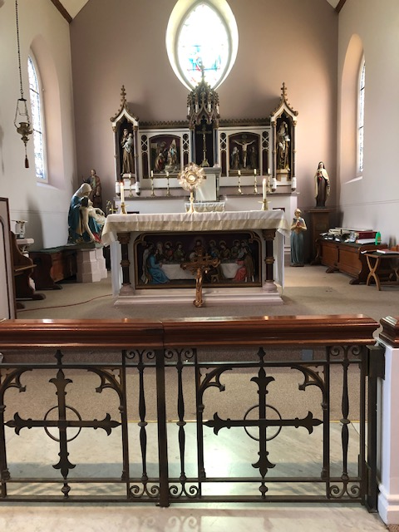
Readers this week:
Sat 6.30 | Oliver Perez; Benedict Okeke; Laarni Fajardo
Sun 9.30 | Uhuegbu Sisters; Vincent Obi
Sun 11.30 | Ellie Tetteh; Chelsea Atoe; Yolanda Danday
Sun 6.30 | Uche Family

Our Parish NOTICES
Collections this week:
CATEGORY | CASH (Loose) | GIFT AID | CONTACTLESS  Amount Gift Aid |  | TOTALS
Offertory | £338.50 | £148.00 | £439.00 | £68.75 | £994.25
Monthly Standing Order Collections – June 2026 |  |  |  |  | £870.00
Football Parking | £155.00 |  |  |  | £155.00


Please use the QR code for your weekly offerings & second collections
SPIRITAN FATHER’s MEETING – Our Priests will be travelling to Manchester on Thursday 30th & Friday 31st July for the Spiritan Annual Assembly.
FR DENNIS – will be travelling to Lourdes with the HCPT Hosanna House Pilgrimage on 26th September. Anyone wishing to travel with him, should come & speak with Fr Dennis or the Parish Office, for further details.
PARISH THANKSGIVING – Thank you for your ‘thanksgiving’ donations which NOW total £4110.53, plus £269.25 gift aid, totaling £4379.78 for the renovation of Frs. dining room. Donations are still being accepted and can be made by bank transfer to RCAS Gillingham; 60-08-37; 55153119 or via the contactless machine, using the ‘THANKSGIVING’ option. There are also ‘Thanksgiving’ envelopes available at the back of the Church. Thank you all for your generosity.
CHILDREN’S LITURGY – VOLUNTEERS NEEDED. Children’s Liturgy will resume in September 2026 and more volunteers are needed to help with these sessions. If you are interested in joining the team, please email the parish office at gillingham@rcaos.org.uk. Please note that all volunteers will be subject to a satisfactory Disclosure and Barring Service (DBS) check.
CHURCH CLEANLINESS – our volunteer cleaners work very hard to keep the Church presentable for everyone. We are encouraging Parishioners and/or their children to refrain from eating during Mass, especially biscuits/crisps or food that creates a lot of crumbs, so that the Church remains tidy for every Mass. Thank You.
DAY-by-DAY – Books for August, September and October are now available in the Repository, at a cost of £1.25 each.
LEGION OF MARY – will have their book barrow/Gazebo set up at the entrance of the Church, after all Masses this weekend. All are invited to take any of the items on the table and have a quick chat with them. Feel free to ask any questions about faith.
IGBO MASS – The Igbo Community are invited to join the IGBO Mass at St Thomas’ Catholic Church, Rainham on 26th July 2026 from 1pm. IGBO Mass will be celebrated at 1pm on the last Sunday of every Month.

DATES FOR YOUR DIARY
26th July | IGBO Mass at St Thomas of Canterbury Church, Rainham. 1pm onwards.
1st August | OLoG Seeds – Young Adult Mass
8th August | Reader’s Training & Formation in the McMahon Hall. 2pm – 4pm
22nd August | Filipino Mass at 1pm, followed by a Gathering in the McMahon Hall.
29th August | Reader’s Training & Formation in the McMahon Hall. 2pm – 4pm
29th August | OLoG Seeds Youth Sports Day & BBQ
AROUND THE CATHOLIC COMMUNITY
Summertime 2026: 11th August – 14th August: Altar Servers Trip to Westminster Pastoral Centre, £199. For aged 11-15. An excellent residential trip for altar servers and those who regularly attend mass on the weekend. It is a few days for deepening one’s catholic faith, in a great social atmosphere, including football, sports and visit to Thorpe Park. For more details of how to get to the venue, with a coach laid on at St. Anselm’s Dartford, see your Parish Priest for a form, or contact Fr. Stephen Boyle, Dartford@rcaos.org.uk, Tel:01322 220075.
ST GEORGE’S CHRONICLE – THE LIVING HERITAGE
St George’s. Chronicle: The Living Heritage is a flagship quarterly journal launched by St George’s Cathedral to highlight the rich history and architectural legacy of the historic Catholic cathedral in London. The publication brings the cathedral's vital role in Catholic emancipation to the forefront. Quarterly subscriptions are available at £3 per copy. Please see the Office for a subscription slip.
A DAY WITH MARY - International Symposium – 29th-31st July
Please find details of the full itinerary on the noticeboard. To register, please contact www.adaywithmary.org/symposium or tel 020 8641 6418
HCPT HOSANNA HOUSE LOURDES PILGRIMAGE – 26th Sept – 2nd Oct 2026
Come and join us. We shall visit places of interest such as Bartres & Gavarnie in the Pyrenees. We are looking forward to a week of prayer, rest and fun. Young helpers would be provided training. For further details, please contact: Amanda/Tharshi on 020 8393 7891 or Emil on 020 2898 9222 or via email to group537@hcpt.org.uk
THE GOOD COUNSEL NETWORK - "The 16th Annual GK Chesterton Pilgrimage will take place on Saturday 1st August, please send any prayer requests to; CatholicGKCSociety@yahoo.co.uk or text them to 07795205114. Details of the many different ways in which you can be involved on the day, as well as printable GKC prayer cards can be found on www.CatholicGKChestertonSociety.co.uk "
Nathanael will be walking 27 miles in one day on the Pilgrimage. He is raising money in aid of The Guild of Our Lady of Good Counsel and every donation will help. Good Counsel assists Mothers in difficult pregnancies and afterwards with financial help, practical support, baby goods and friendship. So please do as a Parish sponsor Nathanael as he raises funds to help save unborn babies from abortion with Good Counsel; https://gofund.me/f48d1981c
MASS INTENTIONS FOR THE WEEK

Saturday (25th July)  Vigil Mass | 10.00am  10.30am  6.30pm | Thanksgiving Intentions  EXPOSITION OF THE BLESSED SACRAMENT and RECONCILIATION  Repose of the souls of Barry & Thelma Hodgman
Sunday (26th July) | 9.30am  11.30am  6.30pm | “For God’s Blessings & Grace upon the Elderly Parishioners”  Pro Populo  Repose of the soul of Davina Colgan
Monday (27th July) | 10.00am | Birthday Intention of Elaine Keating
Tuesday (28th July) | 10.00am | Health & Wellbeing of Gillian Knight
Wednesday (29th July)  Saints Mary, Martha & Lazarus | 10.00am | Thanksgiving Intentions
Thursday (30th July) | 10.00am | Repose of the soul of Elizabeth Hooper
Friday (31st July)  St Ignatius of Loyola | 10.00am  6.15pm  7.30pm | Repose of the soul of Rosaria Carbonara  EUCHARISTIC ADORATION  Repose of the soul of Mary Nash
First Saturday  (1st August)  St Alphonsus Liguori  Vigil Mass | 10.00am  10.30am  3.00pm  6.30pm | Repose of the soul of Jimmy Brown  EXPOSITION OF THE BLESSED SACRAMENT and RECONCILIATION  OLoG Seeds Young Adult Mass  Pro Populo
Sunday (2nd August) | 9.30am  11.30am  6.30pm | 40th Birthday Thanksgiving for Grace Croft  Repose of the souls of Margaret & Harold Cardwell  Repose of the souls of John & Elizabeth Buck

If you would like to book a Mass intention, please see Sue McIntyre or complete a ‘Mass Intention envelope’. Mass Intention donations are £10.00

