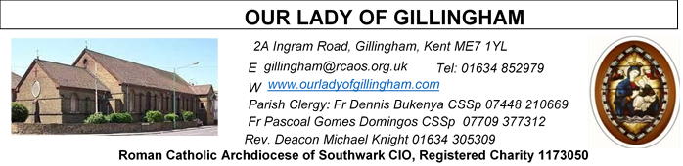 Office Hours – Tuesday, Wednesday & Friday - 10.30am – 1.30pm
19th July 2026
SIXTEENTH SUNDAY – Year A
Please Pray for David Prescott†, Osita Isiwu†, Akinbowale Oluwole Adebiyi†, Mary Shirley†, Chris Milne†, and Sarah Shannon†, who have recently died. Also Pray for all those whose anniversaries occur about this time including: Aldo Gavin, Thomas Kiernan, Valentine Pasquale, Betty Eley, Agnes McDermott, Eileen Martin, Ellen Carter, Mary Aitken, Cenwein Cannavina, Zygmunt Makowski, Francisco Colon, Patrick McCormick, Sheila Hunt, Gladys Long, Michael Robinson, Nella Allcorn, Micholina Szemelak, Abele Fantetti, David Thomas & Richard Burgess.
May their souls, and all the souls of the faithful departed, rest in peace.
Reading 1 | Wis 12:13, 16-19 | After sin you will grant repentance.
Psalm | Ps 85:5-6.9-10. 15-16 r.5 | O Lord, you are good and forgiving.
Reading 2 | Rom 8:26-27 | The Spirit expresses our plea in a way  that could never be put into words.
Gospel Acclamation | cf. Eph 1:17.18 | May the Father of our Lord Jesus  Christ enlighten the eyes of our mind,  so that we can see what hope his call  holds for us.
 | cf. Matt 11:25 | Blessed are you, Father, Lord of heaven  and earth, for revealing the mysteries of  the kingdom to mere children.
Gospel | Matt 13:24-43 | Let them both grow till the harvest.

Readers this week:
Sat 6.30 | Francisca Okeke;  Imelda Cervantes;  Janette Alfaya
Sun 9.30 | Edeji Sisters
Sun 11.30 | Katalina Souza; Archi Macwan; John Jupit Quilas
Sun 6.30 | Charbel Harbiwi, Joan Aruma

Readers next week:
Sat 6.30 | Oliver Perez; Benedict Okeke; Laarni; Fajardo
Sun 9.30 | Uhuegbu Sisters; Vincent Obi
Sun 11.30 | Ellie Tetteh; Chelsea Atoe; Yolanda Danday
Sun 6.30 | Uche Family

SATURDAY
Exposition of the Blessed Sacrament & Reconciliation
10.30am – 11.30am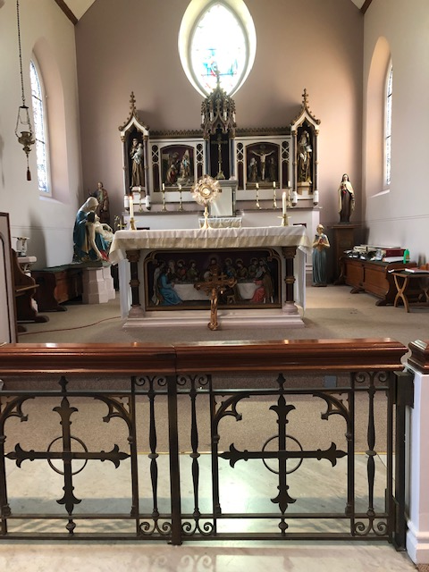
FRIDAY
Eucharistic Adoration
6.15pm – 7.20pm
Followed by
Holy Mass at 7.30pm
Our Parish NOTICES
Please use the QR code for your weekly offerings & second collections
Collections this week:
CATEGORY | CASH (Loose) | GIFT AID | CONTACTLESS  Amount Gift Aid |  | TOTALS
Offertory | £329.74 | £130.50 | £242.00 | £18.75 | £720.99
Second Collection | £179.19 | £5.00 | £65.00 | £16.25 | £265.44
Monthly Standing Order Collections – June 2026 |  |  |  |  | £870.00


FR DENNIS – will be travelling to Lourdes with the HCPT Hosanna House Pilgrimage on 26th September. Anyone wishing to travel with him, should come & speak with Fr Dennis or the Parish Office, for further details.

FR STAN CHUKWUBE – has arrived in the Parish to support Fr Dennis, whilst Fr Pascoal is away. Please, as always, generously welcome Fr Chukwube into our family & join Fr Dennis in thanking him for all his support & contributions to our Parish.

PARISH THANKSGIVING – Thank you for your ‘thanksgiving’ donations which NOW total £4065.53, plus £263.00 gift aid, totaling £4328.53 for the renovation of Frs. dining room. For over 40 years the Presbytery has never been touched. This project includes the painting, decorating, electrical and flooring. Hence it will cost more than the earlier estimates. Thus, donations are still being accepted and can be made by bank transfer to RCAS Gillingham; 60-08-37; 55153119 or via the contactless machine, using the ‘THANKSGIVING’ option. There are also ‘Thanksgiving’ envelopes available at the back of the Church. Thank you all for your generosity.

CHILDREN’S LITURGY – has now finished for the summer break. Children’s Liturgy will resume in September 2026. We are looking for more volunteers to help with these sessions so that they can be held more than once a month. If you are interested in joining the team, please email the parish office at gillingham@rcaos.org.uk. Please note that all volunteers will be subject to a satisfactory Disclosure and Barring Service (DBS) check.

CHURCH CLEANLINESS – our volunteer cleaners work very hard to keep the Church presentable for everyone. We are encouraging Parishioners and/or their children to refrain from eating during Mass, especially biscuits/crisps or food that creates a lot of crumbs, so that the Church remains tidy for every Mass. Thank You.

DAY-by-DAY – Books for August, September and October are now available in the Repository, at a cost of £1.25 each.
DATES FOR YOUR DIARY
25th July | Filipino Mass, followed by a Gathering in the McMahon Hall. All are welcome.
1st August | OLoG Seeds – Young Adult Mass
8th August | Reader’s Training & Formation in the McMahon Hall. 2pm – 4pm
15th August | Reader’s Training & Formation in the McMahon Hall. 2pm – 4pm
AROUND THE CATHOLIC COMMUNITY
Summertime 2026: 11th August – 14th August: Altar Servers Trip to Westminster Pastoral Centre, £199. For aged 11-15. An excellent residential trip for altar servers and those who regularly attend mass on the weekend. It is a few days for deepening one’s catholic faith, in a great social atmosphere, including football, sports and visit to Thorpe Park. For more details of how to get to the venue, with a coach laid on at St. Anselm’s Dartford, see your Parish Priest for a form, or contact Fr. Stephen Boyle, Dartford@rcaos.org.uk, Tel:01322 220075.
ST GEORGE’S CHRONICLE – THE LIVING HERITAGE
St George’s. Chronicle: The Living Heritage is a flagship quarterly journal launched by St George’s Cathedral to highlight the rich history and architectural legacy of the historic Catholic cathedral in London. The publication brings the cathedral's vital role in Catholic emancipation to the forefront. Quarterly subscriptions are available at £3 per copy. Please see the Office for a subscription slip.
SOCIETY FOR THE PROTECTION OF UNBORN CHILDREN
The Rochester & Strood Branch have put together a monthly newsletter. The June edition is on the noticeboard.
A DAY WITH MARY - International Symposium – 29th-31st July
Please find details of the full itinerary on the noticeboard. To register, please contact www.adaywithmary.org/symposium or tel 020 8641 6418
HCPT HOSANNA HOUSE LOURDES PILGRIMAGE – 26th Sept – 2nd Oct 2026
Come and join us. We shall visit places of interest such as Bartres & Gavarnie in the Pyrenees. We are looking forward to a week of prayer, rest and fun. Young helpers would be provided training. For further details, please contact: Amanda/Tharshi on 020 8393 7891 or Emil on 020 2898 9222 or via email to group537@hcpt.org.uk
THOUGHT FOR YOUR SOUL
Leadership Style
As a leader, one has to stand on his/her feet, make up his/her own mind, not go with the crowd. One has to act against abuses, justly and prudently.
- A good leader strives to enhance a genuine sense of community.
- A good leader ought to be enthusiastic, not necessarily demonstrative, and able to inspire enthusiasm in others.
- A good leader says “thank you” regularly and mean it.
When bad men combine, the good must associate, else they will fall one by one. Leaders need courage, “grace under pressure” to take these stands.

MASS INTENTIONS FOR THE WEEK

Saturday (18th July)  Vigil Mass | 10.00am  10.30am  4.00pm  6.30pm | Wellbeing of Pat Harrington  EXPOSITION OF THE BLESSED SACRAMENT and RECONCILIATION  Youth Mass  Repose of the soul of Christopher (Chris) Milne
Sunday (19th July) | 9.30am  11.30am  6.30pm | Good Health & Wellbeing of Gillian Knight  God’s Blessing upon Claire Lapthorn & Thank You for all the help  Pro Populo
Monday (20th July) | 10.00am | Thanksgiving Intentions  Baptism & Reception into Church of Adam Young
Tuesday (21st July) | 10.00am | Intentions of Dinma
Wednesday (22nd July) | 10.00am | Repose of the soul of Milagrina Rose Correia
Thursday (23rd July) | 10.00am | Deceased members of the Kiernan Family
Friday (24th July) | 10.00am  6.15pm  7.30pm | Repose of the soul of Panji Zimba  EUCHARISTIC ADORATION  Repose of the soul of Mary Nash
Saturday (25th July)  Saint Benedict  Vigil Mass | 10.00am  10.30am  12.30 – 2pm  6.30pm | Thanksgiving Intentions  EXPOSITION OF THE BLESSED SACRAMENT and RECONCILIATION  Filipino Mass  Repose of the souls of Barry & Thelma Hodgman
Sunday (26th July) | 9.30am  11.30am  6.30pm | “For God’s Blessings & Grace upon the Elderly Parishioners”  Pro Populo  Repose of the soul of Davina Colgan

If you would like to book a Mass intention, please see Sue McIntyre or complete a ‘Mass Intention envelope’. Mass Intention donations are £10.00

