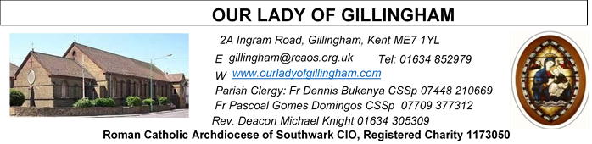 Office Hours – Tuesday, Wednesday & Friday - 10.30am – 1.30pm
12th July 2026
FIFTEENTH SUNDAY – Sea Sunday – Year A
Please Pray for Osita Isiwu†, Akinbowale Oluwole Adebiyi†, Mary Shirley†, Chris Milne†, Sarah Shannon† and Apolonia MacKenzie†, who have recently died. Also Pray for all those whose anniversaries occur about this time including: Ian Boorman, Wilfred O’Neill, John McCarthy, Kathleen Nesbitt, Peter Lyons, Michael Keating, Rosaria Carbonara, Walter Mason, Catherine Pullen, Nellie Stafford, Mary Jeans, Stephen Hoadley, Alfred Wilkie, Alice Redgrave, Eileen Smye, Bernard Bligh, Gregorz Durda, Alfred Young, Lorenza Rutland, Joan Wright and James Sullivan. May their souls, and all the souls of the faithful departed, rest in peace.
Reading 1 | Isa 55:10-11 | The rain makes the earth give growth.
Psalm | Ps 64:10-14 r.Lk 8:8 | Some seed fell into rich soil and  produced its crop.
Reading 2 | Rom 8:18-23 | The whole creation is eagerly waiting  for God to reveal his sons.
Gospel Acclamation | 1 Sam 3:9; John 6:68 | Speak, Lord, your servant is listening:  you have the message of eternal life.
The seed is the word of God, Christ
the sower; whoever finds the seed
will remain for ever.
Gospel | Matt 13:1-23 | A sower went out to sow.

SATURDAY
Exposition of the Blessed Sacrament & Reconciliation
10.30am – 11.30am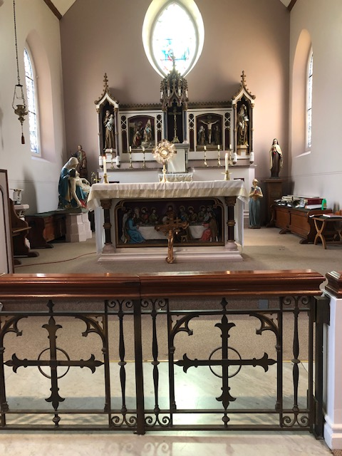
Readers next week:
Sat 6.30 | Francisca Okeke;  Imelda Cervantes;  Janette Alfaya
Sun 9.30 | Edeji Sisters
Sun 11.30 | Katalina Souza; Archi Macwan; John Jupit Quilas
Sun 6.30 | Charbel Harbiwi,  Joan Aruma

Readers this week:
Sat 6.30 | Sandaña Family
Sun 9.30 | Ann Williams; Chimaka Eke;  Nicky Croft
Sun 11.30 | Dominic Gali; Olivia Gali;  Samuel Robson
Sun 6.30 | Archi Macwan;  Anastasia Ebifa;  Akhebai Tegha

FRIDAY
Eucharistic Adoration
6.15pm – 7.20pm
Followed by
Holy Mass at 7.30pm
Our Parish NOTICES
Please use the QR code for your weekly offerings & second collections
Collections this week:
CATEGORY | CASH (Loose) | GIFT AID | CONTACTLESS  Amount Gift Aid |  | TOTALS
Offertory | £485.82 | £153.73 | £424.00 | £63.75 | £1127.30

This Sunday – there will be a second collection for Stella Maris. Stella Maris is a Catholic charity supporting seafarers worldwide, providing practical & pastoral care to all seafarers, regardless of their nationality or belief.

FR PASCOAL – is travelling home to Angola today, to attend the Provincial Chapter, and thereafter he will take his annual leave. Fr Pascoal is hoping to be back at the Parish by the end of August. Please keep him in your prayers for a safe journey.

FR DENNIS – will be travelling to Lourdes with the HCPT Hosanna House Pilgrimage on 26th September. Anyone wishing to travel with him, should come & speak with Fr Dennis or the Parish Office, for further details.

PARISH THANKSGIVING – Thank you for your ‘thanksgiving’ donations which NOW total £3820.53, plus £245.50 gift aid, totaling £4066.03 for the renovation of Frs. dining room. For over 40 years the Presbytery has never been touched. This project includes the painting, decorating, electrical and flooring. Hence it will cost more than the earlier estimates. Thus, donations are still being accepted and can be made by bank transfer to RCAS Gillingham; 60-08-37; 55153119 or via the contactless machine, using the ‘THANKSGIVING’ option. There are also ‘Thanksgiving’ envelopes available at the back of the Church. Thank you all for your generosity.

CHILDREN’S LITURGY – has now finished for the summer break. Children’s Liturgy will resume in September 2026. We are looking for more volunteers to help with these sessions so that they can be held more than once a month. If you are interested in joining the team, please email the parish office at gillingham@rcaos.org.uk. Please note that all volunteers will be subject to a satisfactory Disclosure and Barring Service (DBS) check.

CHURCH CLEANLINESS – our volunteer cleaners work very hard to keep the Church presentable for everyone. We are encouraging Parishioners and/or their children to refrain from eating during Mass, especially biscuits or food that creates a lot of crumbs, so that the Church remains tidy for every Mass. Many thanks.
DATES FOR YOUR DIARY
25th July | Filipino Mass, followed by a Gathering in the McMahon Hall. All are welcome.
1st August | OLoG Seeds – Young Adult Mass
AROUND THE CATHOLIC COMMUNITY
STELLA MARIS (formerly Apostleship of the Sea) – Today is Sea Sunday
Stella Maris is the maritime charity of the Catholic church. Sea Sunday is when the Church prays for all those who live and work at sea. Your support will make a big difference to seafarers and fishers in need. You can donate in church, by visiting www.stellamaris.org.uk/donate, or by texting ‘SEA’ to 70460 to donate £5. This collection is vital to enable Stella Maris to continue its important work. Thank You.

ARCHDIOCESAN DIACONAL DAY - On the weekend of 11/12 July we are celebrating the third Archdiocesan Diaconal Day, during which we pray for the Permanent Deacons serving in our Archdiocese, as well as for the new vocations to this ministry. If you are a man between 21 years to 58 years, prayerful, with the desire to love and serve God and His people, you are involved in services within your parish and community, you have tried many things and still feel drawn to a closer relationship with Christ and His Church you might possibly be called to be a Permanent Deacon? If you require further information about the Permanent Diaconate, please speak to your Parish Priest, (Parish Deacon, if there is one), or contact the Diaconate Formation Director via e-mail: ianblack@rcaos.org.uk.
Summertime 2026: 11th August – 14th August: Altar Servers Trip to Westminster Pastoral Centre, £199. For aged 11-15. An excellent residential trip for altar servers and those who regularly attend mass on the weekend. It is a few days for deepening one’s catholic faith, in a great social atmosphere, including football, sports and visit to Thorpe Park. For more details of how to get to the venue, with a coach laid on at St. Anselm’s Dartford, see your Parish Priest for a form, or contact Fr. Stephen Boyle, Dartford@rcaos.org.uk, Tel:01322 220075.

ST GEORGE’S CHRONICLE – THE LIVING HERITAGE
St George’s. Chronicle: The Living Heritage is a flagship quarterly journal launched by St George’s Cathedral to highlight the rich history and architectural legacy of the historic Catholic cathedral in London. The publication brings the cathedral's vital role in Catholic emancipation to the forefront. Quarterly subscriptions are available at £3 per copy. Please see the Office for a subscription slip.

SOCIETY FOR TH PROTECTION OF UNBORN CHILDREN
The Rochester & Strood Branch have put together a monthly newsletter. The June edition is on the noticeboard.

A DAY WITH MARY - International Symposium – 29th-31st July
Please find details of the full itinerary on the noticeboard. To register, please contact www.adaywithmary.org/symposium or tel 020 8641 6418

HCPT HOSANNA HOUSE LOURDES PILGRIMAGE – 26th Sept – 2nd Oct 2026
Come and join us for a life changing experience. We shall visit places of interest such as Bartres & Gavarnie in the Pyrenees. We are looking forward to a week of prayer, rest and fun. Young helpers would be provided training. For further details, please contact: Amanda/Tharshi on 020 8393 7891 or Emil on 020 2898 9222 or via email to group537@hcpt.org.uk

MASS INTENTIONS FOR THE WEEK

Saturday (11th July)  Vigil Mass | 10.00am  10.30am  12noon  2.00pm  6.30pm | Repose of the soul of Teresa Carroll Snr  EXPOSITION OF THE BLESSED SACRAMENT and RECONCILIATION  Memorial Mass for Rosario Reyes  Marriage Convalidation of Sharon Fernando & Panaivala Peries  Repose of the soul of Josephine Firth
Sunday (12th July) | 9.30am  11.30am  6.30pm | Repose of the soul of Michael Keating  Repose of the soul of John Bhatia  Pro Populo
Monday (13th July) | 10.00am | Repose of the soul of Geraldine Hickey
Tuesday (14th July) | 10.00am | For Gillian Knight’s health & wellbeing
Wednesday (15th July)  St Bonaventure | 10.00am | Repose of the soul of Mary Jeans
Thursday (16th July)  Our Lady of Mount Carmel | 10.00am | Repose of the souls of David & Peter Keating
Friday (17th July) | 10.00am  6.15pm  7.30pm | Wellbeing of Carmel  EUCHARISTIC ADORATION  Repose of the soul of Mary Gallagher
Saturday (18th July)  Saint Benedict  Vigil Mass | 10.00am  10.30am  6.30pm | Wellbeing of Pat Harrington  EXPOSITION OF THE BLESSED SACRAMENT and RECONCILIATION  Repose of the soul of Christopher (Chris) Milne
Sunday (19th July) | 9.30am  11.30am  6.30pm | Pro Populo  God’s Blessing upon Claire Lapthorn & Thank You for all the help  Repose of the soul of Violet Smith

If you would like to book a Mass intention, please see Sue McIntyre or complete a ‘Mass Intention envelope’. Mass Intention donations are £10.00

