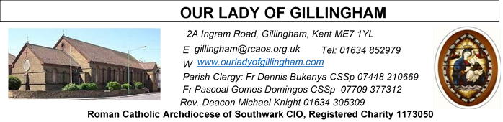 Office Hours – Tuesday, Wednesday & Friday - 10.30am – 1.30pm
5th July 2026
FOURTEENTH SUNDAY – Year A
SATURDAY
Exposition of the Blessed Sacrament & Reconciliation
10.30am – 11.30am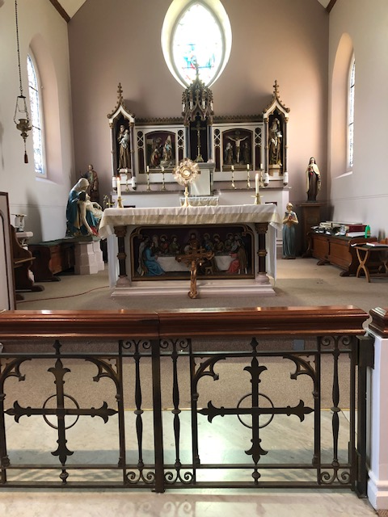
Readers next week:
Sat 6.30 | Sandaña Family
Sun 9.30 | Ann Williams; Chimaka Eke;  Nicky Croft
Sun 11.30 | Dominic Gali; Olivia Gali;  Samuel Robson
Sun 6.30 | Archi Macwan;  Anastasia Ebifa;  Akhebai Tegha

Readers this week:
Sat 6.30 | Gabriel Concepcion;  Alyssa Mae Viernes;  Kieran Shannon
Sun 9.30 | Nnamdi Eke; Chisoba Okeke;  Gillian Knight
Sun 11.30 | Dinah Kansiime;  Onyehialam Sisters
Sun 6.30 | Frances Okafor;  Victoria Shosanya;  Daniela Ibeh

Please Pray for Osita Isiwu†, Akinbowale Oluwole Adebiyi†, Mary Shirley†, Chris Milne†, Sarah Shannon† and Apolonia MacKenzie†, who have recently died;
Also Pray for all those whose anniversaries occur about this time including: Kathleen Figg, Virginia Skerbiene, Eileen Byrne, Elizabeth Goodwin, Cyril Fewkes, Harold Gent, Vera Newton,
Inez Truwein, Ivy Longridge, Tyrone Ward, Catherine Jordan,
Letterio Lauri, Heather Iandolo, Paddy Kehoe, Audrey Green,
Jim Wilson, Marian Kalibabka and David Golding.

May their souls, and all the souls of the faithful departed,
rest in peace
Reading 1 | Zech 9:9-10 | See now, your king comes  humbly to you.
Psalm | Ps 144: 1-2. 8-11. 13-14 r. 1 | I will bless your name for ever, O  God my King or Alleluia!
Reading 2 | Rom 8:9, 11-13 | If by the Spirit you put an end to  the misdeeds of the body, you  will live.
Gospel Acclamation | cf. Matt 11:25 | Blessed are you, Father, Lord of  heaven and earth, for revealing  the mysteries of the kingdom to  mere children.
Gospel | Matt 11:25-30 | I am gentle and humble of heart.

FRIDAY
Eucharistic Adoration
6.15pm – 7.20pm
Followed by
Holy Mass at 7.30pm
Our Parish NOTICES
Collections this week:
CATEGORY | CASH (Loose) | GIFT AID | CONTACTLESS  Amount Gift Aid |  | TOTALS
Offertory | £488.43 | £127.65 | £252.00 | £33.75 | £901.83
Second Collection | £129.17 | £5.00 | £77.00 | £15.50 | £226.67

Next Sunday – there will be a second collection for Stella Maris. Stella Maris is a Catholic charity supporting seafarers worldwide, providing practical & pastoral care to all seafarers, regardless of their nationality or belief.

Please use the QR code for your weekly offerings & second collections
FR PASCOAL – will be travelling home to Angola on 12th July to attend the Provincial Chapter, and thereafter he will take his annual leave. Fr Pascoal is hoping to be back at the Parish by the end of August.

FR DENNIS – will be travelling to Lourdes with the HCPT Hosanna House Pilgrimage on 26th September. Anyone wishing to travel with him, should come & speak with Fr Dennis or the Parish Office, for further details.

LOST PROPERTY – Sunday 21st June @ 9.30am Mass, a Parishioner lost her gold chain bracelet. If anyone remembers seeing an item of jewellery, in the pews or on the floor, please can you let the Office know. Many thanks.

PARISH THANKSGIVING – Thank you for your ‘thanksgiving’ donations which NOW total £2805.53, plus £238.00 gift aid, totaling £3043.53 for the renovation of Frs. dining room. For over 40 years the Presbytery has never been touched. This project includes the painting, decorating, electrical and flooring. Hence it will cost more than the earlier estimates. Thus, donations are still being accepted and can be made by bank transfer to RCAS Gillingham; 60-08-37; 55153119 or via the contactless machine, using the ‘THANKSGIVING’ option. There are also ‘Thanksgiving’ envelopes available at the back of the Church. Thank you all for your generosity.

CHILDREN’S LITURGY - Sunday, 5 July 2026 will be the final Children's Liturgy session before the summer break. Children's Liturgy will resume in September 2026.
We are looking for more volunteers to help with these sessions so that they can be held more than once a month. If you are interested in joining the team, please email the parish office at gillingham@rcaos.org.uk. Please note that all volunteers will be subject to a satisfactory Disclosure and Barring Service (DBS) check.

DATES FOR YOUR DIARY
12th July | Fr Pascoal travelling home to Angola
25th July | Filipino Mass, followed by a Gathering in the McMahon Hall. All are welcome.
1st August | OLoG Seeds – Young Adult Mass
AROUND THE CATHOLIC COMMUNITY
CAFOD-DEC VENEZUELA EARTHQUAKE APPEAL
Our thoughts and prayers are with all the people of Venezuela after two devastating earthquakes near Caracas.Many of our neighbours have been killed or injured, and buildings, including churches, seminaries and Caracas Cathedral, have been damaged. Despite this, our trusted Church partners in Venezuela are already helping the survivors of this crisis with emergency water, food and shelter. Your parish's support will reach families affected by the earthquakes.To find out more about how you can make a donation, please visit https://cafod.org.uk/give/donate-to-emergencies/venezuela-earthquake-appeal

CATHOLIC YOUTH SERVICE – Youth Day – 11th July
St John Fisher School, City Way, Chatham, ME1 2FA from 11am until 5.30pm. £5 per child, including lunch. This is an excellent day of good input on the faith, with sports and creative activities. A chance to make new friends. Ending with Mass for Sunday in the late afternoon. For more information, email youth@rcaos.org.uk
HCPT HOSANNA HOUSE LOURDES PILGRIMAGE – 26th Sept – 2nd Oct 2026
Come and join us for a life changing experience. We shall visit places of interest such as Bartres & Gavarnie in the Pyrenees. We are looking forward to a week of prayer, rest and fun. Young helpers would be provided training. Come and join us to experience a new adventure. For further details, please contact: Amanda/Tharshi on 020 8393 7891 or Emil on 020 2898 9222 or via email to group537@hcpt.org.uk
STOP ASSISTED SUICIDE BEING BROUGHT BACK
Assisted suicide campaigners are trying to bring back the Leadbeater Bill.
‘Not Dead Yet UK’ has launched a simple tool to help you email your MP about the risks this Bill poses to people with disabilities. Please take 30 seconds to email your MP today using the tool here: http://action.notdeadyetuk.org/

THOUGHT FOR THE SOUL
In life, you will fall out with people that you never thought you would. Get betrayed by people you trusted with all your heart. And get used to people you would do anything for. But life also has a beautiful side to it. You will get loved by someone you never thought you would have. Form new friendship with people that will establish more meaningful and stronger relationships. And overcome thing you never thought you would get over. We all have chapters that end with people at some point in life. But take pride in knowing that the very best part of the book about your life is still being written. Heartfelt prayers for you from Fr Dennis.

MASS INTENTIONS FOR THE WEEK

Saturday (4th July)  Vigil Mass | 10.00am  10.30am  3.00pm  6.30pm | Repose of the soul of Eileen Byrne  EXPOSITION OF THE BLESSED SACRAMENT and RECONCILIATION  OLoG Seeds – Young Adult Mass  Repose of the soul of Doreen Colesworthy
Sunday (5th July) | 9.30am  11.30am  6.30pm | Pro Populo  Repose of the soul of Bernard Bligh  Repose of the soul of Peter Nash
Monday (6th July) | 10.00am | Maufe Family Intentions
Tuesday (7th July) | 10.00am | 91st Birthday Thanksgiving for Irene Mergulhao
Wednesday (8th July) | 10.00am | Repose of the soul of Rev Fr John Lacey
Thursday (9th July) | 10.00am | Repose of the soul of Heather Iandolo
Friday (10th July) | 10.00am  6.15pm  7.30pm | Repose of the soul of Vera Batchelor  EUCHARISTIC ADORATION  Repose of the soul of Anthony Crack
Saturday (11th July)  Saint Benedict  Vigil Mass | 10.00am  10.30am  12noon  2.00pm  6.30pm | Repose of the soul of Teresa Carroll Snr  EXPOSITION OF THE BLESSED SACRAMENT and RECONCILIATION  Memorial Mass for Rosario Reyes  Marriage Convalidation of Sharon Fernando & Panaivala Peries  Repose of the soul of Josephine Firth
Sunday (12th July) | 9.30am  11.30am  6.30pm | Repose of the soul of Michael Keating  Repose of the soul of John Bhatia  Pro Populo

If you would like to book a Mass intention, please see Sue McIntyre or complete a ‘Mass Intention envelope’. Mass Intention donations are £10.00

