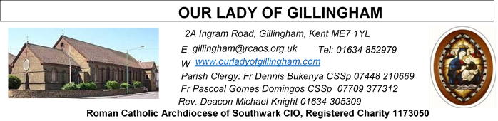 Office Hours – Tuesday, Wednesday & Friday - 10.30am – 1.30pm
28th June 2026
SAINTS PETER & PAUL – Year A
Readers this week:
Sat 6.30 | Francisca Okeke  John Jupit Quilas  Yolanda Danday
Sun 9.30 | Edeji Sisters
Sun 11.30 | Katalina Souza  Imelda Cervantes  Laarni Fajardo
Sun 6.30 | Charbel  Akhebai Teggha

Readers next week:
Sat 6.30 | Gabriel Concepcion  Alyssa Mae Viernes  Kieran Shannon
Sun 9.30 | Nnamdi Eke  Chisoba Okeke  Gillian Knight
Sun 11.30 | Dinah Kansiime  Onyehialam Sisters
Sun 6.30 | Frances Okafor  Victoria Shosanya  Daniela Ibeh

Please Pray for Osita Isiwu†, Akinbowale Oluwole Adebiyi†, Mary Shirley†, Chris Milne†, Sarah Shannon† and Apolonia MacKenzie†, who have recently died;
Also Pray for all those whose anniversaries occur about this time including: Nellie Kitney, Kevin Keogh, Mavis Rogers,
Timothy O’Driscoll, Percival Snowdon, Peggy French, Michael Kavanagh, Joyce Birkbeck, Peter Sullivan, Thomas Killyleagh, Frederick Rogers, Evelyn Ryan, John Herbert and Marie Lee.
May their souls, and all the souls of the faithful departed,
rest in peace
SATURDAY
Exposition of the Blessed Sacrament & Reconciliation
10.30am – 11.30am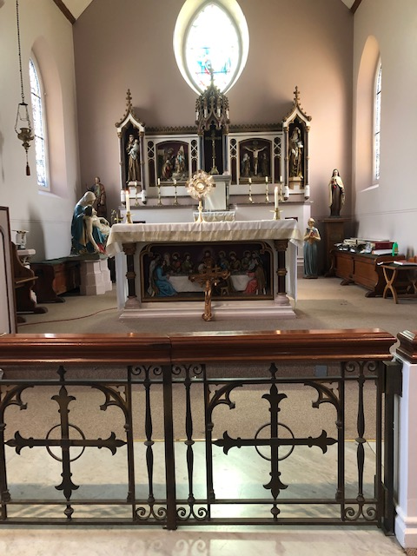
FRIDAY
Eucharistic Adoration
6.15pm – 7.20pm
Followed by
Holy Mass at 7.30pm
Reading 1 | Acts 3:1-10 | I will give you what I have: in the  name of Jesus stand up and walk!
Psalm | Ps 18:2-5 r. 5 | Their word goes forth through all  the earth.
Reading 2 | Gal 1:11-20 | God specially chose me while I  was still in my mother's womb.
Gospel Acclamation | John 21:17 | Lord, you know everything; you  know I love you.
Gospel | John 21:15-19 | Feed my lambs, feed my sheep.

Our Parish NOTICES
Collections this week:
CATEGORY | CASH (Loose) | GIFT AID | CONTACTLESS  Amount Gift Aid |  | TOTALS
Offertory | £376.98 | £103.50 | £324.00 | £47.50 | £851.98
Second Collection | £167.56 | £0 | £32.00 | £0 | £199.56

THIS Sunday – there will be a second collection for Peter’s Pence. These offerings are for the Churches in need.

Please use the QR code for your weekly offerings & second collections

FR PASCOAL – will be travelling home to Angola on 12th July to attend the Provincial Chapter, and thereafter he will take his annual leave. Fr Pascoal is hoping to be back at the Parish by the end of August.

FR DENNIS – will be travelling to Lourdes with the HCPT Hosanna House Pilgrimage on 26th September. Anyone wishing to travel with him, should come & speak with Fr Dennis or the Parish Office, for further details.

LOST PROPERTY – (last) Sunday 21st August @ 9.30am Mass, a Parishioner lost her gold chain bracelet. If anyone remembers seeing an item of jewellery, in the pews or on the floor, please can you let the Office know. Many thanks.

PARISH THANKSGIVING – Thank you for your ‘thanksgiving’ donations which currently total £2248.53, plus £170.00 gift aid, totaling £2418.53. The estimate for the work is £2500, which includes the painting and decoration of the Fathers’ dining room in the Presbytery, which for over 40 years has never been touched. Donations are still being accepted and can be made by bank transfer to RCAS Gillingham; 60-08-37; 55153119 or via the contactless machine, using the ‘THANKSGIVING’ option. There are also ‘Thanksgiving’ envelopes available at the back of the Church.

DATES FOR YOUR DIARY
4th July | OLoG Seeds – Young Adult Mass at 3pm
25th July | Filipino Mass, followed by a Gathering in the McMahon Hall. All are welcome.

AROUND THE CATHOLIC COMMUNITY

STELLA MARIS (FORMERLY CALLED APOSTLESHIP OF THE SEA) is seeking volunteers from this parish, please, to help with Sea Sunday (which falls on 11/12 July this year). This is the day when the Church comes together to pray for seafarers, fishers and their families, and takes a second collection to support the work of Stella Maris. Each volunteer will read out the appeal (which Stella Maris will provide) at the end of Masses that weekend. If you can kindly do this, please contact roland.hayes@stellamarismail.org
Related to that, all parishioners are warmly invited to an online webinar being run by Stella Maris on Wednesday 17th June from 7:30pm to 9pm. You will hear about the work that Stella Maris has been doing with seafarers and fishers over the past year or so, including the use of the funds kindly donated on Sea Sunday last year. To attend this webinar, please sign up at: www.stellamaris.org.uk/thankyou
SOUTHWARK CATHOLIC YOUTH SERVICE – Youth Day – 11th July
St John Fisher School, City Way, Chatham, ME1 2FA from 11am until 5.30pm. £5 per child, including lunch. This is an excellent day of good input on the faith, with sports and creative activities. A chance to make new friends. Ending with Mass for Sunday in the late afternoon. For more information, email youth@rcaos.org.uk

HCPT HOSANNA HOUSE LOURDES PILGRIMAGE – 26th Sept – 2nd Oct 2026
Come and join us for a life changing experience. We shall visit places of interest such as Bartres & Gavarnie in the Pyrenees. We are looking forward to a week of prayer, rest and fun. Young helpers would be provided training. Come and join us to experience a new adventure. For further details, please contact: Amanda/Tharshi on 020 8393 7891 or Emil on 020 2898 9222 or via email to group537@hcpt.org.uk

STOP ASSISTED SUICIDE BEING BROUGHT BACK
Assisted suicide campaigners are trying to bring back the Leadbeater Bill.
‘Not Dead Yet UK’ has launched a simple tool to help you email your MP about the risks this Bill poses to people with disabilities.
Please take 30 seconds to email your MP today using the tool here: http://action.notdeadyetuk.org/

MASS INTENTIONS FOR THE WEEK

Saturday (27th June)  Vigil Mass | 10.00am  10.30am  12.30-2pm  6.30pm | Repose of the soul of Elizabeth Hooper  EXPOSITION OF THE BLESSED SACRAMENT and RECONCILIATION  Filipino Mass  Repose of the soul of Morris Gaghan
Sunday (28th June) | 9.30am  11.30am  6.30pm | “For God’s Blessings & Grace upon the Elderly Parishioners  Pro Populo  Repose of the soul of Akinbowale Adebiyi
Monday (29th June) | 10.00am | Repose of the soul of Rebecca Maufe
Tuesday (30th June) | 10.00am | Repose of the soul of Ken Palen
Wednesday (1st July) | 10.00am | Repose of the soul of Peter Nelson
Thursday (2nd July) | 10.00am | Repose of the soul of Jimmy Brown
Friday (3rd July)  Saint Thomas | 10.00am  12noon  6.15pm  7.30pm | Repose of the soul of Mary & Aubrey Jamieson  Requiem Mass for Oluwole Adebiyi  EUCHARISTIC ADORATION  Repose of the soul of Tony Phillips
Saturday (4th July)  Vigil Mass | 10.00am  10.30am  3.00pm  6.30pm | Repose of the soul of Eileen Byrne  EXPOSITION OF THE BLESSED SACRAMENT and RECONCILIATION  OLoG Seeds – Young Adult Mass  Repose of the soul of Doreen Colesworthy
Sunday (5th July) | 9.30am  11.30am  6.30pm | Pro Populo  Repose of the soul of Bernard Bligh  Repose of the soul of Peter Nash

If you would like to book a Mass intention, please see Sue McIntyre or complete a ‘Mass Intention envelope’. Mass Intention donations are £10.00

