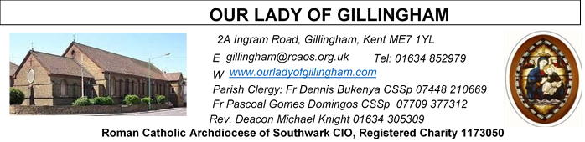 Office Hours – Tuesday, Wednesday & Friday - 10.30am – 1.30pm
21st June 2026
TWELFTH SUNDAY – Year A
SATURDAY
Exposition of the Blessed Sacrament & Reconciliation
10.30am – 11.30am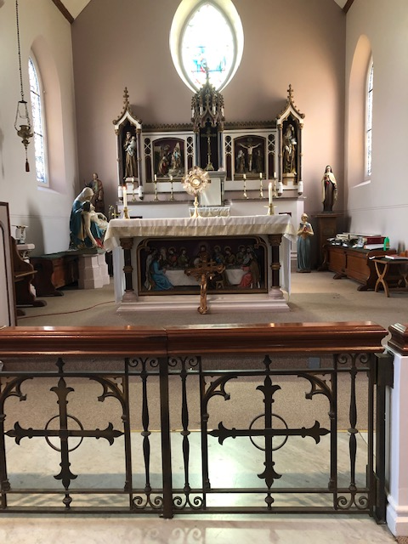
Please Pray for Osita Isiwu†, Akinbowale Oluwole Adebiyi†, Mary Shirley†, Chris Milne†, Sarah Shannon† and Apolonia MacKenzie†, who have recently died; Also Pray for all those whose anniversaries occur about this time including: Elsie Adamo, Ellen Rowley, Catherine Mosely, Mary Jones, Vincent John, Violet O’Hare, Elizabeth Szemelak, Bernard Mason, Patrick Ward, John McGregor, James Brown, Patricia O’Hare, Elizabeth Field, Penelope D’Armenia, Bernard Hall, Mary Brooker, Cyril Field, Daniel O’Donnell and Monica Beer.
May their souls, and all the souls of the faithful departed,
rest in peace
Readers next week:
Sat 6.30 | Francisca Okeke; John Jupit Quilas; Yolanda Danday
Sun 9.30 | Edeji Sisters
Sun 11.30 | Katalina Souza; Imedla Cervantes; Laarni Fajardo
Sun 6.30 | Charbel; Akhebai Tegha

Readers this week:
Sat 6.30 | Sandaña Family
Sun 9.30 | Ann Williams; Nnamdi Eke; Nicky Croft
Sun 11.30 | Dominic Gali; Olivia Gali; Samuel Robson
Sun 6.30 | Archi Macwan; Anastasia Ebifa; Joan Aruma

Reading 1 | Jer 20:10-13 | He has delivered the soul of the  needy from the hands of evil men.
Psalm | Ps 68:8-10. 14.17. 33-35 r.14 | In your great love, answer me, O  God.
Reading 2 | Rom 5:12-15 | The gift considerably outweighed  the fall.
Gospel Acclamation | John 1:14.12 | The Word was made flesh and  lived among us; to all who did  accept him he gave power to  become children of God.
 | John 15:26. 27 | The Spirit of truth will be my  witness; and you too will be my  witnesses.
Gospel | Matt 10:26-33 | Do not be afraid of those who will  kill the body.

FRIDAY
Eucharistic Adoration
6.15pm – 7.20pm
Followed by
Holy Mass at 7.30pm
Our Parish NOTICES
Collections this week:
CATEGORY | CASH (Loose) | GIFT AID | CONTACTLESS  Amount Gift Aid |  | TOTALS
Offertory | £379.19 | £57.00 | £289.00 | £45.50 | £770.69

THIS SUNDAY – there will be a second collection for Day for Life. This is the day in the Church’s life dedicated to celebrating the sacrednes of life.
Next Sunday – there will be a second collection for Peter’s Pence. These offerings are for the Churches in need.

Please use the QR code for your weekly offerings & second collections
PARISH THANKSGIVING – Thank you for your ‘thanksgiving’ donations which currently total £1542.35, plus £133.75 gift aid, totaling £1676.10. The estimate for the work is £2500, which includes the painting and decoration of the Fathers’ dining room in the Presbytery, which for over 40 years has never been touched. Donations are still being accepted and can be made by bank transfer to RCAS Gillingham; 60-08-37; 55153119 or via the contactless machine, using the ‘THANKSGIVING’ option. There are also ‘Thanksgiving’ envelopes available at the back of the Church
OBITUARY- The Requiem Mass for Osita Isiwu, will take place on Thursday 25th June at 11.00am He was a staff member at Medway hospital and has left a wife and 2 young children. Please we appeal to people of goodwill to reach out to this family who are need our support at this moment of bereavement. Alternatively, any support to this family can be brought to the Parish Office or give it the Parish Priest.
BISHOP PAUL – is coming to give a talk to all the young people in our Parish, next Saturday, 27th June at 5pm in the McMahon Hall. Organised by OLoG Seeds Youth Ministry. We seek the cooperation of the parents / guardians to encourage all our young people to participate. Adults are also invited.
STELLA MARIS (FORMERLY CALLED APOSTLESHIP OF THE SEA) is seeking volunteers from this parish, please, to help with Sea Sunday (which falls on 11/12 July this year). This is the day when the Church comes together to pray for seafarers, fishers and their families, and takes a second collection to support the work of Stella Maris. Each volunteer will read out the appeal (which Stella Maris will provide) at the end of Masses that weekend. If you can kindly do this, please contact roland.hayes@stellamarismail.org
Related to that, all parishioners are warmly invited to an online webinar being run by Stella Maris on Wednesday 17th June from 7:30pm to 9pm. You will hear about the work that Stella Maris has been doing with seafarers and fishers over the past year or so, including the use of the funds kindly donated on Sea Sunday last year. To attend this webinar, please sign up at: www.stellamaris.org.uk/thankyou
DATES FOR YOUR DIARY
27th June | Filipino Mass at 12.30pm followed by a gathering in the McMahon Hall, from 2pm until 4pm.
27th June | Bishop Paul talk with OLoG Seeds in the McMahon Hall @ 5pm
AROUND THE CATHOLIC COMMUNITY
DAY FOR LIFE - This Sunday, Catholic churches across England, Wales, Scotland, and Ireland will celebrate the Day for Life 2026. This year’s theme is “The Wonder of the Child in the Womb.” In their message for the occasion, the bishops reflect on the humanity of every unborn child and offer a special word of remembrance to parents who have lost a child before or shortly after birth. A papal blessing has also been given for the Day for Life.
The second collection this Sunday will support the Day for Life Fund, which assists organisations dedicated to protecting life from conception until natural death in a variety of ways.
Further information about the Day for Life, including helpful resources and details on how to donate to the Day for Life Fund, can be found at www.dayforlife.org.
We encourage you to consult the website and share this information with your parishes and communities.
GOOD COUNSEL NETWORK - ‘On Tuesday 23rd June, please pray and fast for the end of abortion and euthanasia in this country. Your prayer and fasting is urgently needed. For information on the days of Prayer and Fasting contact The Good Counsel Network on 020 7723 1740, or via www.goodcounselnetwork.com.
“And the people of Ninevah believed in God; they proclaimed a fast and put on sackcloth, from the greatest to the least…God saw their efforts to renounce their evil ways. And God relented about the disaster which He had threatened to bring on them, and He did not bring it.” (Jonah 3:5,10)
SOUTHWARK CATHOLIC YOUTH SERVICE – Senior Youth Day – 11th July
St John Fisher School, City Way, Chatham, ME1 2FA from 11am until 5.30pm. £5 per child, including lunch. This is an excellent day of good input on the faith, with sports and creative activities. A chance to make new friends. Ending with Mass for Sunday in the late afternoon. For more information, email youth@rcaos.org.uk
HCPT HOSANNA HOUSE LOURDES PILGRIMAGE – 26th Sept – 2nd Oct 2026
Come and join us for a life changing experience. We shall visit places of interest such as Bartres & Gavarnie in the Pyrenees. We are looking forward to a week of prayer, rest and fun. Young helpers would be provided training. Come and join us to experience a new adventure. For further details, please contact: Amanda/Tharshi on 020 8393 7891 or Emil on 020 2898 9222 or via email to group537@hcpt.org.uk
STOP ASSISTED SUICIDE BEING BROUGHT BACK
Assisted suicide campaigners are trying to bring back the Leadbeater Bill.
‘Not Dead Yet UK’ has launched a simple tool to help you email your MP about the risks this Bill poses to people with disabilities.
Please take 30 seconds to email your MP today using the tool here: http://action.notdeadyetuk.org/
.MASS INTENTIONS FOR THE WEEK

Saturday (20th June)  Vigil Mass | 10.00am  10.30am  6.30pm | Repose of the souls of John & Elizabeth Buck  EXPOSITION OF THE BLESSED SACRAMENT and RECONCILIATION  Pro Populo
Sunday (21st June) | 9.30am  11.30am  6.30pm | Wellbeing for Benedicta Onu  Repose of the souls of Frederick & Eileen Weller  Repose of the soul of Osita Isiwu
Monday (22nd June)  St John Fisher &  St Thomas More | 10.00am | Healing of Natalia Missakua
Tuesday (23rd June) | 10.00am | Repose of the souls of Patrick & Bridget McEvoy
Wednesday (24th June)  Nativity of St John the Baptist | 10.00am | Thanksgiving for the Alphonse Family
Thursday (25th June) | 10.00am  11.00am | Repose of the soul of Joseph Hannon  Requiem Mass for Osita Isiwu
Friday (26th June) | 10.00am  6.15pm  7.30pm | Good Health & Wellbeing of Peggy  EUCHARISTIC ADORATION  Repose of the soul of Osita Isiwu
Saturday (27th June)  Vigil Mass | 10.00am  10.30am  12.30-2pm  6.30pm | Repose of the soul of Elizabeth Hooper  EXPOSITION OF THE BLESSED SACRAMENT and RECONCILIATION  Filipino Mass  Repose of the soul of Morris Gaghan
Sunday (28th June) | 9.30am  11.30am  6.30pm | “For God’s Blessings & Grace upon the Elderly Parishioners  Pro Populo  Repose of the soul of Akinbowale Adebiyi

If you would like to book a Mass intention, please see Sue McIntyre or complete a ‘Mass Intention envelope’. Mass Intention donations are £10.00

