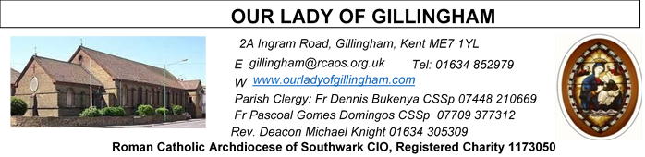 Office Hours – Tuesday, Wednesday & Friday - 10.30am – 1.30pm
14th June 2026
ELEVENTH SUNDAY – Year A
Readers next week:
Sat 6.30 | Sandaña Family
Sun 9.30 | Ann Williams; Nnamdi Eke; Nicky Croft
Sun 11.30 | Dominic Gali; Olivia Gali; Samuel Robson
Sun 6.30 | Archi Macwan; Anastasia Ebifa; Joan Aruma

Readers this week:
Sat 6.30 | Oliver Perez; Alyssa Viernes; Kieran Shannon
Sun 9.30 | Tania Jackson; Chizoba Okeke; Gillian Knight
Sun 11.30 | Onyehialam Sisters;  Dinah Kansiime
Sun 6.30 | Frances Okafor; Victoria Shosanya; Daniela Ibeh

Please Pray for Mary Shirley†, Chris Milne†, Sarah Shannon† and Apolonia MacKenzie†, who have recently died; Also Pray for all those whose anniversaries occur about this time including: Rose Corr, Millicent Driscoll, William Wilson, John Jordan, Margaret Cardwell, Alma Cade, Dorothy Hindle, Seamus Timmons, Lilien van Haeftin, Karl Langan, Anthony Donnarumma, Edward Shevlane, Carmela Klimeck, Charles Corr, Carmen Dow, Christopher Domican and Francis Hamill.
May their souls, and all the souls of the faithful
departed, rest in peace
Reading 1 | Exod 19:2-6 | I will count you a kingdom of priests,  a consecrated nation.
Psalm | Ps 99:2-3. 5 r.3 | We are his people: the sheep of his  flock.
Reading 2 | Rom 5:6-11 | Now that we have been reconciled  by the death of his Son, surely we  may count on being saved by the life  of his Son.
Gospel Acclamation | John 10:27 | The sheep that belong to me listen  to my voice, says the Lord, I know  them and they follow me.
 | Mark 1:15 | The kingdom of God is close at hand.  Repent, and believe the Good News.
Gospel | Matt 9:36–10:8 | He summoned his twelve disciples,  and sent them out.

SATURDAY
Exposition of the Blessed Sacrament & Reconciliation
10.30am – 11.30am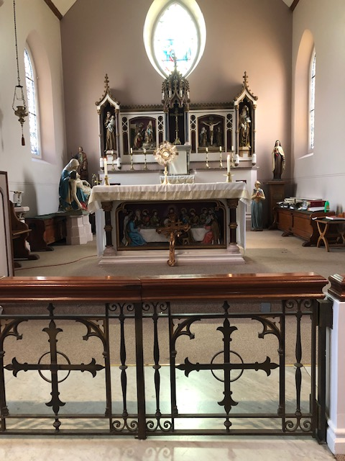
FRIDAY
Eucharistic Adoration
6.15pm – 7.20pm
Followed by
Holy Mass at 7.30pm
Our Parish NOTICES
Collections this week:
CATEGORY | CASH (Loose) | GIFT AID | CONTACTLESS  Amount Gift Aid |  | TOTALS
Offertory | £425.65 | £89.00 | £452.00 | £81.25 | £533.25

THIS SUNDAY – there will be a Parish Thanksgiving & Tythe Donation

Next Sunday – there will be a second collection for Day for Life. This is the day in the Church’s life dedicated to celebrating the sacrednes of life. Proceeds from the collection provide core funding to assist other life-related activities supported by the Church.

Please use the QR code for your weekly offerings & second collections
PARISH THANKSGIVING – TODAY (Sunday 14th June). All donations of thanksgiving shall go towards the painting and decoration of the Fathers’ dining room in the Presbytery, which for over 40 years has never been touched. Thanks very much that, through the thanksgiving of last year, the kitchen was done. The estimate for the work is £2500, so we appeal to you to donate as generously as you can. Payments can also be made by bank transfer to RCAS Gillingham; 60-08-37; 55153119 or via the contactless machine, using the ‘THANKSGIVING’ option.

BISHOP PAUL – is coming to give a talk to all the young people in our Parish on Saturday 27th June at 5pm in the McMahon Hall. Organised by OLoG Seeds Youth Ministry. We seek the cooperation of the parents / guardians to encourage all our young people to participate. Adults are also invited.

STELLA MARIS (FORMERLY CALLED APOSTLESHIP OF THE SEA) is seeking volunteers from this parish, please, to help with Sea Sunday (which falls on 11/12 July this year). This is the day when the Church comes together to pray for seafarers, fishers and their families, and takes a second collection to support the work of Stella Maris. Each volunteer will read out the appeal (which Stella Maris will provide) at the end of Masses that weekend. If you can kindly do this, please contact roland.hayes@stellamarismail.org
Related to that, all parishioners are warmly invited to an online webinar being run by Stella Maris on Wednesday 17th June from 7:30pm to 9pm. You will hear about the work that Stella Maris has been doing with seafarers and fishers over the past year or so, including the use of the funds kindly donated on Sea Sunday last year. To attend this webinar, please sign up at: www.stellamaris.org.uk/thankyou
PARISH REGISTER – It is important that we have contact details for ALL of our Parishioners & consequently we keep an electronic Parish Register. Please, complete a registration form & ensure that you notify us of any changes that occur & help us to keep email addresses & phone numbers up-to-date.
DATES FOR YOUR DIARY
TODAY | Parish Thanksgiving & Tythe donation
20th June | OLoG Youth Seeds – Careers Fayre in the McMahon Hall – 12noon till 6pm
27th June | Filipino Mass at 12.30pm followed by a gathering in the McMahon Hall, from 2pm until 4pm.
27th June | Bishop Paul talk with OLoG Seeds in the McMahon Hall @ 5pm
AROUND THE CATHOLIC COMMUNITY
POPE LEO has just published a new encyclical Magnifica Humanitas (More Human). It speaks about what it means to be human in our time, especially within the age of AI. Join us for these 3 short workshops to introduce and explore aspects of this timely document with input, as well as reflection and prayer.
In St Aloysius Parish Hall, Phoenix Rd, London NW1 1TA, Mondays 13 Jul, 21 Sep, 23 Nov, 7.30-8.45pm. All Welcome!
Register to attend on https://tinyurl.com/MoreHuman26
These workshops will also be online, email info@fcjecojustice.co.uk for more information.
SOUTHWARK CATHOLIC YOUTH SERVICE – Senior Youth Day – 11th July
St John Fisher School, City Way, Chatham, ME1 2FA from 11am until 5.30pm
This is an excellent day of good input on the faith, with sports and creative activities. A chance to make new friends. Ending with Mass for Sunday in the late afternoon. For more information, please email youth@rcaos.org.uk
RETROUVAILLE MARRIAGE SUPPORT:
From relationships that are 'Just in a Rut', needing some refreshment or more serious issues - If you are open to try again – Retrouvaille could be the solution. We have helped thousands of couples get their relationship back on track as they rediscovered hope and trust in the marriage. To find out more:
www.retrouvaille.org.uk +44 797 338 0443
HCPT HOSANNA HOUSE LOURDES PILGRIMAGE – 26th Sept – 2nd Oct 2026
Come and join us for a life changing experience. We shall visit places of interest such as Bartres & Gavarnie in the Pyrenees. We are looking forward to a week of prayer, rest and fun. Young helpers would be provided training. Come and join us to experience a new adventure. For further details, please contact: Amanda/Tharshi on 020 8393 7891 or Emil on 020 2898 9222 or via email to group537@hcpt.org.uk
STOP ASSISTED SUICIDE BEING BROUGHT BACK
Assisted suicide campaigners are trying to bring back the Leadbeater Bill.
‘Not Dead Yet UK’ has launched a simple tool to help you email your MP about the risks this Bill poses to people with disabilities.
Please take 30 seconds to email your MP today using the tool here: http://action.notdeadyetuk.org/ or call Lauren Edwards’ office on 0207 2197667 & ask
Lauren not to use her place in the Private Members’ Bill ballot to bring back the assisted suicide Bill. Lauren has only a few days left before she must present her chosen Bill to Parliament on Wednesday 17 June.
MASS INTENTIONS FOR THE WEEK

Saturday (13th June)  Vigil Mass | 10.00am  10.30am  6.30pm | Special Intention for Joe Cannavina  EXPOSITION OF THE BLESSED SACRAMENT and RECONCILIATION  Repose of the soul of Kevin Bishop
Sunday (14th June) | 9.30am  11.30am  6.30pm | Repose of the souls of Mary & Aubrey Jamieson  Repose of the souls of William & Esther Deere  Pro Populo
Monday (15th June) | 10.00am | Intentions & God’s Blessing for the marriage of Amanda & Steve Holloway
Tuesday (16th June) | 10.00am | Repose of the souls of Beryl & Clive Brooker
Wednesday (17th June) | 10.00am | Repose of the soul of Mary A. Regan
Thursday (18th June) | 10.00am | Repose of the soul of Mary Shirley
Friday (19th June)  Saint John Rigby | 10.00am  6.15pm  7.30pm | Repose of the souls of Fred & Freda King  EUCHARISTIC ADORATION  Repose of the soul of Violet Smith
Saturday (20th June)  Saint Alban  Vigil Mass | 10.00am  10.30am  6.30pm | Repose of the souls of John & Elizabeth Buck  EXPOSITION OF THE BLESSED SACRAMENT and RECONCILIATION  Pro Populo
Sunday (21st June) | 9.30am  11.30am  6.30pm | Wellbeing for Benedicta Onu  Repose of the souls of Frederick & Eileen Weller  Repose of the soul of Osita Isiwu

If you would like to book a Mass intention, please see Sue McIntyre or complete a ‘Mass Intention envelope’. Mass Intention donations are £10.00

