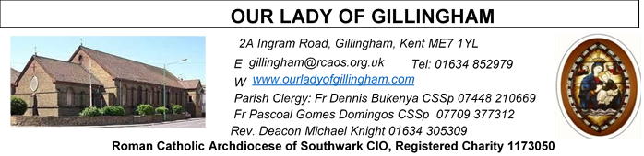 Office Hours – Tuesday, Wednesday & Friday - 10.30am – 1.30pm
7th June 2026
THE MOST HOLY BODY and BLOOD OF CHRIST – Year A
Readers next week:
Sat 6.30 | Oliver Perez; Alyssa Viernes; Kieran Shannon
Sun 9.30 | Tania Jackson; Chizoba Okeke; Gillian Knight
Sun 11.30 | Onyehialam Sisters;  Dinah Kansiime
Sun 6.30 | Frances Okafor; Victoria Shosanya; Daniela Ibeh

Readers this week:
Sat 6.30 | Gabriel Concepcion;  Benedict Okeke;  Janette Alfayad
Sun 9.30 | Vincent Obi; Uhuegbu Sisters
Sun 11.30 | Ellie Tetteh; Chelsea Atoe;  Laarni Fajardo
Sun 6.30 | Uche Family

Please Pray for Mary Shirley†, Chris Milne†, Sarah Shannon† and Apolonia MacKenzie†, who have recently died; Also Pray for all those whose anniversaries occur about this time including:
Cyril Stapor, Jeffery Allison, Edmund Tompolski, Elizabeth Bunting, Teresa Sahadat, Joan Plummer, Christine Harvey, Elsie Fertnig, Kathleen Wardanowski, David Walter, John Breen, Brian Rice, Richard Cotton, Phyllis Biram, Norah Golds & Kevin Bishop.
May their souls, and all the souls of the faithful
departed, rest in peace
Reading 1 | Deut 8:2-3, 14b-16a | He fed you with manna which  neither you nor your fathers had  known.
Psalm | Ps 147:12-15, 19-20 r. 12 | O praise the Lord, Jerusalem!  or Alleluia!
Reading 2 | 1 Cor 10:16-17 | That there is only one loaf means  that, though there are many of us,  we form a single body.
Gospel Acclamation | John 6:51-52 | I am the living bread which has  come down from heaven, says the  Lord. Anyone who eats this bread  will live for ever.
Gospel | John 6:51-58 | My flesh is real food and my blood  is real drink.

SATURDAY
Exposition of the Blessed Sacrament & Reconciliation
10.30am – 11.30am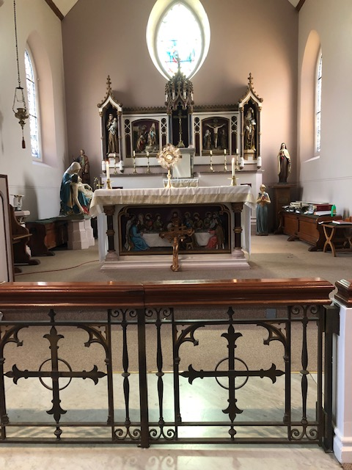
FRIDAY
Eucharistic Adoration
6.15pm – 7.20pm
Followed by
Holy Mass at 7.30pm
Our Parish NOTICES
Please use the QR code for your weekly offerings & second collections
Collections this week:
CATEGORY | CASH (Loose) | GIFT AID | CONTACTLESS  Amount Gift Aid |  | TOTALS
Offertory | £383.87 | £184.81 | £51.50 | £1.25 | £621.43

NEXT SUNDAY – there will be a Parish Thanksgiving & Tythe Donation

CORPUS CHRISTI (The Most Holy Body & Blood of Christ) - 7th JUNE
There will be a Eucharistic procession after the 11.30am mass which shall be concluded by Benediction in the Church.

THE MOST SACRED HEART OF JESUS – Friday 12th June
Mass will be celebrated at 10.00am & 7.30pm. The readers will be:
10.00am | Mary Sandaña; Kathleen Kara; James Spencer
7.30pm | Akhebai Tegha; Joan Aruma; Kieran Shannon

BISHOP PAUL – is coming to give a talk to all the young people in our Parish on Saturday 27th June at 5pm in the McMahon Hall. Topic: The Sacrament of Holy Orders. Organisers: OLOG Seeds youth ministry. We seek the cooperation of the parents / guardians to encourage all our young people to participate. Adults are also invited.

PARISH THANKSGIVING - has been scheduled on Sunday 14th June. All our donations of thanksgiving shall go towards the painting and decoration of the Fathers’ dining room in the Presbytery, which for over 40 years has never been touched. Thanks very much that, through the thanksgiving of last year the kitchen was done. Envelopes for our thanksgiving for this year shall be distributed next Sunday 7th June. We appeal to you to donate generously.

PARISH REGISTER – It is important that we have contact details for ALL of our Parishioners & consequently we keep an electronic Parish Register. Please, complete a registration form & ensure that you notify us of any changes that occur & help us to keep email addresses & phone numbers up-to-date.

MASS INTENTIONS – If you wish to book a Mass Intention, please come & see Sue McIntyre in the Office on a Tuesday, Wednesday or Friday morning. Alternatively, use a Mass Intention envelope, which are available at the back of church or on Sue’s desk. If the date requested isn’t available, Sue will contact you to discuss an alternative. Only one Mas Intention is allowed per Mass & a £10 donation, is requested, which can be paid via contactless or cash.
DATES FOR YOUR DIARY
6th June | OLoG Youth Seeds – Young Adult Mass at 3pm
7th June | The Most Holy Body & Blood of Christ (Corpus Christi) – Holy Day of Obligation.
12th June | Solemnity of the Most Sacred Heart of Jesus. Masses at 10am & 7.30pm
14th June | Parish Thanksgiving & Tythe donation
20th June | OLoG Youth Seeds – Careers Fayre in the McMahon Hall – times tbc
27th June | Filipino Mass at 12.30pm followed by a gathering in the McMahon Hall
27th June | Bishop Paul talk with OLoG Seeds in the McMahon Hall @ 5pm

AROUND THE CATHOLIC COMMUNITY

DISCOVERING CHESTERTON CONFERENCE will take place in London on Saturday 13th June. Learn about the life and work of Gilbert Keith Chesterton, Catholic journalist, novelist, essayist, apologist, lecturer, playwright, poet, beloved husband, friend, adoptive uncle, and even potential saint at this one-day conference. Booking Required Ticket Price: £15. To book, email catholicgkcsociety@yahoo.co.uk or Tel, 07795205114. Light Lunch provided! www.catholicgkchestertonsociety.co.uk
There are a few leaflets & poster at the back of the church with more information.

POPE LEO has just published a new encyclical Magnifica Humanitas (More Human). It speaks about what it means to be human in our time, especially with in the age of AI. Join us for these 3 short workshops to introduce and explore aspects of this timely document with input, as well as reflection and prayer.
In St Aloysius Parish Hall, Phoenix Rd, London NW1 1TA, Mondays 13 Jul, 21 Sep, 23 Nov, 7.30-8.45pm. All Welcome!
Register to attend on https://tinyurl.com/MoreHuman26
These workshops will also be online, email info@fcjecojustice.co.uk for more information.

RETROUVAILLE MARRIAGE SUPPORT:
From relationships that are 'Just in a Rut', needing some refreshment or more serious issues - If you are open to try again – Retrouvaille could be the solution. We have helped thousands of couples get their relationship back on track as they rediscovered hope and trust in the marriage. To find out more:
www.retrouvaille.org.uk +44 797 338 0443

MASS INTENTIONS FOR THE WEEK
Saturday (6th June)  Vigil Mass | 10.00am  10.30am  1.30pm  3.00pm  6.30pm | Repose of the soul of Josephine Firth  EXPOSITION OF THE BLESSED SACRAMENT and RECONCILIATION  Baptism  OLoG Seeds – Young Adult Mass  Intentions of the Lee Family
Sunday (7th June)  The Most Holy Body & Blood of Christ  (Corpus Christi) | 9.30am  11.30am  6.30pm | Birthday Thanksgiving for Anthonia Okeke  Pro Populo  Repose of the soul of Frank Hanham
Monday (8th June) | 10.00am | Repose of the soul of Clera Pereira
Tuesday (9th June) | 10.00am | Repose of the soul of Mary Shirley
Wednesday (10th June) | 10.00am | Good Health of Rebecca Maufe
Thursday (11th June)  St Barnabas | 10.00am | Repose of the souls of Margaret & Harold Cardwell
Friday (12th June)  The Most Sacred Heart of Jesus | 10.00am  6.15pm  7.30pm | Repose of the souls of Kevin & Pauline Ketchen  EUCHARISTIC ADORATION  Repose of the soul of Norah Golds
Saturday (13th June)  The Immaculate Heart of the Blessed Virgin Mary  Vigil Mass | 10.00am  10.30am  6.30pm | Special Intention for Joe Cannavina  EXPOSITION OF THE BLESSED SACRAMENT and RECONCILIATION  Repose of the soul of Kevin Bishop
Sunday (14th June) | 9.30am  11.30am  6.30pm | Repose of the souls of Mary & Aubrey Jamieson  Repose of the souls of William & Esther Deere  Prop Populo

