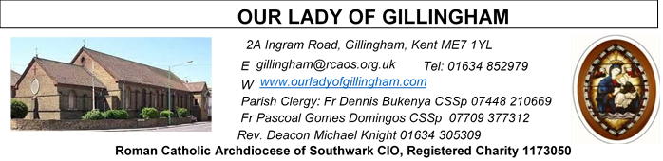 Office Hours – Tuesday, Wednesday & Friday - 10.30am – 1.30pm
31st May 2026
THE MOST HOLY TRINITY – Year A
Readers this week:
Sat 6.30 | Francisca Okeke; Lucy;  John Jupit Quilas
Sun 9.30 | Edeji Sisters
Sun 11.30 | Chelsea Atoa; Olivia Gali; Dominic Gali
Sun 6.30 | Uche Family

Readers next week:
Sat 6.30 | Gabriel Concepcion;  Benedict Okeke; Janette Alfayad
Sun 9.30 | Vincent Obi;  Uhuegbu Sisters
Sun 11.30 | Ellie Tetteh; Chelsea Atoe; Laarni Fajardo
Sun 6.30 | Uche Family

Please Pray for Mary Shirley†, Chris Milne†, Sarah Shannon† and Apolonia MacKenzie†, who have recently died; Also Pray for all those whose anniversaries occur about this time including:
Terence Sadler, Morris Melissa, Debra Gray, Agnes Ball, Laurence Rebello, Michael Iandolo, Lily Lewis, Bruno Bove, Joshua Paine, John (Sean) Duffy, Eleuterio Sequeira, Evanas Dargis, George Owens, Clodagh Parris, Coro Flynn, Alan Bunting, Irene Mason, Doris Boxhall, John Flannery, David Boxall, Esther Meaney, Margaret McGargle, Frank Hill, Seamus McEvoy, John Gilhooley, Peter Seath, Rosina Hare, Elizabeth Hooper, Antonine Staper and Nellie Roach.
May their souls, and all the souls of the faithful
departed, rest in peace
Reading 1 | Exod 34:4-6, 8-9 | Lord, Lord, a God of tenderness and  compassion.
Psalm | Dan 3:52-56 r. 52 | To you glory and praise for evermore.
Reading 2 | 2 Cor 13:11-13 | The grace of Jesus Christ, the love of  God, and the fellowship of the Holy  Spirit.
Gospel Acclamation | Apoc 1:8 | Glory be to the Father, and to the Son,  and to the Holy Spirit, the God who is,  who was, and who is to come.
Gospel | John 3:16-18 | God sent his Son so that through him  the world might be saved.

SATURDAY
Exposition of the Blessed Sacrament & Reconciliation
10.30am – 11.30am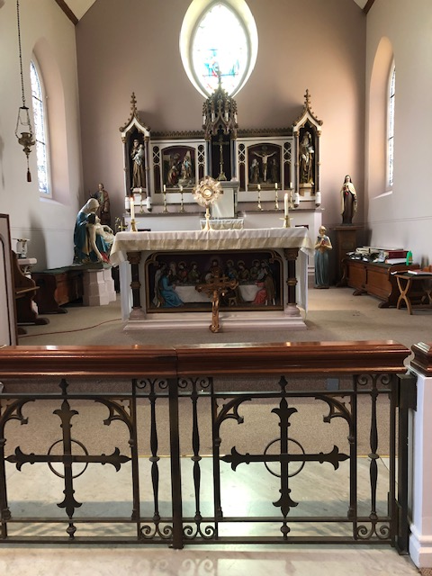
FRIDAY
Eucharistic Adoration
6.15pm – 7.20pm
Followed by
Holy Mass at 7.30pm
Our Parish NOTICES
Please use the QR code for your weekly offerings & second collections
Collections this week:
CATEGORY | CASH (Loose) | GIFT AID | CONTACTLESS  Amount Gift Aid |  | TOTALS
Offertory | £500.11 | £115.01 | £367.40 | £32.50 | £1.15.02
Second Collection | £112.94 | £10.00 | £54.50 | £7.38 | £184.82


PENTECOST CELEBRATION – Thanks for the support and contributions that you made towards the success of the Pentecost celebration last Sunday. Gratitude to all those who were involved in the liturgy; the clergy, the altar servers, the choirs, catechists, stewards, church decorators, readers, and those who took part in bidding prayers. We are grateful to the Pentecost organising committee, and all those who contributed in the form of food, drinks, money, labour and entertainment.
BISHOP PAUL – is coming to give a talk to all the young people in our Parish on Saturday 27th June at 5pm in the McMahon Hall. Topic: The Sacrament of Holy Orders. Organisers: OLOG Seeds youth ministry. We seek the cooperation of the parents / guardians to encourage all our young people to participate. Adults are also invited.
PARISH THANKSGIVING - has been scheduled on Sunday 14th June. All our donations of thanksgiving shall go towards the painting and decoration of the Fathers’ dining room in the Presbytery, which for over 40 years has never been touched. Thanks very much that, through the thanksgiving of last year the kitchen was done. Envelopes for our thanksgiving for this year shall be distributed next Sunday 7th June. We appeal to you to donate generously.
7th JUNE – is the feast of Corpus Christ (Most Holy Body and Blood of Christ). We shall have the Eucharistic procession after the 11.30am mass which shall be concluded by Benediction in the Church.
PARISH REGISTER – It is important that we have contact details for ALL of our Parishioners & consequently we keep an electronic Parish Register. If you are new to the Parish or think you have not previously completed a Parish Registration form, please take a copy from the back of Church & return the completed form to the Office or Fr Dennis. Please, also ensure that you notify us of any changes that occur & help us to keep email addresses & phone numbers up-to-date.
MASS INTENTIONS – If you wish to book a Mass Intention, please come & see Sue McIntyre in the Office on a Tuesday, Wednesday or Friday morning. Alternatively, use a Mass Intention envelope, which are available at the back of church or on Sue’s desk. If the date requested isn’t available, Sue will contact you to discuss an alternative. Only one Mas Intention is allowed per Mass & a £10 donation, is requested, which can be paid via contactless or cash.
DATES FOR YOUR DIARY
31st May | Marian Possession for all parishioners after 11.30am Mass
6th June | OLoG Youth Seeds – Young Adult Mass at 3pm
7th June | The Most Holy Body & Blood of Christ (Corpus Christi) – Holy Day of Obligation.
14th June | Parish Thanksgiving & Tythe donation
17th June | Solemnity of the Most Sacred Heart of Jesus. Masses at 10am & 7.30pm
20th June | OLoG Youth Seeds – Careers Fayre in the McMahon Hall – times tbc
27th June | Filipino Mass at 12.30pm followed by a gathering in the McMahon Hall

AROUND THE CATHOLIC COMMUNITY
WESTMINSTER ASSISTED SUICIDE BILL HAS FALLEN
The assisted suicide Bill has failed to pass all stages in the House of Lords. This means that Kim Leadbeater’s assisted suicide Bill has fallen and will not become law! This is a major milestone, but the battle is not over. Assisted suicide campaigners have said they are going to try to bring the Bill back in the next parliamentary session and use the Parliament Acts to bypass the Lords.
To find out more about this significant milestone and what comes next, visit: https://righttolife.org.uk/LeadbeaterBillFalls
THE DIVINE MERCY APOSTOLATE (London) is holding a First Saturday Divine Mercy Recollection Day at the Shrine of Our Lady of Walsingham, on Saturday 6th June 2026 from 10:30 am to 4:30 pm. The Recollection Day will include Holy Mass, Talk, Hour of Mercy with Benediction and Veneration of the Image of Merciful Jesus. All welcome. Tickets cost £30 per person. Please call Millie on 07957594646 for more information. Coaches from Slough, Ealing Broadway, North London, Barking and Victoria.
MISSIO AND THE MILL HILL MISSIONARIES invite all Red Box supporters and the wider Diocesan community to come together for two important events in 2026:
St Simon Stock Church, Bleakwood Rd, Walderslade, Kent ME5 0NF on Saturday 6 June at 11am. Join Fr Joseph Donkor (Missio Diocesan Director for Southwark) and the Mill Hill Missionaries for Mass, followed by lunch and sharing of mission work.
St Elizabeth of Portugal Roman Catholic Church, The Vineyard, Richmond TW10 6AQ on Saturday, 3rd October at 11am. Join us for this special World Mission month mass with Missio National Director, Fr Anthony Chantry MHM, and Fr Joseph Donkor. Everyone is welcome to attend. Please email redbox@missio.org.uk or visit https://missio.org.uk/mission-masses-and-events/ for further information.

MASS INTENTIONS FOR THE WEEK
Saturday (30th May)  Vigil Mass | 10.00am  10.30am  3.00pm  6.30pm | Repose of the souls of the Deceased members of the Di Lisio & Cannavina families  EXPOSITION OF THE BLESSED SACRAMENT and RECONCILIATION  Convalidation of Uche & Kyna  Repose of the soul of Ebubechukwu and God’s protection over the Uzoma family
Sunday (31st May)  The Most Holy Trinity | 9.30am  11.30am  6.30pm | “For God’s Blessings & Grace upon the Elderly Parishioners”  Pro Populo  Special Intention of Joe Cannavina
Monday (1st June)  St Justin | 10.00am | Repose of the soul of Eleuterio Sequeira
Tuesday (2nd June) | 10.00am | Repose of the soul of Sean Duffy
Wednesday (3rd June)  St Charles Lwanga & Companions | 10.00am | Requiem Mass for Mary Shirley
Thursday (4th June) | 10.00am | Intentions of Ann Martin for the Pary Family
First Friday (5th June)  St Boniface | 10.00am  6.15pm  7.30pm | Wellbeing & Birthday Thanksgiving for Phil Croft  EUCHARISTIC ADORATION  Repose of the souls of John & April Larkin
First Saturday  (6th June)  Vigil Mass | 10.00am  10.30am  1.30pm  3.00pm  6.30pm | Repose of the soul of Josephine Firth  EXPOSITION OF THE BLESSED SACRAMENT and RECONCILIATION  Baptism  OLoG Seeds – Young Adult Mass  Intentions of the Lee Family
Sunday (7th June)  The Most Holy Body & Blood of Christ  (Corpus Christi) | 9.30am  11.30am  6.30pm | Birthday Thanksgiving for Anthonia Okeke  Pro Populo  Repose of the soul of Frank Hanham

