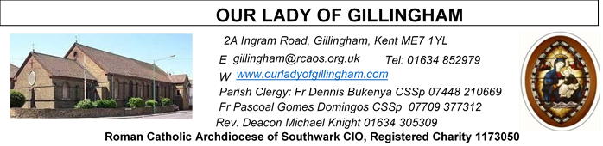 Office Hours – Tuesday, Wednesday & Friday - 10.30am – 1.30pm
17th May 2026
SEVENTH SUNDAY of EASTER – Year A
Readers this week:
Sat 6.30pm | Oliver Perez; Crystabelle  Imelda Cervantes
Sun 9.30am | Vincent Obi; Chizoba Okeke; Gillian Knight
Sun 11.30am | Onyehialam Sisters  Dinah Kansiime
Sun 6.30pm | Victoria Shosanya  Daniela Ibeh

Readers next week (Pentecost Sunday):
Sat 6.30pm | Laarni Fajardo; Yolanda Danday; Kieran Shannon
Sun 9.30am | Ann Williams; Akhebai Tegha;  Nicky Frost
Sun 11.30am | Shakira Kara; Anastasia Ebifa;  Samuel Robson
Sun 6.30pm | Frances Okafor; Joan Aruma

Reading 1 | Acts 1:12-14 | All joined in continuous prayer.
Psalm | Ps 26:1, 4, 7-8 r. 13 | I am sure I shall see the Lord's  goodness in the land of the living.  or Alleluia!
Reading 2 | 1 Pet 4:13-16 | It is a blessing for you when they  insult you for bearing the name  of Christ.
Gospel Acclamation | John 14:18 | I will not leave you orphans, says  the Lord; I will come back to you,  and your hearts will be full of joy.
Gospel | John 17:1-11 | Father, glorify your Son.

Please Pray for Mary Shirley†, Chris Milne†, Sarah Shannon† and Apolonia MacKenzie†, who have recently died; Also Pray for all those whose anniversaries occur about this time including: William Cade, Ross Croucher, James Oakley, Desmond Styne, Theresa Sullivan, Patricia Hanson, Sylvia Cragon, Vivien Pear, John Edwards, William Cronin, Esther Race, Peter White, Pauline Clifford, Michael Cullen, Margaret Ling, Alice O’Flaherty, Mary Barry, Patrick Keegan, Oswald Evans, James Murphy and James Driver.
May their souls, and all the souls of the faithful departed, rest in peace

SATURDAY
Exposition of the Blessed Sacrament & Reconciliation
10.30am – 11.30am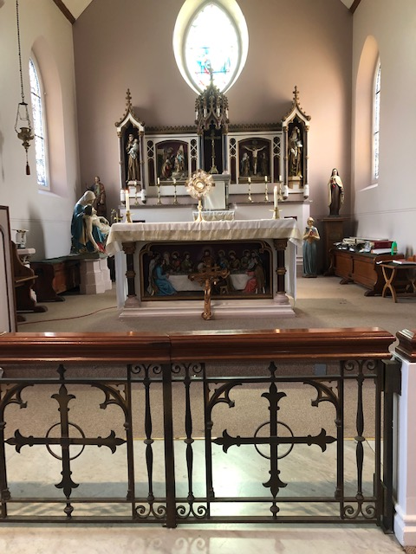
FRIDAY
Eucharistic Adoration
6.15pm – 7.20pm
Followed by
Holy Mass at 7.30pm
Our Parish NOTICES
Collections this week:
CATEGORY | CASH (Loose) | GIFT AID | CONTACTLESS  Amount Gift Aid |  | TOTALS
Offertory | £357.24 | £125.50 | £512.50 | £53.38 | £1048.62

This Week there will be a second collection for Word Communications Day
NEXT Week there will be a second collection to support the Spiritan Mission, worldwide

Please use the QR code for your weekly offerings & second collections
MAY MARIAN DEVOTION – Following the invitation of the Archbishop everybody please pray the holy rosary for life every day for the protection and promotion of life especially for the vulnerable ones. This is Week III, praying the Luminous Mysteries for people with disabilities. Here at the Church we pray the rosary every day at 9.30am before mass.
PENTECOST SUNDAY – NEXT Sunday 24th May. The Church was founded on Pentecost. To bring the universality of our Church, the bidding prayers shall be in different languages. Also, on Pentecost please put on national/traditional attires. After, 11.30am Mass, we shall celebrate together as a family of God with a parish meal. Hence, we appeal to parishioners to prepare, ‘bring and share meals’ and drinks of different types from the different nationalities. Those willing to donate, please write your names on the sheets at the back of the Church. We also need volunteers/helpers to help out on that day. Those donating drinks, please bring them to Fathers’ house. Parishioners with allergies or a prescribed diet, we recommend that you attend with your own packed lunch.
GIFT AID – Parishioners who have previously signed up to Gift Aid & pay their weekly offertory in cash using the gift aid envelopes, please collect your new box of envelopes from Dayle or the Office.
PRE-LOVED SALE – NEXT Saturday 23rd May, 1pm until 3pm. There will be a sale of second hand/pre-loved items in the McMahon Hall. Come & have a browse & help to raise funds for the Church
DATES FOR YOUR DIARY
23rd May | Pre-loved Sale in the McMahon Hall from 1pm until 3pm
23rd May | Filipino Mass in Church from 12noon, followed by a gathering in the McMahon Hall from 4pm. All are welcome.
24th May | Pentecost Sunday – No Teas after 9.30am Mass - Celebrations in the Church Garden (weather permitting) after 11.30am Mass
24th May | First Holy Communion THANKSGIVING Mass at 11.30am – all First Holy Communicants to attend, followed by Celebrations in the Church Garden
31st May | Marian Possession for all parishioners after 11.30am Mass
AROUND THE CATHOLIC COMMUNITY
MISSIO AND THE MILL HILL MISSIONARIES invite all Red Box supporters and the wider Diocesan community to come together for two important events in 2026:
St Simon Stock Church, Bleakwood Rd, Walderslade, Kent ME5 0NF on Saturday 6 June at 11am. Join Fr Joseph Donkor (Missio Diocesan Director for Southwark) and the Mill Hill Missionaries for Mass, followed by lunch and sharing of mission work.
St Elizabeth of Portugal Roman Catholic Church, The Vineyard, Richmond TW10 6AQ on Saturday, 3rd October at 11am. Join us for this special World Mission month mass with Missio National Director, Fr Anthony Chantry MHM, and Fr Joseph Donkor. Everyone is welcome to attend. Please email redbox@missio.org.uk or visit https://missio.org.uk/mission-masses-and-events/ for further information.
ROSARY FOR LIFE - Archbishop John Wilson is calling on all of us to join him in praying the Rosary for Life this May (Month of Mary). Together, we will pray through the Joyful, Sorrowful, Glorious and Luminous Mysteries, each one offered for the most vulnerable facing growing threats to life: unborn children at risk of abortion, victims of war and persecution, people with disabilities, and the elderly and vulnerable. For video, audio and written versions of the Rosary for Life, visit rcaos.org.uk/rosaryforlife. Pray the Rosary. Encounter Christ. Defend life.
WESTMINSTER ASSISTED SUICIDE BILL HAS FALLEN
The assisted suicide Bill has failed to pass all stages in the House of Lords. This means that Kim Leadbeater’s assisted suicide Bill has fallen and will not become law! This is a major milestone, but the battle is not over. Assisted suicide campaigners have said they are going to try to bring the Bill back in the next parliamentary session and use the Parliament Acts to bypass the Lords.
To find out more about this significant milestone and what comes next, visit: https://righttolife.org.uk/LeadbeaterBillFalls
PILGRIMAGE TO LOURDES - Bishop Paul Hendricks will be making a presentation regarding the Diocesan Pilgrimage to Lourdes in August. The presentation will be at 7pm on Saturday 16th May following the Vigil Mass at 6pm at English Martyrs RC Church in Strood. The venue is the Parish Hall. There is plenty of parking in the school playground adjacent to the church and Parish Hall. Tea and coffee will be available. If you are at all interested in this pilgrimage do not miss this opportunity to learn more.
THE DIVINE MERCY APOSTOLATE (London) is holding a First Saturday Divine Mercy Recollection Day at the Shrine of Our Lady of Walsingham, on Saturday 6th June 2026 from 10:30 am to 4:30 pm. The Recollection Day will include Holy Mass, Talk, Hour of Mercy with Benediction and Veneration of the Image of Merciful Jesus. All welcome. Please call Millie on 07957594646 for more information. Coaches from Slough, Ealing Broadway, North London, Barking and Victoria.
GOOD COUNSEL NETWORK – THURSDAY 21st MAY
Please pray and fast for the end of abortion and euthanasia in this country. Your prayer and fasting is urgently needed. For information on the days of Prayer and Fasting contact The Good Counsel Network on 020 7723 1740, or via www.goodcounselnetwork.com.
MASS INTENTIONS FOR THE WEEK

Saturday (16th May)  St Simon Stock  Vigil | 10.00am  10.30am  12noon  6.30pm | Intentions of the First Holy Communicants  EXPOSITION OF THE BLESSED SACRAMENT and RECONCILIATION  First Holy Communion Service  Deceased members of the Di Lisio & Cannavina families
Sunday (17th May) | 9.30am  11.30am  6.30pm | In Thanksgiving  Wellbeing for Benedicta Onu  Pro Populo
Monday (18th May) | 10.00am | Repose of the souls of James & Mary Woodford
Tuesday (19th May) | 10.00am | Repose of the soul of Ebubechukwu & God’s protection on the Uzoma Family
Wednesday (20th May) | 10.00am | Repose of the soul of Mary Shirley
Thursday (21st May) | 10.00am | Repose of the soul of Ebubechukwu & God’s protection on the Uzoma Family
Friday (22nd May) | 10.00am  6.15pm  7.30pm | Repose of the soul of Lillian Huckings  EUCHARISTIC ADORATION  Repose of the souls of Pat & Jack Caller
Saturday  (23rd May)  Vigil Mass of Pentecost | 10.00am  10.30am  12noon  6.30pm | Birthday Thanksgiving for Teresa Cottam  EXPOSITION OF THE BLESSED SACRAMENT and RECONCILIATION  Filipino Mass  Lee Family Intentions
Sunday (24th May)  Pentecost Sunday | 9.30am  11.30am  6.30pm | Repose of the soul of Santonia Alvares  First Holy Communion Thanksgiving  Pro Populo

Please ensure that, if you book a Mass via the contactless machine, you have booked your Mass Intention in the diary first. Mass Intentions require a £10 donation.
MAY DEVOTION 2026
THE HOLY ROSAY FOR LIFE
Week III - 17th to 23rd May: The Luminous Mysteries
AND
THE 9 DAYS NOVENA TO THE HOLY SPIRIT
15th to 23rd May: Pray for the gifts of the Holy Spirit

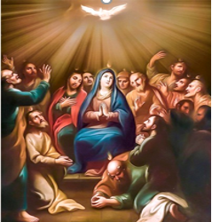

The Church was founded on Pentecost. At Pentecost the Holy Spirit was manifested in a divine flame of fire. The Spirit’s flame descended upon the assembled disciples together with the Blessed Virgin Mary. It was kindled in them and gave them the new ardour of God. Thus, what Jesus had previously said was fulfilled: I came to cast fire upon the earth; and would that it were already kindled (Lk 12:49).
Beseeching the same Holy Spirit through the intercession of the Blessed Virgin Mary, we are praying the Holy rosary for Life. The Rosary for Life is prayed through the Joyful, Sorrowful, Glorious and Luminous Mysteries, each one offered for the most vulnerable facing growing threats to life: unborn children at risk of abortion, victims of war and persecution, victims of abuse, people with disabilities, the orphans and the elderly.

THE HOLY ROSAY FOR LIFE – MAY 2026
Week III - 17th to 23rd May: The Luminous Mysteries
We pray for People with Disabilities
The First Luminous Mystery - The Baptism of Jesus
SCRIPTURE - Matthew 3:16-17
“Jesus was baptised, immediately he went up from the water, and behold, the heavens were opened to him, and he saw the Spirit of God descending like a dove and coming to rest on him; and behold, a voice from heaven said, ‘This is my beloved Son, with whom I am well pleased.’”
PRAYER INTENTION
We offer this decade for all people living with a disability: may they know they are beloved children of God, chosen and called by name.
The Second Luminous Mystery - The Wedding at Cana
SCRIPTURE - John 2:4-5
“Jesus said to her, ‘Woman, what does this have to do with me? My hour has not yet come.’ His mother said to the servants, ‘Do whatever he tells you.’”
PRAYER INTENTION
We offer this decade for all who care for people with disabilities — families, carers and medical professionals: may the Blessed Virgin Mary intercede for them and fill them with compassion, patience and love.
The Third Luminous Mystery - The Proclamation of the Kingdom
SCRIPTURE - Mark 1:15
“The time is fulfilled, and the kingdom of God is at hand; repent and believe in the Gospel.”
PRAYER INTENTION
We offer this decade for all disabled people who feel marginalised or forgotten: may they know that the Lord Jesus calls each of them to his Kingdom and calls them his Beloved.
The Fourth Luminous Mystery - The Transfiguration
SCRIPTURE - Matthew 17:5
“Behold, a bright cloud overshadowed them, and a voice from the cloud said, ‘This is my beloved Son, with whom I am well pleased; listen to Him.’”
PRAYER INTENTION
We offer this decade for all people with disabilities: may they know that the love of the Lord Jesus radiates from them and through their lives, his love graces all they encounter.

The Fifth Luminous Mystery - The Institution of the Eucharist
SCRIPTURE - Mark 14:22-24
“He took bread, and after blessing it broke it and gave it to them, and said, ‘Take; this is my body.’ And he took a cup, and when he had given thanks he gave it to them, and they all drank of it. And he said to them, ‘This is my blood of the covenant, which is poured out for many.’”
PRAYER INTENTION
We offer this decade for the full inclusion of all our brothers and sisters: may all disabled people know that the Lord Jesus, who gives himself to us in the Eucharist, calls his Body — the Church — to embrace and love them.
Closing Prayers
HAIL HOLY QUEEN (SALVE REGINA)
Hail, holy Queen, mother of mercy, our life, our sweetness, and our hope. To thee do we cry, poor banished children of Eve. To thee do we send up our sighs mourning and weeping in this vale of tears. Turn then, most gracious advocate, thine eyes of mercy toward us, and after this our exile show us the blessed fruit of thy womb, Jesus. O clement, O loving, O sweet Virgin Mary.

Pray for us, O Holy Mother of God. That we may be made worthy of the promises of Christ.
CONCLUDING PRAYER
Let us pray. O God, whose only begotten Son, by His life, death, and resurrection, has purchased for us the rewards of eternal life. Grant, we beseech Thee, that while meditating on these mysteries of the most holy rosary of the Blessed Virgin Mary, we may imitate what they contain and obtain what they promise, through Christ our Lord. Amen.

May the divine assistance remain with us. And may souls of all the faithful departed through the mercy of God, rest in peace.

MEMORARE
Remember, O most gracious Virgin Mary, that never was it known that anyone who fled to thy protection, implored thy help, or sought thy intercession was left unaided. Inspired with this confidence, I fly unto thee, O Virgin of virgins, my mother; to thee do I come, before thee I stand, sinful and sorrowful. O Mother of the Word Incarnate, despise not my petitions, but in thy clemency hear and answer me. Amen.
CLOSING PRAYER
Mary, Queen of Peace, grant us peace in our hearts, harmony in our families and peace throughout the world. Watch over those in the fear and shadow of war, and protect them with your motherly love. Through Christ our Lord. Amen.

LITANY
Most Sacred Heart of Jesus, have mercy on us.
Immaculate Heart of Mary, pray for us.
Our Lady of Guadalupe, pray for us.
Our Lady of Lourdes, pray for us.
Our Lady, Queen of Peace, pray for us.
St. Joseph, pray for us.
May all the Angels and Saints in heaven.

NOVENA TO THE HOLY SPIRIT
15th to 23rd May
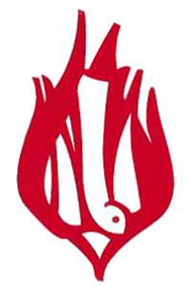

Opening Prayer

V Come, Holy Spirit, fill the hearts of your faithful.
R And enkindle in them the fire of your love.
V Send forth your Spirit and they shall be created.
R And you shall renew the face of the earth.
O God who taught the hearts of the faithful by the light of the Holy Spirit, grant that by the gift of the same Spirit we may be always truly wise and ever rejoice in His consolation. Through Christ our Lord Amen.

PRAYER FOR THE SEVEN GIFTS OF THE HOLY SPIRIT
Christ Jesus, before ascending into heaven, You promised to send the Holy Spirit to Your apostles and disciples. Grant that the same Spirit may perfect in our lives the work of Your grace and love. Grant us the Spirit of Fear of the Lord that we may be filled with a loving reverence toward You. The Spirit of Piety that we may find peace and fulfilment in the service of God while serving others. The Spirit of Fortitude that we may bear our cross with You and, with courage, overcome the obstacles that interfere with our salvation. The Spirit of Knowledge that we may know You and know ourselves and grow in holiness. The Spirit of Understanding to enlighten our minds with the light of Your truth. The Spirit of Counsel that we may choose the surest way of doing Your will, seeking first the Kingdom of God. Grant us the Spirit of Wisdom that we may aspire to the things that last forever. Teach us to be Your faithful disciples and animate us in every way with Your Spirit. Amen.
Glory be to the Father…
In the name of the Father ……

