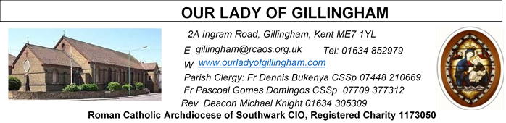 Office Hours – Tuesday, Wednesday & Friday - 10.30am – 1.30pm
3rd May 2026
FIFTH SUNDAY of EASTER – Year A
Readers next week:
Sat 6.30pm | Gabriel Concepcion  Benedict Okeke  Janette Alfayad
Sun 9.30am | Tania Jackson  Uhuegbu Sisters
Sun 11.30am | Ellie Tetteh  Chelsea Atoe  Kathleen Kara
Sun 6.30pm | Uche Family

SATURDAY
Exposition of the Blessed Sacrament & Reconciliation
10.30am – 11.30am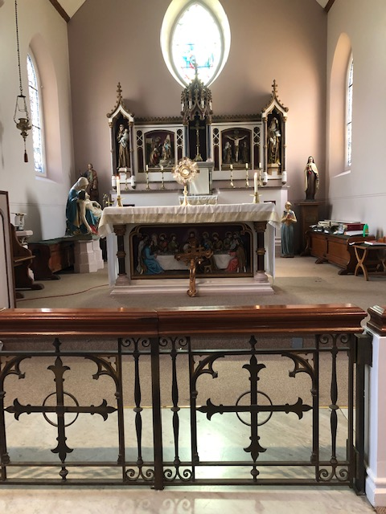
Readers this week:
Sat 6.30pm | Sandaña Family
Sun 9.30am | Edeji Sisters
Sun 11.30am | Dominic Gali  Olivia Gali  Samuel Robson
Sun 6.30pm | Frances Okafor  Joan Aruma

Please Pray for Mary Shirley†, Chris Milne†, Sarah Shannon† and Apolonia MacKenzie†, who have recently died;
Also Pray for all those whose anniversaries occur about this time including: Margaret O’Sullivan, John Sullivan, John Bareham, Mr Walker, Isabella Cooper, Joanna Anderson, Eileen Gilham, Anne Riddell, Norah Hackett, Nicolina Larini, William Tuffin, Patrick Carroll, Elizabeth Mallichan, Anthony Vallejo, Mary Lane, Michael Keating and Maria Cassington.
May their souls, and all the souls of the faithful departed, rest in peace

Reading 1 | Acts 6:1-7 | They elected seven men full of  the Holy Spirit.
Psalm | Ps 32:1-2, 4-5, 18-19 r. 22 | May your love be upon us, O  Lord, as we place all our hope  in you. or Alleluia!
Reading 2 | 1 Pet 2:4-9 | But you are a chosen race, a  royal priesthood.
Gospel Acclamation | John 14:6 | Jesus said: 'I am the Way, the  Truth and the Life.  No one can come to the father  except through me.
Gospel | John 14:1-12 | I am the Way, the Truth and the  Life.

FRIDAY
Eucharistic Adoration
6.15pm – 7.20pm
Followed by
Holy Mass at 7.30pm
Our Parish NOTICES
Please use the QR code for your weekly offerings & second collections
Collections this week:
CATEGORY | CASH (Loose) | GIFT AID | CONTACTLESS  Amount Gift Aid |  | TOTALS
Offertory | £630.96 | £88.65 | £389.00 | £53.75 | £1162.36
Second Collection  (Parish Training Fund) | £213.95 | £33.20 | £373.00 | £12.00 | £632.15


MAY MARIAN DEVOTION – Following the invitation of the Archbishop everybody please pray the holy rosary for life every day for the protection and promotion of life especially for the vulnerable ones. Here at the Church we pray the rosary every day at 9.30am before mass.

SAFEGUARDING SUNDAY 2026. TODAY - Sunday 3rd May.
In line with today’s Gospel, we are called to protect, called to care, called to act. Safeguarding is not the work of a few; it is a shared responsibility. You can find out more about Safeguarding Sunday at rcaos.org.uk/safeguardingsunday or via the QR code.

PENTECOST SUNDAY - Sunday 24th May. The Church was founded on Pentecost. To bring the universality of our Church, the bidding prayers shall in different languages. Also, on Pentecost please put on national/traditional attires. After 11.30pm Mass we shall celebrate together as a family of God with a parish meal. Hence, we appeal to parishioners to prepare, ‘bring and share meals’ of different types from the different nationalities and drinks. Those willing to donate write your names on the sheets at back of the Church.
GIFT AID – Parishioners who have previously signed up to Gift Aid & pay their weekly offertory in cash using the gift aid envelopes, please collect your new box of envelopes from Dayle or the Office.
PRE-LOVED SALE – Saturday 23rd May, 1pm until 3pm. There will be a sale of second hand/pre-loved items in the McMahon Hall. Come & have a browse & help to raise funds for the Church
DATES FOR YOUR DIARY
3rd May | Safeguarding Sunday – National Day of Prayer - details to follow
9th May | First Holy Communion Rehearsal at 11.45am in Church
14th May | The Ascension of the Lord (Holy Day of Obligation)
15th May | Novena for the Gifts of the Holy Spirit begins
16th May | FIRST HOLY COMMUNION SERVICE @ 12noon.
24th May | Pentecost Sunday – Celebrations in the Church Garden

AROUND THE CATHOLIC COMMUNITY
MISSIO AND THE MILL HILL MISSIONARIES invite all Red Box supporters and the wider Diocesan community to come together for two important events in 2026:
- St Simon Stock Church, Bleakwood Rd, Walderslade, Kent ME5 0NF on Saturday 6 June at 11am. Join Fr Joseph Donkor (Missio Diocesan Director for Southwark) and the Mill Hill Missionaries for Mass, followed by lunch and sharing of mission work.
- St Elizabeth of Portugal Roman Catholic Church, The Vineyard, Richmond TW10 6AQ on Saturday, 3rd October at 11am. Join us for this special World Mission month mass with Missio National Director, Fr Anthony Chantry MHM, and Fr Joseph Donkor.
Everyone is welcome to attend. Please email redbox@missio.org.uk or visit https://missio.org.uk/mission-masses-and-events/ for further information.
ROSARY FOR LIFE - Archbishop John Wilson is calling on all of us to join him in praying the Rosary for Life this May (Month of Mary). Together, we will pray through the Joyful, Sorrowful, Glorious and Luminous Mysteries, each one offered for the most vulnerable facing growing threats to life: unborn children at risk of abortion, victims of war and persecution, people with disabilities, and the elderly and vulnerable. For video, audio and written versions of the Rosary for Life, visit rcaos.org.uk/rosaryforlife. Pray the Rosary. Encounter Christ. Defend life.
WESTMINSTER ASSISTED SUICIDE BILL HAS FALLEN
The assisted suicide Bill has failed to pass all stages in the House of Lords. This means that Kim Leadbeater’s assisted suicide Bill has fallen and will not become law! This is a major milestone, but the battle is not over. Assisted suicide campaigners have said they are going to try to bring the Bill back in the next parliamentary session and use the Parliament Acts to bypass the Lords.

To find out more about this significant milestone and what comes next, visit: https://righttolife.org.uk/LeadbeaterBillFalls
RETROUVAILLE MARRIAGE SUPPORT
From relationships that are 'Just in a Rut', needing some refreshment or more serious issues - If you are open to try again – Retrouvaille could be the solution. We have helped thousands of couples get their relationship back on track as they rediscovered hope and trust in the marriage. To find out more:
www.retrouvaille.org.uk +44 797 338 0443
Beginning Experience: WIDOWED, SEPARATED AND DIVORCED
Weekend 8th to 10th May 2026 at Worth Abbey, West Sussex, RH1 4SB.
Beginning Experience is a peer ministry to the widowed, separated and divorced led by trained volunteers. Their work is carried out at special weekend gatherings, which encourage participants to deal with the natural process of grief and loneliness. For further details, please contact Mary on 07730 884315 or email: BeginningExperience.soe@gmail.com.

MASS INTENTIONS FOR THE WEEK

Saturday (2nd May)  Vigil | 10.00am  10.30am  1.00pm  3.00pm  6.30pm | Birthday Thanksgiving for Bella Edeji  EXPOSITION OF THE BLESSED SACRAMENT and RECONCILIATION  Marriage Convalidation of Maria & Ernest  OLOG Seeds Young Adult Mass  Birthday Thanksgiving for Rose Mary Okeke
Sunday (3rd May) | 9.30am  11.30am  6.30pm | Good Health & Wellbeing of Teresa Cottam  Thanksgiving for the Dadson Family  Pro Populo
Monday (4th May) | 10.00am | Repose of the soul of Eutropia Galendez
Tuesday (5th May) | 10.00am | Repose of the soul of Antonio Pereira
Wednesday (6th May) | 10.00am | Good Health & Wellbeing of Gillian Knight
Thursday (7th May) | 10.00am | Birthday Thanksgiving for Chinedu Benedict Okeke
Friday (8th May) | 10.00am  6.15pm  7.30pm | Good Health & Wellbeing of Gillian Knight  Eucharistic Adoration  Repose of the soul of Ebubechukwu & God’s protection over the Uzoma Family
Saturday  (9th May)  Vigil | 10.00am  10.30am  6.30pm | Repose of the soul of Mary Lane  EXPOSITION OF THE BLESSED SACRAMENT and RECONCILIATION  Repose of the soul of Michael Patrick Keating
Sunday (10th May) | 9.30am  11.30am  6.30pm | Intentions of the First Holy Communicants  Pro Populo &  Repose of the soul of Helen Tajanlangit  Repose of the soul of Apolonia MacKenzie

Please ensure that, if you book a Mass via the contactless machine, you have booked your Mass Intention in the diary first. Mass Intentions require a £10 donation.

