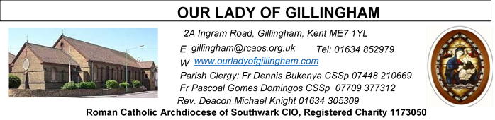 Office Hours – Tuesday, Wednesday & Friday - 10.30am – 1.30pm
26th April 2026
FOURTH SUNDAY of EASTER – Year A
Please Pray for Chris Milne†, Sarah Shannon†, Apolonia MacKenzie†, Bridget Hollingsworth† and Jo Firth† who have recently died; Also Pray for all those whose anniversaries occur about this time including: Thomas Rowley,
John McCann, Pasquale Rocco, John Cassidy, Derek Roach, Janet Breen, Josephine Knell, Eric Jones, Lina Welch, Laurence Turner, Doreen McCormick, Joele Wilcox,
Stefan Szemelak, Jane Liston, Lawrence Perris,
Elizabeth Crosby, William Hurley, Helen Smith, Lewis Lee, Peter Flynn and Giovanni Didonato.
May their souls, and all the souls of the faithful departed, rest in peace

Reading 1 | Acts 2:14a, 36-41 | God made him both Lord and  Christ
Psalm | Ps 22:1-6 r. 1 | The Lord is my shepherd; there  is nothing I shall want.  or Alleluia!
Reading 2 | 1 Pet 2:20b-25 | You have come back to the  shepherd of souls.
Gospel Acclamation | John 10:14 | I am the good shepherd, says  the Lord; I know my own sheep  and my own know me.
Gospel | John 10:1-10 | I am the gate of the sheepfold.

SATURDAY
Exposition of the Blessed Sacrament & Reconciliation
10.30am – 11.30am
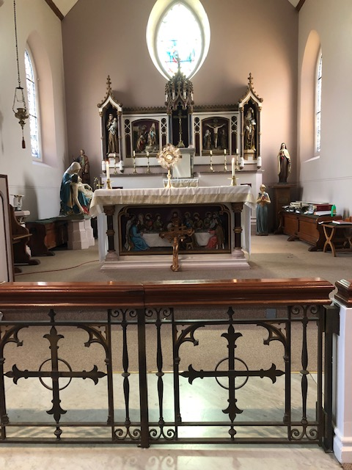
FRIDAY
Eucharistic Adoration
6.15pm – 7.20pm
Followed by
Holy Mass at 7.30pm

Readers this week:

Sat 6.30pm | Janette Alfayad, John Quilas, Kieran Shannon
Sun 9.30am | Vincent Obi, Chizoba Okeke, Gillian Knight
Sun 11.30am | Onyehialam Sisters, Dinah Kansiime
Sun 6.30pm | Victoria Shosanya, Anastasia Ebifa

Our Parish NOTICES
Collections this week:
CATEGORY | CASH (Loose) | GIFT AID | CONTACTLESS  Amount Gift Aid |  | TOTALS
Offertory | £591.92 | £172.01 | £295.00 | £42.50 | £1101.43
Second Collection | £163.48 |  | £65.00 | £13.75 | £242.23
Football Parking | £310.00 |  |  |  | £310.00

Second Collection THIS Sunday is for the Priest Training Fund.

Please use the QR code for your weekly offerings & second collections
FR PASCOAL’s ANNUAL RETREAT - Fr Pascoal will be away this week on his annual retreat.

PENTECOST SUNDAY - Sunday 24th May. The Church was founded on Pentecost. To bring the universality of our Church, we ask our parishioners who come from different nationalities to bring their national flags (small size) to the parish office next week for decoration purposes. Also, on Pentecost to wear their national/traditional attires. After 11.30pm Mass we shall celebrate together as a family of God with a parish meal. Hence, we appeal to parishioners to prepare, ‘bring and share meals’ of different types from the different nationalities and drinks. Those willing write your names on a sheet at back of the Church.
MINISTRY for the ELDERLY – Spring Dance – THANK YOU to everyone who came along & supported this event. It was a very enjoyable afternoon of food & socialising, entertainment & wonderful dancing by both Parishioners & Priests. A big THANK YOU to the amazing team of volunteers.
GIFT AID – Parishioners who have previously signed up to Gift Aid & pay their weekly offertory in cash using the gift aid envelopes, please collect your new box of envelopes from Dayle or the Office.

EASTER EGG RAFFLE – The OLoG SEEDS would like to thank everyone who supported their Easter Egg raffle. They raised £224.10 including donations, with a final profit of £194.51, after expenses. All proceeds will go towards future projects. Winning Numbers still to be collected are: (97) Udoki; (165) Anthony; (778) Ugochi Ihiona; (881) Grace; (22); (720) Celesta Therese; (597) Mayette.
PRE-LOVED SALE – Saturday 23rd May, 1pm until 3pm. There will be a sale of second hand/pre-loved items in the McMahon Hall. Come & have a browse & help to raise funds for the Church

Safeguarding Sunday 2026. Sunday 3rd May is Safeguarding Sunday. In line with today’s Gospel, we are called to protect, called to care, called to act. Safeguarding is not the work of a few; it is a shared responsibility. You can find out more about Safeguarding Sunday at rcaos.org.uk/safeguardingsunday or via the QR code.
DATES FOR YOUR DIARY
25th April | First Holy Communion Workshop in the McMahon Hall at 11.45am
25th April | Filipino Mass @ 1.30pm, followed by a gathering in the McMahon Hall from 3pm until 6pm
3rd May | Safeguarding Sunday – National Day of Prayer - details to follow
9th May | First Holy Communion Rehearsal at 11.45am in Church
14th May | The Ascension of the Lord
15th May | Novena for the Gifts of the Holy Spirit begins
16th May | FIRST HOLY COMMUNION SERVICE @ 12noon, followed by celebrations in the McMahon Hall.
24th May | Pentecost Sunday
AROUND THE CATHOLIC COMMUNITY
IGBO CATHOLIC MASS – (Today) Sunday 26th April @ 1pm at St Thomas of Canterbury Catholic Church, Rainham, ME8 7RH
TODAY - Good Shepherd Sunday – SUPPORT OUR FUTURE PRIESTS

The priesthood has always been at the heart of the Church. This Good Shepherd Sunday, we pray for vocations and support the Priest Training Fund, which forms men for service across our parishes, schools, hospitals, and communities. We currently have 9 seminarians, each costing around £30,000 per year over six years of formation. Your generosity helps make their calling possible.
- 👉 Donate online: www.rcaos.org.uk/donate/PTF
- 📞 Call: 020 7960 2504 (weekdays, 9am–5pm)
- 🙏 Or use the envelopes at the back of church
Leave a lasting legacy to the Church: www.rcaos.org.uk/donate/leave-a-legacy.

MISSIO AND THE MILL HILL MISSIONARIES invite all Red Box supporters and the wider Diocesan community to come together for two important events in 2026:
- St Simon Stock Church, Bleakwood Rd, Walderslade, Kent ME5 0NF on Saturday 6 June at 11am. Join Fr Joseph Donkor (Missio Diocesan Director for Southwark) and the Mill Hill Missionaries for Mass, followed by lunch and sharing of mission work.
- St Elizabeth of Portugal Roman Catholic Church, The Vineyard, Richmond TW10 6AQ on Saturday, 3rd October at 11am. Join us for this special World Mission month mass with Missio National Director, Fr Anthony Chantry MHM, and Fr Joseph Donkor.
Everyone is welcome to attend. Please email redbox@missio.org.uk or visit https://missio.org.uk/mission-masses-and-events/ for further information.
ROSARY FOR LIFE - Archbishop John Wilson is calling on all of us to join him in praying the Rosary for Life this May (Month of Mary). Together, we will pray through the Joyful, Sorrowful, Glorious and Luminous Mysteries, each one offered for the most vulnerable facing growing threats to life: unborn children at risk of abortion, victims of war and persecution, people with disabilities, and the elderly and vulnerable. For video, audio and written versions of the Rosary for Life, visit rcaos.org.uk/rosaryforlife. Pray the Rosary. Encounter Christ. Defend life.
MASS INTENTIONS FOR THE WEEK
Saturday (25th April)  Vigil | 10.00am  1.30pm  6.30pm | Repose of the souls of Clarence, Teresa & Carlton Aubert  EXPOSITION OF THE BLESSED SACRAMENT and RECONCILIATION  Filipino Mass  “For God’s Blessings & Grace upon the Elderly Parishioners”
Sunday (26th April) | 9.30am  11.30am  6.30pm | Repose of the soul of David Keating  Repose of the soul of Mary Jane Saunders  Pro Populo
Monday (27th April) | 10.00am | Repose of the soul of Jed NoHilly
Tuesday (28th April) | 10.00am | Health & Wellbeing of Dominique Cannavina
Wednesday (29th April)  St Catherine of Siena | 10.00am | Repose of the soul of Jed NoHilly
Thursday (30th April) | 10.00am | Good Health & Wellbeing of Gillian Knight
First Friday (1st May)  St Jospeh the Worker | 10.00am  6.15pm  7.30pm | Good Health & Wellbeing of Ann Formosa & family  Eucharistic Adoration  Intentions of the Keating Family
First Saturday  (2nd May)  St Athanasius  Vigil | 10.00am  10.30am  1.00pm  3.00pm  6.30pm | Birthday Thanksgiving for Bella Edeji  EXPOSITION OF THE BLESSED SACRAMENT and RECONCILIATION  Marriage Convalidation of Maria & Ernest  OLOG Seeds Young Adult Mass  Birthday Thanksgiving for Rose Mary Okeke
Sunday (26th April) | 9.30am  11.30am  6.30pm | Good Health & Wellbeing of Teresa Cottam  Thanksgiving for the Dadson Family  Pro Populo

Please ensure that, if you book a Mass via the contactless machine, you have booked your Mass Intention in the diary first. Mass Intentions require a £10 donation.

