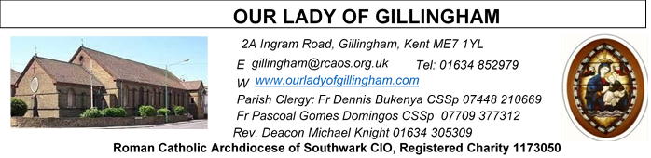
19th April 2026
THIRD SUNDAY of EASTER – Year A
Please Pray for Sarah Shannon†, Apolonia MacKenzie†, Bridget Hollingsworth† and Jo Firth† who have recently died;
Also Pray for all those whose anniversaries occur about this time including: David Savage, Tino Mosca, Beatrice Golding, John Larkin, Olga Martin, William Kinnear, Anthony Bunting, Ciaran Duffy, Jeremy Rafferty, Rosaleen Byrne, Canon Thomas McMahon, Michael Oweczko, Patricia Ward, Danny Lee, Nellie Moss, Allana Smith, Angeline Owen, Carmel Zarafa, John Cardwell and Lucia Pietrunti.
May their souls, and all the souls of the faithful departed, rest in peace

Readers this week:
Sat 6.30pm | Alyssa Mae Viernes  Lucy  Imelda Cervantes
Sun 9.30am | Tania Jackson  Uhuegbu Sisters
Sun 11.30am | Shakira Kara  Chelsea Atoe  Kathleen Kara
Sun 6.30pm | Daniella Ibeh  Frances Okafor

Readers next week:
Sat 6.30pm | Janette Alfayad  John Quilas  Kieran Shannon
Sun 9.30am | Vincent Obi  Chizoba Okeke  Gillian Knight
Sun 11.30am | Onyehialam Sisters  Dinah Kansiime
Sun 6.30pm | Victoria Shosanya  Anastasia Ebifa

SATURDAY
Exposition of the Blessed Sacrament & Reconciliation
10.30am – 11.30am
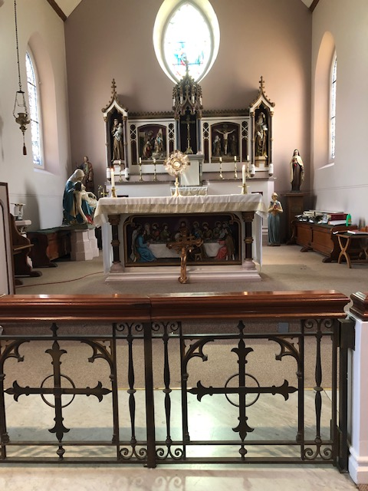
Reading 1 | Acts 2:14, 22-33 | It was impossible for him to be  held in the power of Hades.
Psalm | Ps 16:1-2. 5, 7-11 r. 11 | Show us, Lord, the path of life.  or Alleluia!
Reading 2 | 1 Pet 1:17-21 | Your ransom was paid in the  precious blood of a lamb without  spot or stain, namely, Christ.
Gospel Acclamation | Luke 24:32 | Lord Jesus, explain the scriptures  to us. Make our hearts burn within us as you  talk to us.
Gospel | Luke 24:13-35 | They recognised him at the  breaking of bread.

FRIDAY
Eucharistic Adoration
6.15pm – 7.20pm
Followed by
Holy Mass at 7.30pm

Our Parish NOTICES
Office Hours – Tuesday, Wednesday & Friday - 10.30am – 1.30pm
Collections this week:
CATEGORY | CASH (Loose) | GIFT AID | CONTACTLESS  Amount Gift Aid |  | TOTALS
Offertory | £439.35 | £91.00 | £422.00 | £55.00 | £1007.35
Football Parking | £260.00 |  |  |  | £260.00

Second Collection THIS Sunday for Maintenance of St George’s Cathedral.
Second Collection NEXT Sunday is for the Priest Training Fund
Please use the QR code for your weekly offerings & second collections
EASTER EGG RAFFLE – The OLoG SEEDS would like to thank everyone who supported their Easter Egg raffle. They raised £224.10 including donations, with a final profit of £194.51, after expenses. All proceeds will go towards future projects. Winning Numbers are: 1st (518) Laarni; 2nd (32) Gloria Bergin; 3rd (97) Udoki; 4th (165) Anthony; 5th (778) Ugochi Ihiona; 6th (881) Grace; 7th (22) Gloria Bergin; 8th (720) Celesta Therese; 9th (421) Laarni; 10th (597) Mayette.
Please bring your winning raffle ticket to the Presbytery to collect your prize.

EASTER PAINTING & PHOTO COMPETITION – There are two competitions on offer to all young people aged between 7yrs & 18yrs. Entries will be split into 3 different age categories: 7-11yrs; 11-14yrs; 14-18yrs. Closing date for the Painting Competition is Sunday 19th April & for the Photo Competition is Monday 20th April. Please see the Posters at the back of the Church for entry details.
MINISTRY FOR THE ELDERLY – SPRING DANCE – TODAY Sunday 19th April 2026 at 2pm. Parishioners aged 70+ are invited to join Fr Dennis in the McMahon Hall, for a ‘chat & a cuppa’, and some light entertainment.
GIFT AID – Parishioners who have previously signed up to Gift Aid & pay their weekly offertory in cash using the gift aid envelopes, please collect your new box of envelopes from Dayle or the Office.
DATES FOR YOUR DIARY

25th April | First Holy Communion Workshop in the McMahon Hall at 11.45am
25th April | Filipino Mass @ 1.30pm, followed by a gathering in the McMahon Hall from 3pm until 6pm
3rd May | Safeguarding Sunday – National Day of Prayer - details to follow
9th May | First Holy Communion Rehearsal at 11.45am in Church
16th May | FIRST HOLY COMMUNION SERVICE @ 12noon, followed by celebrations in the McMahon Hall.
AROUND THE CATHOLIC COMMUNITY
IGBO CATHOLIC MASS – Sunday 26th April @ 1pm at St Thomas of Canterbury Catholic Church, Rainham, ME8 7RH
NEXT SUNDAY - Good Shepherd Sunday – SUPPORT OUR FUTURE PRIESTS

The priesthood has always been at the heart of the Church. This Good Shepherd Sunday, we pray for vocations and support the Priest Training Fund, which forms men for service across our parishes, schools, hospitals, and communities. We currently have 9 seminarians, each costing around £30,000 per year over six years of formation. Your generosity helps make their calling possible.
- 👉 Donate online: www.rcaos.org.uk/donate/PTF
- 📞 Call: 020 7960 2504 (weekdays, 9am–5pm)
- 🙏 Or use the envelopes at the back of church
Leave a lasting legacy to the Church: www.rcaos.org.uk/donate/leave-a-legacy.
SUMMER CELEBRATION OF ST JUDE – Saturday 30th May – 11.00am
In the grounds of the Carmelite Shrine of St Jude, 34 Tanners Street, Faversham.
This will be a lovely occasion when we can, usually, celebrate Mass outside in the sunshine, followed by a procession past the Shrine of Saint Jude. We also have an opportunity for pilgrims to be anointed with Saint Jude oil. You are welcome to attend as a Parish Pilgrimage or individually. Groups larger than 30+ should notify the Shrine Office in advance: shrineoffice@stjudeshrine.org. Refreshments will be provided throughout the day. Programme for the day: 11.00am Devotions with Anointing; 13.30 Open Air Mass; 14.30 Processions past the Shrine of Saint Jude.

CATHOLIC ASSOCIATION’S 125th ANNIVERSARY OF PILGRIMAGES TO LOURDES - 21- 28TH August 2026
The Catholic Association Pilgrimage (CA) is responsible for coordinating the welcome and care of many pilgrims including our ‘assisted pilgrims’ - those on our annual pilgrimage to Lourdes who have particular care and support needs.
The CA pilgrimage is medically supported. The all-round care the CA team can provide means that we can support pilgrims in ways which are rarely possible.
Assisted Pilgrims can choose to stay in either a hotel with some basic support given by volunteer helpers (such as wheelchair assistance in getting around town or to services), or in the Accueil Notre Dame, where medical and personal care is provided. We have the opportunity for our assisted pilgrims to travel via a Jumbulance or by air.
Volunteer Helpers of all ages and backgrounds come to Lourdes as volunteer helpers to answer Our Lady’s request to ‘come in procession’. The minimum age for helping is 16 and there is no maximum age. If you are aged 16-25, you can be a part of the Young Helpers’ Group. Financial support may be available through your Diocesan/Group Director or the CA. For more information email: register@catholicassociation.co.uk or call: 07537 183321,

PILGRIMAGE TO MEDJUGORJE with FATHER GODWIN – 23-26 October 2026
Return Flight to Croatia (15kg bag included). Coach to Bosnia, Medjugorje to visit our Blessed Mother. Half board accommodation & travel guide included. Cost £480 (shared basis) Single Supplement £580. For more information contact Vincent Sexton on 07503 122313
MASS INTENTIONS FOR THE WEEK

Saturday (18th April)  Vigil | 10.00am  6.30pm | Repose of the soul of Eleuterio Sequeira  EXPOSITION OF THE BLESSED SACRAMENT and RECONCILIATION  Repose of the soul of Jean Babbington
Sunday (19th April) | 9.30am  11.30am  6.30pm | Repose of the soul of Irene Alvares  Repose of the soul of Roberto Galendez  Pro Populo
Monday (20th April) | 10.00am | Repose of the soul of Patrick Walsh
Tuesday (21st April)  Saint Anselm | 10.00am | Repose of the soul of Ciaran Duffy
Wednesday (22nd April) | 10.00am | Repose of the souls of Aubrey & Mary Jamieson
Thursday (23rd April)  Saint George | 10.00am | Repose of the soul of Canon Thomas McMahon
Friday (24th April) | 10.00am  6.15pm  7.30pm | Repose of the soul of Rosaleen Byrne  Eucharistic Adoration  Repose of the soul of John Larkin
Saturday (25th April)  Saint Mark  Vigil | 10.00am  10.30am  1.30pm  6.30pm | Repose of the souls of Clarence, Teresa & Carlton Aubert  EXPOSITION OF THE BLESSED SACRAMENT and RECONCILIATION  Filipino Mass  “For God’s Blessings & Grace upon the Elderly Parishioners”
Sunday (26th April) | 9.30am  11.30am  6.30pm | Repose of the soul of David Keating  Repose of the soul of Mary Jane Saunders  Pro Populo

Please ensure that, if you book a Mass via the contactless machine, you have booked your Mass Intention in the diary first. Mass Intentions require a £10 donation.

