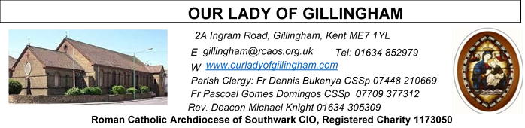
12th April 2026
DIVINE MERCY SUNDAY – Year A
Readers this week:
Sat 6.30pm | Sandana Family
Sun 9.30am | Edeji Sisters
Sun 11.30am | Dominic Gali  Olivia Gali  Samuel Robson
Sun 6.30pm | Uche Family

Sun  9.30am | Uhuegbu Family  Tania Jackson
Sun  11.30am | Chelsea Atoa  Kara Family
Sun  6.30pm | Frances Okafor  Daniela Ibeh  Joan Aruma

FRIDAY
Eucharistic Adoration
6.15pm – 6.55pm
Followed by Stations of the Cross at 7pm and Holy Mass at 7.30pm
Please Pray for Apolonia MacKenzie†, Bridget Hollingsworth†, Jo Firth†, and Pauline Ketchen†, who have recently died;
Also Pray for all those whose anniversaries occur about this time including: Carmen Buttigies, Joan Staples, Christopher McLaughlin, Antonio Cilloni, Agatha Winers, Vera Leslice, Martina Thomas, Ruth Caulfield, Lloyd Albert, Maria Finlay, Elizabeth Clark, Mary Harewood, Kathleen Timson, Rose Mullan, John Nesbit, Patrick Ryan and Margaret Enright.
May their souls, and all the souls of the faithful departed, rest in peace

SATURDAY
Exposition of the Blessed Sacrament & Reconciliation
10.30am – 11.30am
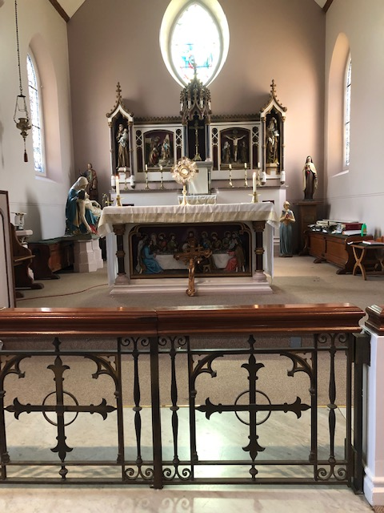
Readers next week:
Sat 6.30pm | Alyssa Mae Viernes  Lucy  Imelda Cervantes
Sun 9.30am | Tania Jackson  Uhuegbu Sisters
Sun 11.30am | Shakira Kara  Chelsea Atoe  Kathleen Kara
Sun 6.30pm | Daniella Ibeh  Frances Okafor

Reading 1 | Acts 2:42-47 | The faithful all lived together and  owned everything in common.
Psalm | Ps 117:2-4, 13-15, 22-24 r.1 | Give thanks to the Lord for he is  good, for his love has no end  or Alleluia, alleluia, alleluia!
Reading 2 | 1 Pet 1:3-9 | In his great mercy he has given us a  new birth as his sons by raising  Jesus from the dead.
Gospel Acclamation | John 20:29 | Jesus said: 'You believe because  you can see me. Happy are those  who have not seen and yet believe.'
Gospel | John 20:19-31 | Eight days later, Jesus came.

Our Parish NOTICES
Office Hours – Tuesday, Wednesday & Friday - 10.30am – 1.30pm
Collections this week:
CATEGORY | CASH (Loose) | GIFT AID | CONTACTLESS  Amount Gift Aid |  | TOTALS
Offertory | £2376.33 | £426.00 | £878.00 | £137.50 | £3817.83
Good Friday for Holy Land Places | £703.67 |  | £15.00 |  | £718.67

Second Collection THIS week is for the Maintenance of St George’s Cathedral

Second Collection NEXT Sunday for the Poor Parishes, which enables the Archdiocese to offer grants to the Poorer Parishes in the diocese.
Please use the QR code for your weekly offerings & second collections

EASTER OFFERING ENVELOPES – Thank you for your very generous donations to Fr Dennis & Fr Pascoal. The Easter collection amounted to £3254.33
EASTER EGG RAFFLE – The OLoG SEEDS have drawn the Easter Egg Raffle. Winning Numbers are: 1st (518); 2nd (32); 3rd (97); 4th (165); 5th (778); 6th (881); 7th (22); 8th (720); 9th (421); 10th (597)
Please bring your winning raffle ticket to the Presbytery to collect your prize.

EASTER PAINTING & PHOTO COMPETITION – There are two competitions on offer to all young people aged between 7yrs & 18yrs. Entries will be split into 3 different age categories: 7-11yrs; 11-14yrs; 14-18yrs. Closing date for the Painting Competition is Sunday 19th April & for the Photo Competition is Monday 20th April. Please see the Posters at the back of the Church for entry details.
MINISTRY FOR THE ELDERLY – SPRING DANCE – Sunday 19th April 2026 at 2pm. Parishioners aged 70+ are invited to join Fr Dennis in the McMahon Hall, for a ‘chat & a cuppa’, and some light entertainment. Refreshments will be provided. A letter & invitation have been distributed either via email or post/hand delivered. Please RSVP, so we know how many are attending. You are welcome to bring a ‘plus one’ or support person for assistance. If you haven’t received an invitation or haven’t registered with the Parish & would like to attend, please leave your name, address, phone number & email address (if applicable) with the Parish Secretary in the Office.
GIFT AID – All Parishioners who have previously signed up to Gift Aid, please collect your new box of envelopes from Dayle or the Office.

DATES FOR YOUR DIARY

19th April | Ministry for the Elderly – Spring Dance – McMahon Hall at 2pm
25th April | First Holy Communion Workshop in the McMahon Hall at 11.45am
25th April | Filipino Mass @ 1.30pm, followed by a gathering in the McMahon Hall from 3pm until 6pm
AROUND THE CATHOLIC COMMUNITY

Mass in Celebration of the Sacrament of Marriage - 11th July @ St George’s Cathedral: If you are celebrating your 1st/10th/25th/40th/50th/60th + wedding anniversary this year, please let us know as soon as possible, and no later than the middle of May, providing the following details: your names in the format “John and Mary Smith”; your home address; your parish; and the anniversary you are celebrating. You will be sent an invitation from the Archbishop for the renewal of vows during Mass. Contact us at mflkent@rcaos.org.uk The title of your email, please write your parish location e.g. Tenterden, Gillingham.
VOCATIONS WEEKEND FOR WOMEN (20s/30s) -DISCERNING GOD'S CALL IN YOUR LIFE - 15th - 17th May, Liverpool
The weekend is organised by the Sisters, Faithful Companions of Jesus (FCJ).
Jesus invites each of us to 'Come and See' - this weekend will give the opportunity to explore the vocation to religious life and to reflect on God's call to you. If you are wondering if God is calling you to religious life and would like to find out more why not come along? There will be opportunity for prayer, reflection and input, chance to live alongside the religious community and to ask questions and to meet others who are also wondering where God is calling them.
For more information contact Sr Lynne fcJ at fcjvocationeurope@gmail.com or visit our website www.fcjsisters.org To register: https://bit.ly/Vocation2026

MARRIAGE CARE: Would you like train in relationship counselling and provide couples with professional, effective support, that makes a real difference? Marriage Care’s next Certificate in Relationship Counselling (CRC) training course will begin in March 2027,the deadline for applications is 30th June. Please note that there are costs associated with training on the CRC, including a non-refundable registration fee of around £175. These costs, which are outlined on their website.
Marriage Care are looking for those who are empathetic, understanding and have an enthusiasm for supporting adult relationships. Whilst you do not need experience as a counsellor for this role, self-awareness and having the time and space to commit to all that the training and role entails is essential.
For more information please visit: www.marriagecare.org.uk or email: volunteer@marriagecare.org.uk

PILGRIMAGE TO MEDJUGORJE with FATHER GODWIN – 23-26 October 2026
Return Flight to Croatia (15kg bag included). Coach to Bosnia, Medjugorje to visit our Blessed Mother. Half board accommodation & travel guide included. Cost £480 (shared basis) Single Supplement £580. For more information contact Vincent Sexton on 07503 122313
MASS INTENTIONS FOR THE WEEK
Saturday (11th April)  Vigil | 9.40am  10.00am  1.30pm  6.30pm | Day 9 – Closing of the Divine Mercy Novena  Repose of the souls of Clarence, Teresa & Carlton Aubert  Nuptial Mass for Chison & Cynthia  Pro Populo &  Repose of the soul of Ebubechukwu Ihionu
Divine Mercy Sunday – Chaplet of Divine Mercy (15mins prior to each Mass)
Sunday (12th April)  Divine Mercy Sunday | 9.30am  11.30am  6.30pm | Repose of the soul of Apolonia MacKenzie  Special Intentions for all Priests & Vocations  Repose of the soul of Ebubechukwu Ihionu
Monday (13th April) | 10.00am | Birthday Thanksgiving for Stephen Cottam
Tuesday (14th April) | 10.00am | Good Health & Wellbeing of Dominique Cannavina
Wednesday (15th April) | 10.00am | Repose of the soul of David Potter
Thursday (16th April) | 10.00am | For Souls in Purgatory
Friday (17th April) | 10.00am  6.15pm  7.30pm | Repose of the soul of Apolonia McKenzie  Adoration of the Blessed Sacrament  Repose of the soul of Patrick Bishop
Saturday (18th April)  Vigil | 10.00am  10.30am  6.30pm | Repose of the soul of Eleuterio Sequeira  EXPOSITION OF THE BLESSED SACRAMENT and RECONCILIATION  Repose of the soul of Jean Babbington
Sunday (19th April) | 9.30am  11.30am  6.30pm | Repose of the soul of Irene Alvares  Repose of the soul of Roberto Galendez  Pro Populo

Please ensure that, if you book a Mass via the contactless machine, you have booked your Mass Intention in the diary first. Mass Intentions require a £10 donation.

