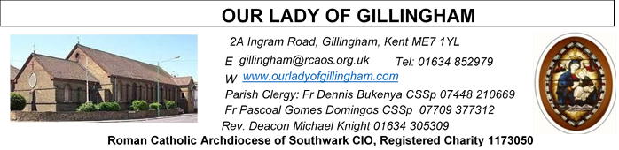
22nd MARCH 2026
Fifth Sunday of Lent – Year A
Please Pray for Apolonia MacKenzie†, Bridget Hollingsworth†, Pauline Ketchen†, Jo Firth†, Mary Eason† and Clarice Moca G.Domingos†, who have recently died;
Also Pray for all those whose anniversaries occur about this time including: Grace Fingleton, Francesco Verdolini, Lorna Ryan, Fr Pierre Barbyer, Kathleen Mary, Martin (Pat) Knell,
George Bond, Brenda Corcoran, Doreen Stone, Leo Ross, William Banks, Ivy McCann and Tammy Dickie.
May their souls, and all the souls of the faithful departed, rest in peace

Readers this week:
Sat  6.30pm | Crystabelle  Imelda Cervantes  Kieran Shannon
Sun 9.30am | Tania Jackson  Uhuegbu Sisters
Sun 11.30am | Kara Family  Chelsea Atoe
Sun 6.30pm | Daniella Ibeh  Frances Okafor

Sun  9.30am | Uhuegbu Family  Tania Jackson
Sun  11.30am | Chelsea Atoa  Kara Family
Sun  6.30pm | Frances Okafor  Daniela Ibeh  Joan Aruma

Readers
Weds 25th March:
10.00am
Jim Spencer
Ann Williams
7.30pm
Laarni Fajardo
Akhebai Tegha

Readers Next week:
Sat  6.30pm | Gabriel Concepcion  Oliver Perez  Laarni Fajardo
Sun 9.30am | Vincent Obi  Chizoba Okeke  Gillian Knight
Sun 11.30am | Onyehialam Sisters  Dinah Kansiime
Sun 6.30pm | Victoria Shosanya  Anastasia Ebifa

Sun  9.30am | Uhuegbu Family  Tania Jackson
Sun  11.30am | Chelsea Atoa  Kara Family
Sun  6.30pm | Frances Okafor  Daniela Ibeh  Joan Aruma

SATURDAY
Exposition of the Blessed Sacrament & Reconciliation
10.30am – 11.30am 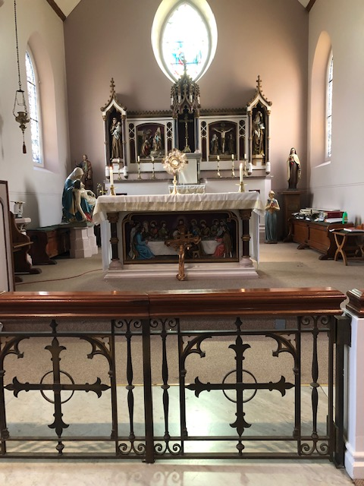
FRIDAY
Exposition of the Blessed Sacrament
6.15pm – 6.55pm
Followed by Stations of the Cross at 7pm and
Holy Mass at 7.30pm

Reading 1 | Ezek 37:12-14 | I shall put my spirit in you, and  you will live.
Psalm | Ps 129 r. 7 | With the Lord there is mercy  And fullness of redemption.
Reading 2 | Rom 8:8-11 | The Spirit of him who raised  Jesus from the dead is living in  you.
Gospel Acclamation | John 11: 25-26 | I am the resurrection and the life, says the  Lord, whoever believes in me  will never die.
Gospel | John 11:1-45 | I am the resurrection and the life.

Our Parish NOTICES
Office Hours – Tuesday, Wednesday & Friday - 10.30am – 1.30pm
Collections this week:
CATEGORY | CASH (Loose) | GIFT AID | CONTACTLESS  Amount Gift Aid |  | TOTALS
Offertory | £870.76 | £131.05 | £375.00 | £42.25 | £1419.06
Retiring Collection  (Fr Joseph) | £299.54 |  | £130 | - | £429.54
Football Parking | £175.00 |  |  |  | £175.00

Please use the QR code for your weekly offerings & second collections

MY PARISH COMMITMENT – PLANNED GIVING APPEAL ..
As you will be aware, we have been running a planned giving drive over the last two weeks. First weekend we reflected on how we are each uniquely called to exercised Stewardship of our God-given gifts of Time, Treasure & Talents, investing and sharing these with those around us in the best way to give glory to God. Our parish is one of the gifts we have received, thanks to the generosity of those who went before us. Last week your fellow parishioners, on the finance committee, shared with you some of the ways in which our parish needs help to ensure our parish continues to flourish and is handed on to future generations in even better condition than we received it. This week, you will all have the opportunity to put your decisions into practise by completing a form – each household will be handed one.
Please take a form even if you are already a planned giver and gift aider in the parish. This is because this is a parish-wide renewal, so it is important for each one of us to reflect on our blessings and pray about our Stewardship of this parish. This form will also ensure your contact details and Gift Aid details are up-to-date which is very important for parish records.

Additionally, over the last few weeks you will have heard us talk about stewardship, and the concept of sharing our gifts of time and talent.
Once you have finished completing the offertory pledge form, please turn to the volunteer sign-up form. Here you will see there is the opportunity to sign up to a variety of volunteering opportunities in the parish. We shall contact you in the coming weeks to provide you with more information. I welcome you to mention if you have any other talents that could be of use to us as a parish community.
REQUIEM MASS of Apolonia MacKenzie will take place on Monday 30th March 2026 at 12noon, followed by her burial at Woodlands Cemetery.

EASTER EGG RAFFLE – The OLoG SEEDS are holding an Easter Egg Raffle. £1 per strip of tickets, which will be on sale after Mass. Please support our Young Parishioners.

DATES FOR YOUR DIARY

Wednesday  25th March | THE ANNUNCIATION OF THE LORD (Holy Day of Obligation) Masses will be held at 10.00am & 7.30pm
28th March | Filipino Mass at 12noon followed by a gathering in the McMahon Hall from 2pm until 5pm
Evening of 28th March – clocks go FORWARD by 1 hour
29th March | PALM SUNDAY OF THE PASSION OF THE LORD
Lenten Spiritual Programme
LENTEN REFLECTION - Lord make me a good steward so that through my Lenten observance, I respond to your invitation to praying, fasting and almsgiving. Enrich me with the spirit, love, sharing and reconciliation.
Mondays | Stations of the Cross at 10.30am after morning mass
Fridays | Private meditation & exposition of the Blessed Sacrament 6.15-6.55pm
Fridays | Stations of the Cross at 7pm before evening Mass
Saturdays | Exposition of Blessed Sacrament and Confession at 10.30am
AROUND THE CATHOLIC COMMUNITY
PRAY THE ROMERO ROSARY AT ST GEORGE’S CATHEDRAL. Join Archbishop John Wilson and the Cathedral clergy in praying the rosary every Friday at 5pm throughout Lent. This is a beautiful opportunity to draw closer to the Lord Jesus in prayer. Archbishop John will personally lead the devotion at the National Shrine of St Oscar Romero at St George’s Cathedral (SE1 6HR) on Friday 6th and Friday 27th March at 5pm. On all other Fridays during Lent, the Cathedral clergy will lead the rosary, followed by the Stations of the Cross at 6pm. Let the rosary connect you to the Lord Jesus this Lenten season. Find out more at: rcaos.org.uk/romerorosary
DIOCESAN PILGRIMAGE TO LOURDES – 21st to 28th August 2026
I warmly invite you to join me on this year’s SOUTHWARK DIOCESAN PILGRIMAGE TO LOURDES. A pilgrimage is a great opportunity to refresh and renew our relationship with the Lord Jesus, with the help of Our Lady’s prayers. I have also found it a blessing to be able to accompany and to be inspired by other pilgrims, some of whom are sick, elderly or disabled. Details for booking travel and accommodation: https://www.tangney-tours.com/diocese-pilgrimages/diocese-ca/
We also ask pilgrims to complete a form with details, including medical requirements (if any) at https://www.catholicassociation.co.uk/join2026
For more information, please contact Canon Edward Perera (edwardperera@rcaos.org.uk) or Deacon John Fogarty (johnfogarty@rcaos.org.uk) or myself, Bishop Paul Hendricks (paulhendricks@rcaos.org.uk)
FORMING CATHOLIC STUDENT LEADERS - Two summer courses exploring faith, ethics and leadership for sixth form students, offered by the Christian Heritage Centre at Stonyhurst: (1) Join us for 6 days in the beautiful Ribble Valley to explore themes linked to The Common Good (Year 12, 10-15 August);
(2) The Human Ecology (Year 13, 5-10 July). Meet new friends, discuss and share with peers, tutors and academics, learn new skills, develop your relationship with Christ, build your character.
For more details: www.christianleadershipformation.com

MASS INTENTIONS FOR THE WEEK

Saturday (21st Mar) | 6.30pm | Pro Populo
Sunday (22nd Mar)  Fifth Sunday of Lent | 9.30am  11.30am  6.30pm | Healing & Spiritual Welfare of Ian Parmenter  Repose of the soul of Samuel Odoom  Repose of the soul of Frank Hanham
Monday (23rd Mar) | 10.00am  10.30am | Repose of the soul of Junie Tomias  Stations of the Cross
Tuesday (24th Mar) | 10.00am | Repose of the soul of Yvonne Durkan
Wednesday (25th Mar)  The Annunciation of the Lord | 10.00am  7.30pm | Repose of the soul of Junie Tomias  Good Health & Wellbeing of Dominique Cannavina
Thursday (26th Mar) | 10.00am | Thanksgiving Intention for Varghese Sebastian & Family
Friday (27th Mar) | 10.00am  6.15pm  7.00pm  7.30pm | Repose of the soul of Pauline Ketchen  EXPOSITION OF THE BLESSED SACRAMENT  Stations of the Cross  Thanksgiving Intentions for Mrs Moni Adebiyi
Saturday (28th Mar)  Vigil | 10.00am  10.30am  12noon  6.30pm | Repose of the soul of Junie Tomias  EXPOSITION OF THE BLESSED SACRAMENT and RECONCILIATION  Filipino Mass  “For God’s Blessings & Grace upon the Elderly Parishioners”
Sunday (29th Mar)  Palm Sunday of the Passion of the Lord | 9.30am  11.30am  6.30pm | Repose of the soul of the Selvaraj Family  Pro Populo  Repose of the soul of Tony Phillips

MASS INTENTIONS – Please ensure, when paying via Contactless, that your Intention has been entered into the diary & include the Intention date in the ‘message’ section on the Contactless device. Mass Intentions are £10.00

