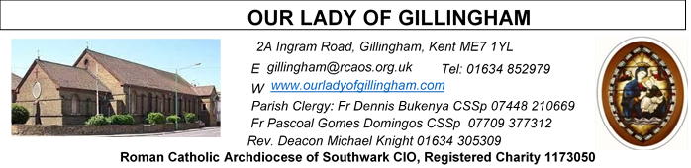
25 JANUARY 2026
Third Sunday in Ordinary Time – YEAR A
SATURDAY
Exposition of the Blessed Sacrament & Reconciliation
10.30am – 11.30am 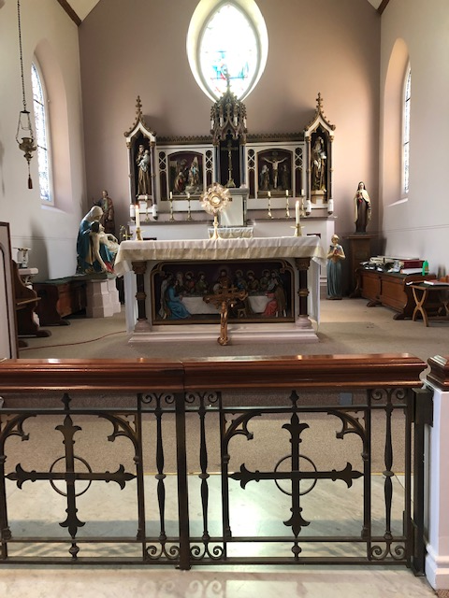
Please Pray for Jo Firth, Mary Eason, Ancy John Kumar, Luna Webster, baby Blake Moon who have recently died;
And also Pray for all those whose anniversaries occur about this time including: Thomas Macken,
John Gordon, Michael Connolly, Margaret King,
Olive Lewis, Andrew Campbell, Michael Jessup, Roy Batt, Horace Haslam, Patrick Kennedy, Ivy Dias & Honorah Hubbert.
May their souls, and all the souls of the faithful departed, rest in peace

Readers this week:
Sat  6.30pm | Gabriel Concepcion  Juan Jupit Quilas  Kieran Shannon
Sun 9.30am | Ann Williams  Akhebai Tegha  Sharon Chinwuba
Sun 11.30am | Chelsea Atoe  Anastasia Ebifa  Dinah Kansiime
Sun 6.30pm | Sandana Family

Sun  9.30am | Uhuegbu Family  Tania Jackson
Sun  11.30am | Chelsea Atoa  Kara Family
Sun  6.30pm | Frances Okafor  Daniela Ibeh  Joan Aruma

Reading 1 | Isa 8:23b–9:3 | In Galilee of the nations the  people have seen a great  light.
Psalm | Ps 26:1. 4.  13-14 r. 1 | The Lord is my light and my  help.
Reading 2 | 1 Cor 1:10-13, 17 | Make up the differences  between you instead of  disagreeing among  yourselves.
Gospel Acclamation | Matt 4:23 | Jesus proclaimed the Good  News of the kingdom, and  cured all kinds of sickness  among the people.
 | Matt 4:12-23 | He went and settled in  Capernaum: in this way the  prophecy of Isaiah was to be  fulfilled.
Gospel | Matt 4:12-17 | He went and settled in  Capernaum: in this way the  prophecy of Isaiah was to be  fulfilled.

FRIDAY
Eucharistic Adoration
6.15pm – 7.20pm
Followed by Holy Mass at 7.30pm
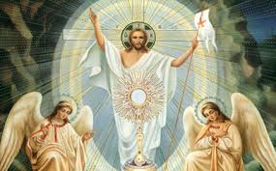
Our Parish NOTICES
Office Hours – Tuesday, Wednesday & Friday - 10.30am – 1.30pm
Collections this week:
CATEGORY | CASH (Loose) | GIFT AID | CONTACTLESS  Amount Gift  Aid |  | TOTALS
Offertory | £504.40 | £64.00 | £346.00 | £30.50 | £944.90
Second Collection  (Pax Christi) | £171.40 | - | £86.00 | £18.75 | £276.15
Football Parking | £280.00 | - | - | - | £280.00

Retiring Collection THIS WEEK for St George’s Cathedral

Please use the QR code for your weekly offerings & second collections
LEGION OF MARY – Would you like to become a Member?
You are invited to join the Legion of Mary in our Parish. The Catholic lay faithful serving the person of Jesus Christ under the leadership of Mary, Queen and Mother. If you are interested, please speak to Deacon Michael or call 07412859763 for more information.
KNIGHTS OF ST COLUMBA – ALMA MATER FUND
The Alma Mater fund is an initiative by the Society for the Protection of Unborn Children. It provides financial Grants to University students across the UK who are
Facing crisis pregnancies, helping them to continue pursuing their academic and personal goals. To date, the fund has provided Grants to over 90 students and
Is currently experiencing unprecedented demand. This is why the Knights have chosen to support this initiative as our National Action project until 2026. There is a poster at the back of the Church for further information & details of how to donate.
CARETAKER VACANCY – Our Lady of Gillingham STILL NEEDS YOU. Do you have strong DIY & cleaning skills; a flexible approach; problem-solving skills and an ability to work under pressure? The Caretaker position will become vacant at the end of December, and therefore we require a new person for the role, to start as soon as possible. For further information, please speak with Fr Dennis.
To apply, please send your CV to hr@rcaos.org.uk
DATES FOR YOUR DIARY

31st Jan | First Holy Communion class “Chapter 2”. Please meet in the McMahon  Hall, from 11.45am until 12.45pm
31st Jan | Marriage Preparation with Deacon Michael. Please meet in the  McMahon Hall, from 1pm until 3.15pm
31st Jan | Filipino Mass at 1pm followed by a Gathering in the McMahon Hall, from 3.30pm. Everyone is welcome.

AROUND THE CATHOLIC COMMUNITY

ST GEORGE’S CATHEDRAL SECOND COLLECTION THIS WEEKEND
For over half a century, St George’s Cathedral has been the Mother Church of the Archdiocese of Southwark, home to 175 parishes and over 50,000 Roman Catholics. For many Catholics living and working across London and the South East of England, St George’s has been a beacon of light.
Today, St George’s Cathedral continues to attract thousands of worshippers and visitors each year. The Cathedral frequently hosts important Diocesan and national celebrations, as well as concerts and events for various Catholic charities. There is a rich musical tradition, maintaining a choir of boys and men, as well as a girls’ choir, both of which sing at Sunday Masses and on major feasts.

St George’s Cathedral is entirely reliant upon the generosity of its parishioners, volunteers and the Archdiocese of Southwark to keep its doors open. It does not receive Vatican or government funding, nor has an endowment to rely on. Your support can enable the Cathedral to remain open daily to those seeking a place of peace, prayer and worship.
- Donate Online: www.rcaos.org.uk/Cathedral
- Or Scan QR Code using telephone camera (right)
- Cash / Cheque – please use the St George’s Cathedral envelopes.
RACIAL JUSTICE SUNDAY – 1st February 2026
Archbishop John Wilson will celebrate Mass for Racial Justice Sunday at St George’s Cathedral on Sunday 1 February 2026, at the 10am Mass.
Racial Justice Sunday is a time for the Church to pray, reflect and take action against racism, while celebrating the diversity of our Archdiocese. Everyone is invited to take part, and those who wish may wear national or cultural dress as a sign of unity and pride. After Mass, all are welcome to gather in Amigo Hall for refreshments — a chance to meet one another, share experiences and continue the conversation about faith and inclusion. You are warmly encouraged to attend in person, but if you cannot make it you can watch the livestream through the following link: https://www.youtube.com/live/fdmGwmESSgI

THE GOOD COUNSEL BLACK TIE BALL will take place at 6pm on St Valentine’s Day, Saturday 14th February 2026 in Kensington, London. Live Band. Silent Auction. London’s Catholic Pro-Life Ball raising money to help save lives and change lives. Tickets £135 each. Or a table of ten for £1,300. For bookings and enquiries email GCNBall@gmail.com or telephone 07795205117
RETROUVAILLE - LAST CALL for online marriage programme.
Does your marriage need some TLC? Need help with communication and trust? Retrouvaille helps marriages. It can bring hope and healing to relationships.
Next date: 12th February 2026.
www.retrouvaille.org.uk Tel: 07887 296983

MASS INTENTIONS FOR THE WEEK

Saturday (24th January)  Vigil Mass | 10.00am  10.30am  6.30pm | Repose of the soul of Harold Hopper  EXPOSITION OF THE BLESSED SACRAMENT and RECONCILIATION  Pro Populo
Sunday (25th January) | 9.30am  11.30am  6.30pm | Repose of the soul of Mary & Aubrey Jamieson  100th Birthday Thanksgiving for Kathleen Simmonds  Repose of the soul of Teresa Carroll Snr
Monday (26th January)  Saints Timothy & Titus | 10.00am | Repose of the soul of Patricia Ada Osakwe
Tuesday (27th January) | 10.00am | Repose of the soul of Andrew Shirley
Wednesday (28th January)  Saint Thomas Aquinas | 10.00am | Repose of the soul of Joyce Alley
Thursday (29th January) | 10.00am | Repose of the soul of Jo Firth
Friday (30th January) | 10.00am  6.15pm  7.30pm | Wellbeing of Philip and John Croft  ADORATION  Repose of the soul of Tony Phillips
Saturday (31st January)  Saint John Bosco  Vigil | 10.00am  10.30am  1pm  6.30pm | Repose of the soul of Mary Mahoney  EXPOSITION OF THE BLESSED SACRAMENT and RECONCILIATION  Filipino Mass  For God’s Blessings & Grace upon the Elderly Parishioners
First Sunday (1st February) | 9.30am  11.30am  6.30pm | Repose of the soul of Jo Firth  Repose of the soul of Declan Gavin  Pro Populo

MASS INTENTIONS – Please ensure, when paying via Contactless, that your Intention has been entered into the diary & include the Intention date in the ‘message’ section on the Contactless device. Mass Intentions are £10.00

