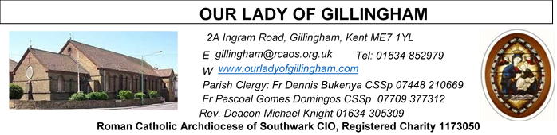
22nd FEBRUARY 2026
First Sunday of Lent – Year A
FRIDAY
Eucharistic Adoration
6.15pm – 6.55pm
Followed by Stations of the Cross at 7pm and
Holy Mass at 7.30pm

Reading 1 | Gen 2:7-9; 3:1-7 | The creation and sin of our first  parents.
Psalm | Ps 50:3-6, 12-14 17 r. 3 | Have mercy on us, O Lord, for we  have sinned.
Reading 2 | Rom 5:12-19 | However great the number of sins  committed, grace was even greater.
shorter | Rom 5:12. 17-19 | However great the number of sins  committed, grace was even greater.
Gospel Acclamation | Matt 4:4 | Man does not live on bread alone  but on every word that comes from  the mouth of God.
Gospel | Matt 4:1-11 | Jesus fasts for forty days and is  tempted.

SATURDAY
Exposition of the Blessed Sacrament & Reconciliation
10.30am – 11.30am 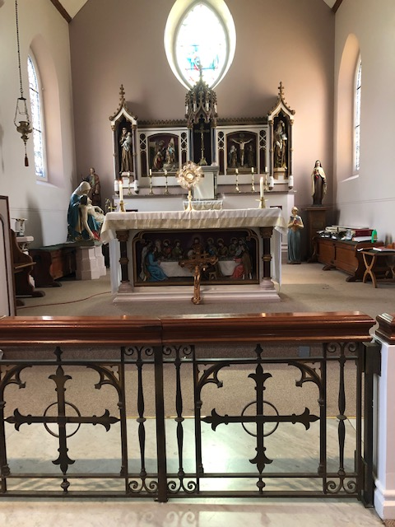
Please Pray for Pauline Ketchin, Jo Firth†, Mary Eason†, Clarice Moca G.Domingos†, and Ancy John Kumar† who have recently died; And also Pray for all those whose anniversaries occur about this time including:
Robert Patrick Plummer, Marion Edwards, Razario Rubio, Maude Harris, Miargaret Patricia Wills, Andrew Snowdown, Patricia Ann Hamilton, Patrick Aloysius Galvin, Philip Andrew Redshaw, Florence Newson, Margaret Wharfe, Brian Michael Meade, Patrick Kennedy, John Joseph Tapley and Albert Francis Parris.
May their souls, and all the souls of the faithful departed, rest in peace

Readers this week:
Sat  6.30pm | Alyssa Mae Viernes  Gabriel Concepcion  Juan Jupit Quilas
Sun 9.30am | Edeji Sisters
Sun 11.30am | Samuel Robson  Gali Family
Sun 6.30pm | Uche Family

Sun  9.30am | Uhuegbu Family  Tania Jackson
Sun  11.30am | Chelsea Atoa  Kara Family
Sun  6.30pm | Frances Okafor  Daniela Ibeh  Joan Aruma

Our Parish NOTICES
Office Hours – Tuesday, Wednesday & Friday - 10.30am – 1.30pm
Please use the QR code for your weekly offerings & second collections
Collections this week:
CATEGORY | CASH (Loose) | GIFT AID | CONTACTLESS  Amount Gift Aid |  | TOTALS
Offertory | £279.08 | £50.00 | £251.00 | £28.75 | £608.83
Clergy Fund | £199.65 | £27 | £132.00 | £29.25 | £387.90
Football Parking | - |  | - | -
 Next Weeks Second Collection is for CAFOD Fast Day
.

PRAY FOR JO FIRTH – Please continue to pray for Jo Firth, who passed away on Tuesday 20th January 2026. Josephine will be received into the Church on Monday 2nd March 2026 @ 4.15pm. The Requiem Mass will take place on Tuesday 3rd March 2026 @ 11.30am, followed by her burial at Woodlands Cemetery.

LENTEN REFLECTION - Lord make me a good steward that through my Lenten observation, I respond to your invitation to praying, fasting and almsgiving. Enrich me with the spirit, love, sharing and reconciliation.

FOODBANK - We are still collecting non-perishable food & essential hygiene and baby items for the Medway Foodbank. Please leave your donations in the box at the back of Church. Please DO NOT leave perishable fruit & vegetables or ‘out of date’ items.
The Medway Foodbank has sent a ‘THANK YOU’ certificate & following message ..
“On behalf of the team at Medway Foodbank, please see the certificate for the donations made between July and December 2025 (including Harvest collections).
Your donations have been invaluable in enabling us to help those in
need in Medway so thank you for your amazing support”.

CAFOD Fast Day will take place on Friday 27th February.
You are invited to offer your fast and Lenten sacrifice in support of the vital work of CAFOD. Please bring your Fast Day offering and present it at the collection next Sunday, 1st March.

Stewardship Campaign – Programme of Planned Giving - Our parish will be carrying out a Programme of Planned Giving and Stewardship Campaign on 8th, 15th and 22nd March 2026.

DATES FOR YOUR DIARY

22nd Feb | Sacrament of Baptism
27th Feb | CAFOD Fast Day – Next week second collection will be for CAFOD.
28th Feb | First Holy Communion Class ‘Chapters 5 & 6’ in the McMahon Hall at 11.45am
Lenten Spiritual Programme
Mondays | Stations of the Cross at 10.30am after morning mass
Fridays | Private mediation, exposition of Blessed Sacrament and at 6.15pm to 6.55pm
Fridays | Stations of the Cross at 7pm before evening mass
Saturdays | Exposition of Blessed Sacrament and Confession at 10.30am
AROUND THE CATHOLIC COMMUNITY

AMBASSADORS FOR CHRIST: A CATHOLIC APOLOGETICS RESOURCE. The Archdiocese of Southwark has launched an exciting apologetics project to provide evidence-based answers to questions such as "Is Jesus God?" or “does prayer work?”. Ambassadors for Christ is designed to equip you with a deeper understanding of your faith, so you can confidently answer questions and be a joyful witness for the Lord Jesus and his Church. Every Monday, a new video will be posted on YouTube, along with a worksheet to enable parishes, schools, youth groups and families to use them as part of their faith formation. To watch the videos and take part in this exciting project, please visit: rcaos.org.uk/ambassadorsforchrist.
SOUTHWARK CATHOLIC YOUTH SERVICE - Pilgrimages for Young Adults Young adults (aged 18 to 35) are invited to join Archbishop John on pilgrimage to Lourdes, from 7-13 June 2026. The cost is £789, including flights and full-board accommodation on a shared basis. Please visit: www.tinyurl.com/lourdes26
Young adults (aged 18 to 35) are also invited to register interest for the World Youth Day pilgrimage to Korea in August 2027 at www.tinyurl.com/wyd2027
For information about youth activities for all ages across the Archdiocese please visit our website at www.tinyurl.com/scys1

Igbo Catholic Community – Gathering on Sunday, 22nd February 2026, St. Thomas of Canterbury Church in Rainham, Kent, ME8 7RH starting with Mass at 1pm afterwards celebration in parish centre.

MASS INTENTIONS FOR THE WEEK

Sunday (22nd Feb)  First Sunday of Lent | 9.30am  11.30am  6.30pm | “For God’s Blessings & Grace upon the Elderly Parishioners  Repose of the souls of Fred & Freda King  Pro Populo
Monday (23rd Feb) | 10.00am | Repose of the soul of Bea Doyle
Tuesday (24th Feb) | 10.00am | Repose of the soul of Joyce Alley  Repose of the soul of Ann Marie Ntolo
Wednesday (25th Feb) | 10.00am  7.30pm | Repose of the soul of Patrick Galvin
Thursday (26th Feb) | 10.00am | Birthday and Thanksgiving for Stephen Cottam
Friday (27th Feb)  CAFOD Fast Day | 10.00am  6.15pm  7.30pm | Repose of the soul of Eileen Byrne  ADORATION  Pro Populo
Saturday (28th Feb)  Vigil | 10.00am  10.30am  6.30pm | Pro Populo  EXPOSITION OF THE BLESSED SACRAMENT and RECONCILIATION  Repose of the soul of Pauline Ketchin
Sunday (01 Mar)  Second Sunday of Lent | 9.30am  11.30am  6.30pm | Repose of the souls of Stephen Cho Ndikum, Agnes Ndikum Awa and Ngefor Stellans Ndikum  Pro Populo  Pro Populo

MASS INTENTIONS – Please ensure, when paying via Contactless, that your Intention has been entered into the diary & include the Intention date in the ‘message’ section on the Contactless device. Mass Intentions are £10.00

