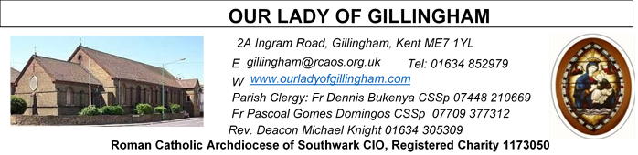
15 MARCH 2026
Third Sunday of Lent – Year A
SATURDAY
Exposition of the Blessed Sacrament & Reconciliation
10.30am – 11.30am 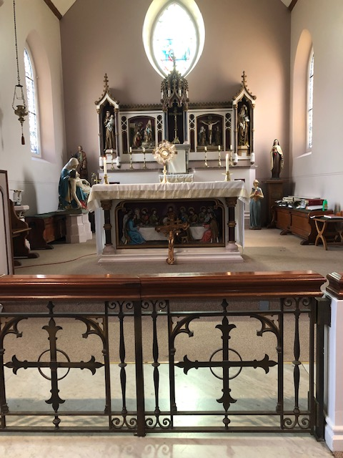
Please Pray for Apolonia MacKenzie†, Bridget Hollingsworth†, Pauline Ketchen†, Jo Firth†, Mary Eason† and Clarice Moca G.Domingos†, who have recently died;
Also Pray for all those whose anniversaries occur about this time including: Francis Brincat, Bernice Flannery, Maureen Hodgson, Anne Featherstone, Edna Busher, James Quirke, Charles Lay, Benjamita Rebello, Eileen Fleming, Karen Bruce, Rosaria Formosa, John O’Neill, John Harte, Pauline Fairfax, Brian Sadler, Darrell Fransz, Mary Hanna, & Eileen Jenkin.
May their souls, and all the souls of the faithful departed, rest in peace

Readers Next week:
Sat  6.30pm | Crystabelle  Imelda Cervantes  Kieran Shannon
Sun 9.30am | Tania Jackson  Uhuegbu Sisters
Sun 11.30am | Kara Family  Chelsea Atoe
Sun 6.30pm | Daniella Ibeh  Frances Okafor

Sun  9.30am | Uhuegbu Family  Tania Jackson
Sun  11.30am | Chelsea Atoa  Kara Family
Sun  6.30pm | Frances Okafor  Daniela Ibeh  Joan Aruma

Readers this week:
Sat  6.30pm | Alyssa Mae Viernes  Lucy  Janette Alfayad
Sun 9.30am | Edeji Sisters
Sun 11.30am | Samuel Robson  Gali Family
Sun 6.30pm | Uche Family

Sun  9.30am | Uhuegbu Family  Tania Jackson
Sun  11.30am | Chelsea Atoa  Kara Family
Sun  6.30pm | Frances Okafor  Daniela Ibeh  Joan Aruma

Reading 1 | 1 Sam 16:1, 6-7, 10-13 | David is anointed king of Israel.
Psalm | Ps 22 r. 1 | The Lord is my shepherd;  there is nothing I shall want.
Reading 2 | Eph 5:8-14 | Rise from the dead, and Christ  will shine on you,
Gospel Acclamation | John 8: 12 | I am the light of the world, says  the Lord; anyone who believes  in me will have the light of life.
Gospel | John 9:1-41 | He went off and washed himself,  and came away with his sight  restored.

FRIDAY
Exposition of the Blessed Sacrament
6.15pm – 6.55pm
Followed by Stations of the Cross at 7pm and
Holy Mass at 7.30pm

Our Parish NOTICES
Office Hours – Tuesday, Wednesday & Friday - 10.30am – 1.30pm
Collections this week:
CATEGORY | CASH (Loose) | GIFT AID | CONTACTLESS  Amount Gift Aid |  | TOTALS
Offertory | £627.54 | £145.60 | £400.25 | £36.25 | £436.250
Football Parking | £235.00 |  |  |  | £235.00

Please use the QR code for your weekly offerings & second collections

LENTEN REFLECTION - Lord make me a good steward so that through my Lenten observance, I respond to your invitation to praying, fasting and almsgiving. Enrich me with the spirit, love, sharing and reconciliation.

ANNUAL LEGION OF MARY ACIES CEREMONY, consecration to Our Lady, will take place here in Our Lady of Gillingham church, on Saturday the 21st of March at 1pm. All children of our blessed Mother Mary are welcome. There will be Prayer, talk from the Priest, Consecration, Benediction and refreshments in the parish hall.'

OUR PARISH, OUR NEEDS, OUR RESPONSIBILITY – PLANNED GIVING APPEAL ..
‘And indeed, which of you here, intending to build a tower, would not first sit down and work out the cost to see if he had enough to complete it?’ –
Luke 14:28
Last week, our Parish embarked on a Planned Giving appeal. Over the coming weeks we ask all parishioners to take this opportunity to prayerfully reflect on their commitment to our Parish. Everyone should consider giving something, mindful of their blessings and circumstances. Today you will hear more about Planned Giving and Stewardship, including why our Parish needs financial help to cover our costs. Please take a “Week 2 – Our Parish, Our Responsibility” appeal newsletter.
Our goal is to receive an informed decision from everyone in the parish.
Next weekend we shall ask all parishioners to complete a pledge card - this will enable our parish to plan ahead with confidence for the future.
If you have any questions, Dayle will be available after Mass today, or speak with Fr Dennis

EASTER EGG RAFFLE – The OLoG SEEDS are holding an Easter Egg Raffle. £1 per strip of tickets, which will be on sale after Mass. Please support our Young Parishioners.

DATES FOR YOUR DIARY

21st March | First Holy Communion Class (Chapters 9 & 10) at 11.45am in the McMahon Hall
21st March | Legion of Mary “Acies” Renewal of Vows. In Church from 1pm & continuing in the McMahon Hall until 4pm
Wednesday  25th March | THE ANNUNCIATION OF THE LORD (Holy Day of Obligation) Masses will be held at 10.00am & 7.30pm
28th March | Filipino Mass at 12noon followed by a gathering in the McMahon Hall from 2pm until 5pm
Evening of 28th March – clocks go FORWARD by 1 hour
29th March | PALM SUNDAY OF THE PASSION OF THE LORD
Lenten Spiritual Programme
Mondays | Stations of the Cross at 10.30am after morning mass
Fridays | Private meditation & exposition of the Blessed Sacrament 6.15-6.55pm
Fridays | Stations of the Cross at 7pm before evening Mass
Saturdays | Exposition of Blessed Sacrament and Confession at 10.30am
AROUND THE CATHOLIC COMMUNITY
PRAY THE ROMERO ROSARY AT ST GEORGE’S CATHEDRAL. Join Archbishop John Wilson and the Cathedral clergy in praying the rosary every Friday at 5pm throughout Lent. This is a beautiful opportunity to draw closer to the Lord Jesus in prayer. Archbishop John will personally lead the devotion at the National Shrine of St Oscar Romero at St George’s Cathedral (SE1 6HR) on Friday 6th and Friday 27th March at 5pm. On all other Fridays during Lent, the Cathedral clergy will lead the rosary, followed by the Stations of the Cross at 6pm. Let the rosary connect you to the Lord Jesus this Lenten season. Find out more at: rcaos.org.uk/romerorosary
DIOCESAN PILGRIMAGE TO LOURDES – 21st to 28th August 2026
I warmly invite you to join me on this year’s SOUTHWARK DIOCESAN PILGRIMAGE TO LOURDES. A pilgrimage is a great opportunity to refresh and renew our relationship with the Lord Jesus, with the help of Our Lady’s prayers. I have also found it a blessing to be able to accompany and to be inspired by other pilgrims, some of whom are sick, elderly or disabled. Details for booking travel and accommodation: https://www.tangney-tours.com/diocese-pilgrimages/diocese-ca/
We also ask pilgrims to complete a form with details, including medical requirements (if any) at https://www.catholicassociation.co.uk/join2026
For more information, please contact Canon Edward Perera (edwardperera@rcaos.org.uk) or Deacon John Fogarty (johnfogarty@rcaos.org.uk) or myself, Bishop Paul Hendricks (paulhendricks@rcaos.org.uk)
FORMING CATHOLIC STUDENT LEADERS - Two summer courses exploring faith, ethics and leadership for sixth form students, offered by the Christian Heritage Centre at Stonyhurst: (1) Join us for 6 days in the beautiful Ribble Valley to explore themes linked to The Common Good (Year 12, 10-15 August);
(2) The Human Ecology (Year 13, 5-10 July). Meet new friends, discuss and share with peers, tutors and academics, learn new skills, develop your relationship with Christ, build your character.
For more details: www.christianleadershipformation.com
MASS INTENTIONS FOR THE WEEK

Saturday (14th Mar) | 6.30pm | Repose of the souls of Margaret & Harold Cardwell
Sunday (15th Mar)  Fourth Sunday of Lent | 9.30am  11.30am  6.30pm | Repose of the souls of Mary & Aubrey Jamieson  Repose of the soul of Sammy Formosa  Pro Populo
Monday (16th Mar) | 10.00am  10.30am | Repose of the soul of Jo Firth  Stations of the Cross
Tuesday (17th Mar)  St Patrick | 10.00am | Repose of the soul of Pauline Ketchen
Wednesday (18th Mar) | 10.00am | Repose of the soul of Dominique Cannavina
Thursday (19th Mar)  St Joseph | 10.00am | Repose of the soul of Edna Nelson
Friday (20th Mar) | 10.00am  6.15pm  7.00pm  7.30pm | Good Health of Sarah Adams & her unborn child  EXPOSITION OF THE BLESSED SACRAMENT  Stations of the Cross  Repose of the soul of Jean-Claude Beguinot
Saturday (21st Mar)  Vigil | 10.00am  10.30am  1.00pm  6.30pm | Repose of the soul of John J. Saunders  EXPOSITION OF THE BLESSED SACRAMENT and RECONCILIATION  Legion of Mary “ACIES” (Renewal of Vows)  Pro Populo
Sunday (22nd Mar)  Fifth Sunday of Lent | 9.30am  11.30am  6.30pm | Healing & Spiritual Welfare of Ian Parmenter  Repose of the soul of Samuel Odoom  Repose of the soul of Frank Hanham

MASS INTENTIONS – Please ensure, when paying via Contactless, that your Intention has been entered into the diary & include the Intention date in the ‘message’ section on the Contactless device. Mass Intentions are £10.00

