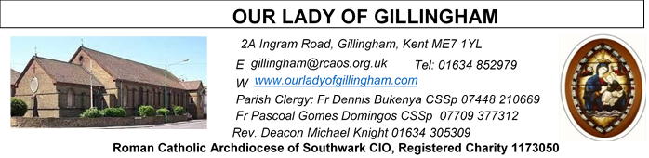
15th FEBRUARY 2026
Sixth Sunday in Ordinary Time – YEAR A
Day for the Unemployed
FRIDAY
Eucharistic Adoration
6.15pm – 7.20pm
Followed by Holy Mass at 7.30pm

SATURDAY
Exposition of the Blessed Sacrament & Reconciliation
10.30am – 11.30am 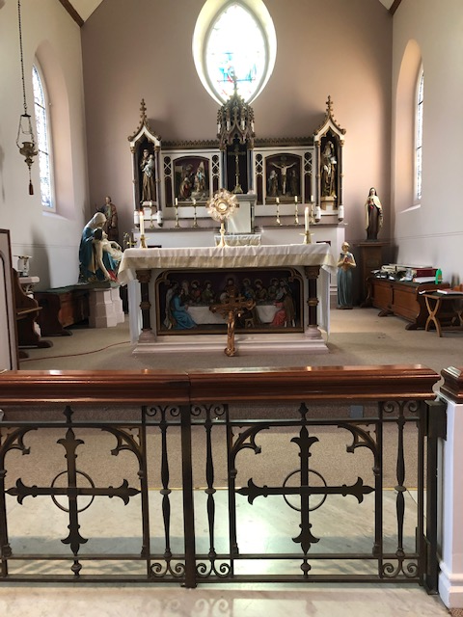
Reading 1 | Eccl 15:15-20 | He never commanded anyone  to be godless.
Psalm | Ps 118:1-2, 4-5, 17-18, 33-34 r. 1 | They are happy who follow  God's law!
Reading 2 | 1 Cor 2:6-10 | God predestined wisdom to be  for our glory before the ages  began.
Gospel Acclamation | 1 Sam 3:9; John 6:68 | Speak, Lord, your Servant is  listening: you have the message  of eternal life.
 | Matt 11:25 | Blessed are you, Father, Lord  of heaven and earth, for  revealing the mysteries of the  kingdom to mere children.
Gospel | Matt 5:17-37 | You have learnt how it was said  to your ancestors; but I say this  to you.

Readers this week:
Sat  6.30pm | Sandana Family
Sun 9.30am | Sharon Chinwuba  Nicky Croft  Ann Williams
Sun 11.30am | Ellie Tetteh  Dinah Kansiime  Laarni Fajardo
Sun 6.30pm | Akhebai Tegha  Anatasia Ebifa  Joan Aruma

Sun  9.30am | Uhuegbu Family  Tania Jackson
Sun  11.30am | Chelsea Atoa  Kara Family
Sun  6.30pm | Frances Okafor  Daniela Ibeh  Joan Aruma

Please Pray for Jo Firth†, Mary Eason†,
Clarice Moca G.Domingos†, and Ancy John Kumar† who have recently died; And also Pray for all those whose anniversaries occur about this time including:
Gillian Evans, Lillian Mayson, Lillian (Nellie) Lennon, Bernadette Adapen, Karen Bruce, Kathleen Cox, Godfrey Vandenberg, Michael Black, Linda Hannion, Joyce Terry, Joseph Borg, William Tomlin, Hannah Swadling, Martha Kitson, John Triggs, Paul Beatty, Soni Gallagher, Florence Bond, Tadeuso Wardawiowski, Joanne Jean Smith, Janet Matthews, Cecil Lee and Aurchio (Tom) Perera.
May their souls, and all the souls of the faithful departed, rest in peace

Our Parish NOTICES
Office Hours – Tuesday, Wednesday & Friday - 10.30am – 1.30pm
Collections this week:
CATEGORY | CASH (Loose) | GIFT AID | CONTACTLESS  Amount Gift Aid |  | TOTALS
Offertory | £444.89 | £71.60 | £476.00 | £53.25 | £1045.74
Football Parking | £220.00 |  | - | - | £220.00

Retiring Collection TODAY will be for the Clergy Support Fund. Please use the envelopes provided.

Please use the QR code for your weekly offerings & second collections
PRAY FOR JO FIRTH – Please continue to pray for Jo Firth, who passed away on Tuesday 20th January 2026. Josephine will be received into the Church on Monday 2nd March 2026 @ 4.15pm. The Requiem Mass will take place on Tuesday 3rd March 2026 @ 11.30am, followed by her burial at Woodlands Cemetery.

THE SEASON LENT – begins on 18th February 2026 (Ash Wednesday)
Lent is ordered to preparing for the celebration of Easter, since the Lenten liturgy prepares for celebration of the Paschal Mystery both catechumens, by the various stages of Christian Initiation, and the faithful, who recall their own baptism and do penance.
LEGION OF MARY – Would you like to become a Member?
You are invited to join the Legion of Mary in our Parish. The Catholic lay faithful serving the person of Jesus Christ under the leadership of Mary, Queen and Mother. If you are interested, please speak to Deacon Michael or call 07412859763 .
FOODBANK - We are still collecting non-perishable food & essential hygiene and baby items for the Medway Foodbank. Please leave your donations in the box at the back of Church. Please DO NOT leave perishable fruit & vegetables or ‘out of date’ items.
The Medway Foodbank has sent a ‘THANK YOU’ certificate & following message ..
“On behalf of the team at Medway Foodbank, please see the certificate for the donations made between July and December 2025 (including Harvest collections).
Your donations have been invaluable in enabling us to help those in
need in Medway so thank you for your amazing support”.

DATES FOR YOUR DIARY

14th Feb | First Holy Communion Class ‘Chapters 3 & 4’ in the McMahon Hall at 11.45am
14th Feb | Knights of St Columba Pre-Lenten Walk from St Thomas of Canterbury Catholic Church to The Friary, Aylesford Priory. Starts at 10.00am
18th Feb | ASH WEDNESDAY – Holy Day of Obligation – Mass will be at 10.00am & 7.30pm. A day of fasting & abstinence.
28th Feb | First Holy Communion Class ‘Chapters 5 & 6’ in the McMahon Hall at 11.45am
AROUND THE CATHOLIC COMMUNITY

CLERGY SUPPORT FUND SECOND COLLECTION – TODAY
The Clergy in our Archdiocese have given us so much. They have been there for us in our happiest moments and comforted us when we have lost loved ones. Supporting Priests in their retirement is one way to show your appreciation for all they have done for parishes. The Clergy Support Fund enables the Archdiocese of Southwark to care for Priests in their retirement, old age, and at their time of ill health. Please use the ‘Clergy Support Fund’ envelope or telephone 020 7960 2504 (Mon-Fri) or use the QR code to make your donation.

AMBASSADORS FOR CHRIST: A CATHOLIC APOLOGETICS RESOURCE. The Archdiocese of Southwark has launched an exciting apologetics project to provide evidence-based answers to questions such as "Is Jesus God?" or “does prayer work?”. Ambassadors for Christ is designed to equip you with a deeper understanding of your faith, so you can confidently answer questions and be a joyful witness for the Lord Jesus and his Church. Every Monday, a new video will be posted on YouTube, along with a worksheet to enable parishes, schools, youth groups and families to use them as part of their faith formation. To watch the videos and take part in this exciting project, please visit: rcaos.org.uk/ambassadorsforchrist.
SOUTHWARK CATHOLIC YOUTH SERVICE - Pilgrimages for Young Adults Young adults (aged 18 to 35) are invited to join Archbishop John on pilgrimage to Lourdes, from 7-13 June 2026. The cost is £789, including flights and full-board accommodation on a shared basis. Please visit: www.tinyurl.com/lourdes26
Young adults (aged 18 to 35) are also invited to register interest for the World Youth Day pilgrimage to Korea in August 2027 at www.tinyurl.com/wyd2027
For information about youth activities for all ages across the Archdiocese please visit our website at www.tinyurl.com/scys1

MASS INTENTIONS FOR THE WEEK

Saturday (14th Feb)  Vigil Mass | 10.00am  10.30am  6.30pm | Repose of the soul of Mr & Mrs Di Lisio  EXPOSITION OF THE BLESSED SACRAMENT and RECONCILIATION  Repose of the soul of Eileen Gallagher
Sunday (15th Feb)  Day for the Unemployed | 9.30am  11.30am  6.30pm | Birthday Thanksgiving for Jennifer  Pro Populo  Repose of the soul of Peter Nash
Monday (16th Feb) | 10.00am | Repose of the souls of Kathleen & James McEvans
Tuesday (17th Feb)  End of Ordinary Time Before Lent | 10.00am | Repose of the soul of Sheila O’Hare
Wednesday (18th Feb)  ASH WEDNESDAY | 10.00am  7.30pm | Repose of the soul of Daniel Nelson
Thursday (19th Feb) | 10.00am | Repose of the soul of Jo Firth
Friday (20th Feb) | 10.00am  6.15pm  7.30pm | Repose of the soul of Mary & Aubrey Jamieson  ADORATION  Repose of the soul of Violet King
Saturday (21st Feb)  Vigil | 10.00am  10.30am  6.30pm | Repose of the soul of Joseph Borg  EXPOSITION OF THE BLESSED SACRAMENT and RECONCILIATION  Special Intentions
Sunday (22nd Feb) | 9.30am  11.30am  6.30pm | “For God’s Blessings & Grace upon the Elderly Parishioners  Repose of the souls of Fred & Freda King  Pro Populo

MASS INTENTIONS – Please ensure, when paying via Contactless, that your Intention has been entered into the diary & include the Intention date in the ‘message’ section on the Contactless device. Mass Intentions are £10.00

