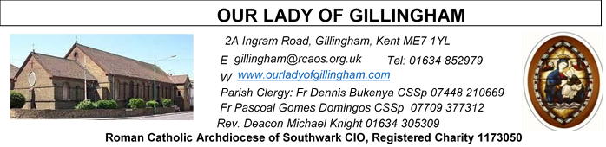
08 MARCH 2026
Third Sunday of Lent – Year A
Readers Next week:
Sat  6.30pm | Alyssa Mae Viernes  Lucy  Janette Alfayad
Sun 9.30am | Edeji Sisters
Sun 11.30am | Samuel Robson  Gali Family
Sun 6.30pm | Uche Family

Sun  9.30am | Uhuegbu Family  Tania Jackson
Sun  11.30am | Chelsea Atoa  Kara Family
Sun  6.30pm | Frances Okafor  Daniela Ibeh  Joan Aruma

SATURDAY
Exposition of the Blessed Sacrament & Reconciliation
10.30am – 11.30am 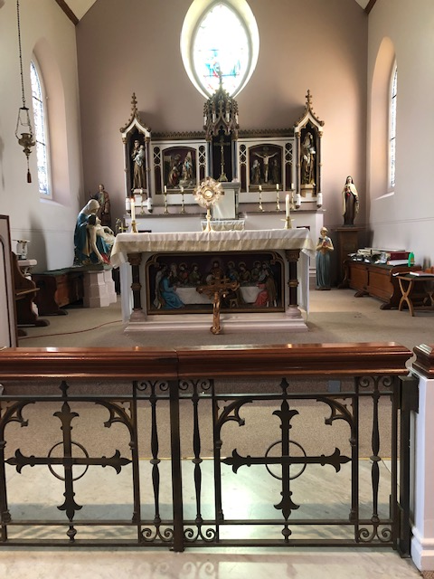
Readers this week:
Sat  6.30pm | Sandana Family
Sun 9.30am | Ann Williams  Nicky Croft  Sharon Chinwuba
Sun 11.30am | Ellie Tetteh  Dinah Kansiime  Laarni Fajardo
Sun 6.30pm | Akhebai Tegha  Anastasia Ebifa  Joan Aruma

Sun  9.30am | Uhuegbu Family  Tania Jackson
Sun  11.30am | Chelsea Atoa  Kara Family
Sun  6.30pm | Frances Okafor  Daniela Ibeh  Joan Aruma

Please Pray for Bridget Hollingsworth†, Pauline Ketchen†,
Jo Firth†, Mary Eason†, Clarice Moca G.Domingos†, and Ancy John Kumar† who have recently died;
Also Pray for all those whose anniversaries occur about this time including: John Rooney, Allan Feria, David Taylor, Richard Gibbons, Olga Scott, Michael O’Sullivan, William Grant, Ronald Gordon, Olive Swinstead, Samuel Hunter, Freda Jarmack, Jane Greef, Geoffrey Townshend, Phyllis Snuggs, Sydney Long, Michael Pearman, Maddalena Zeuli, and Thomas Smale.
May their souls, and all the souls of the faithful departed, rest in peace

Reading 1 | Gen 12:1-4 | The call of Abraham, father of  the People of God
Psalm | Ps 32:4-5, 18-20. 22 r. 22 | May your love be upon us, O  Lord, as we place all our hope  in you.
Reading 2 | 2 Tim 1:8-10 | God calls and enlightens us.
Gospel Acclamation | Matt 17:5 | From the bright cloud the  Father's voice was heard:  'This is my Son, the Beloved.  Listen to him.'
Gospel | Matt 17:1-9 | His face shone like the sun.

FRIDAY
Exposition of the Blessed Sacrament
6.15pm – 6.55pm
Followed by Stations of the Cross at 7pm and
Holy Mass at 7.30pm

Our Parish NOTICES
Office Hours – Tuesday, Wednesday & Friday - 10.30am – 1.30pm
Collections this week:
CATEGORY | CASH (Loose) | GIFT AID | CONTACTLESS  Amount Gift Aid |  | TOTALS
Offertory | £507.28 | £42.00 | £524.00 | £67.50 | £1140.88
Second Collection (CAFOD) | £409.44 | £40.00 | £95.00 | £15.00 | £559.44

Please use the QR code for your weekly offerings & second collections
LENTEN REFLECTION - Lord make me a good steward so that through my Lenten observance, I respond to your invitation to praying, fasting and almsgiving. Enrich me with the spirit, love, sharing and reconciliation.

STEWARDSHIP CAMPAIGN – PROGRAMME OF PLANNED GIVING - Our parish will be carrying out a Programme of Planned Giving and Stewardship Campaign on 8th, 15th and 22nd March 2026.

KEEPING OUR CHURCH TIDY – ‘A gentle reminder’
Let us work together as a community to keep the Church tidy. We have a dedicated group of volunteers, who diligently clean the Church every week, but please do not leave newsletters, tissues, rubbish etc in the pews. If you do not wish to take the newsletter home, please return it to the back of the Church. Please also return any books or hymn books to bookcase.

DATES FOR YOUR DIARY

14th March | First Holy Communion Class (Chapters 7 & 8) at 11.45am in the McMahon Hall
21st March | First Holy Communion Class (Chapters 9 & 10) at 11.45am in the McMahon Hall
21st March | Legion of Mary “Acies” Renewal of Vows. In Church from 1pm & continuing in the McMahon Hall until 4pm
28th March | Filipino Mass at 12noon followed by a gathering in the McMahon Hall from 2pm until 5pm
Lenten Spiritual Programme
Mondays | Stations of the Cross at 10.30am after morning mass
Fridays | Private meditation & exposition of the Blessed Sacrament 6.15-6.55pm
Fridays | Stations of the Cross at 7pm before evening Mass
Saturdays | Exposition of Blessed Sacrament and Confession at 10.30am

AROUND THE CATHOLIC COMMUNITY
PRAY THE ROMERO ROSARY AT ST GEORGE’S CATHEDRAL. Join Archbishop John Wilson and the Cathedral clergy in praying the rosary every Friday at 5pm throughout Lent. This is a beautiful opportunity to draw closer to the Lord Jesus in prayer. Archbishop John will personally lead the devotion at the National Shrine of St Oscar Romero at St George’s Cathedral (SE1 6HR) on Friday 6th and Friday 27th March at 5pm. On all other Fridays during Lent, the Cathedral clergy will lead the rosary, followed by the Stations of the Cross at 6pm. Let the rosary connect you to the Lord Jesus this Lenten season. Find out more at: rcaos.org.uk/romerorosary
A DAY WITH MARY is taking place at Westminster Cathedral on Saturday 14 March 2026 (9.45am to 5.00pm). Further information is available at https://www.adaywithmary.org/ or https://eventcatholic.com/
MUSICAL PILGRIMAGE ON THE AUGUSTINE CAMINO JUNE 8TH-14TH 2026
Setting off from Rochester Cathedral, we will walk about 10 miles a day through the beautiful Kent countryside to Canterbury, then onto the shrine of St Augustine in Ramsgate. Each evening, Eddie Gilmore will perform a little concert in a pub en route. Contact Eddie for more details: gileag@gmail.com www.eddiegilmore.org

AMBASSADORS FOR CHRIST: A CATHOLIC APOLOGETICS RESOURCE.
The Archdiocese of Southwark has launched an exciting apologetics project to provide evidence-based answers to questions such as "Is Jesus God?" or “does prayer work?”. Ambassadors for Christ is designed to equip you with a deeper understanding of your faith, so you can confidently answer questions and be a joyful witness for the Lord Jesus and his Church. Every Monday, a new video will be posted on YouTube, along with a worksheet to enable parishes, schools, youth groups and families to use them as part of their faith formation. To watch the videos and take part in this exciting project, please visit: rcaos.org.uk/ambassadorsforchrist.

SOUTHWARK CATHOLIC YOUTH SERVICE - Pilgrimages for Young Adults Young adults (aged 18 to 35) are invited to join Archbishop John on pilgrimage to Lourdes, from 7-13 June 2026. The cost is £789, including flights and full-board accommodation on a shared basis. Please visit: www.tinyurl.com/lourdes26
Young adults (aged 18 to 35) are also invited to register interest for the World Youth Day pilgrimage to Korea in August 2027 at www.tinyurl.com/wyd2027
For information about youth activities for all ages across the Archdiocese please visit our website at www.tinyurl.com/scys1

MASS INTENTIONS FOR THE WEEK

Saturday (7th Feb) | 6.30pm | Spiritual Welfare of Ian Parmenter
Sunday (8th Mar)  Third Sunday of Lent | 9.30am  11.30am  6.30pm | Repose of the soul of Ifunanya Lucy Nwangene  Pro Populo  Repose of the soul of Elizabeth Hooper
Monday (9th Mar) | 10.00am  10.30am  2.30pm | Repose of the soul of Dennis Thompson  Stations of the Cross  Requiem Mass for Bridget Hazel Hollingsworth
Tuesday (10th Mar) | 10.00am | Repose of the soul of Anthony Alvares
Wednesday (11th Mar) | 10.00am | Repose of the soul of Mary Jones
Thursday (12th Mar) | 10.00am | Thanksgiving for the promotion of Justina Surgia
First Friday (13th Mar) | 10.00am  6.15pm  7.00pm  7.30pm | Repose of the soul of Kevin Flynn  EXPOSITION OF THE BLESSED SACRAMENT  Stations of the Cross  Repose of the souls of Fred & Freda King
Saturday (14th Mar)  Vigil | 10.00am  10.30am  6.30pm | Birthday Thanksgiving for Toni Putland  EXPOSITION OF THE BLESSED SACRAMENT and RECONCILIATION  Repose of the souls of Margaret & Harold Cardwell
Sunday (15th Mar)  Fourth Sunday of Lent | 9.30am  11.30am  6.30pm | Repose of the souls of Mary & Aubrey Jamieson  Repose of the soul of Sammy Formosa  Pro Populo

MASS INTENTIONS – Please ensure, when paying via Contactless, that your Intention has been entered into the diary & include the Intention date in the ‘message’ section on the Contactless device. Mass Intentions are £10.00

