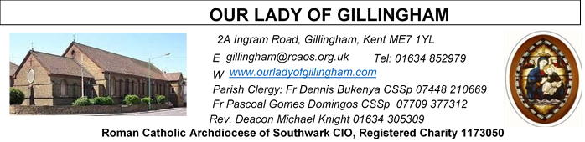
8th FEBRUARY 2026
Fifth Sunday in Ordinary Time – YEAR A
Reading 1 | Isa 58:7-10 | Then will your light shine  Like  the dawn.
Psalm | Ps 111:4-9 r. 4 | The good man is a light in  the darkness for the  upright. Or Alleluia!
Reading 2 | 1 Cor 2:1-5 | During my stay with you,  the only knowledge I  claimed to have was  about Jesus as the  crucified Christ.
Gospel Acclamation | John 8:12 | I am the light of the World,  says the Lord, anyone  who follows me will have  the light of life.
Gospel | Matt 5:13-16 | You are the light of the  world.

Day for Victims of Trafficking

Readers this week:
Sat  6.30pm | Gabriel Concepcion  Francisca Okeke  Janette Alfayad
Sun 9.30am | Vincent Obi  Chizoba Okeke  Gillian Knight
Sun 11.30am | Anthonia Fatuase Onyehialam Sisters
Sun 6.30pm | Anthonia Fatuase  Victoria Shosanya

Sun  9.30am | Uhuegbu Family  Tania Jackson
Sun  11.30am | Chelsea Atoa  Kara Family
Sun  6.30pm | Frances Okafor  Daniela Ibeh  Joan Aruma

FRIDAY
Eucharistic Adoration
6.15pm – 7.20pm
Followed by Holy Mass at 7.30pm
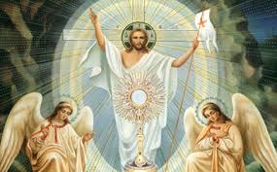
SATURDAY
Exposition of the Blessed Sacrament & Reconciliation
10.30am – 11.30am 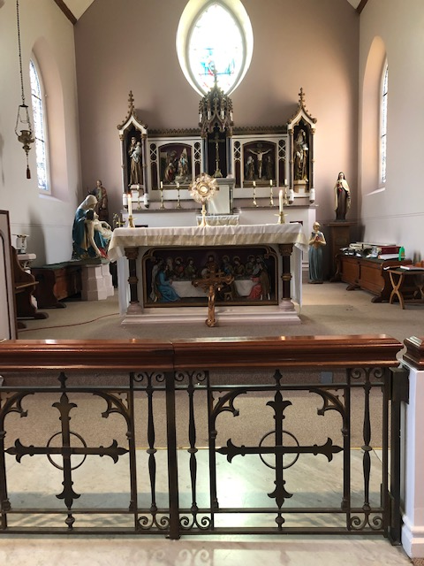
Please Pray for Jo Firth†, Mary Eason†,
Clarice Moca G.Domingos†, and Ancy John Kumar† who have recently died;
And also Pray for all those whose anniversaries occur about this time including:
Henry Leckie, Margaret Attfield, Olive Carwardine, Bridget Harte, Robert (Peter) Martin, Peter Nash, Igina Nasillo, Harry Barton, James Dent,
David Golding, Rose Clegg, Salvatore Robusto,
Sharon Fernandes, Jan Cygan, Margaret Hougham,
Olive Sherry, Margaret (Peggy) Miller, Eileen Jarrett,
Sonia Cleall, Ingeborg Sancto, Muriel Mathias and Muriel Evans.

May their souls, and all the souls of the faithful departed, rest in peace

Our Parish NOTICES
Office Hours – Tuesday, Wednesday & Friday - 10.30am – 1.30pm
Collections this week:
CATEGORY | CASH (Loose) | GIFT AID | CONTACTLESS  Amount Gift Aid |  | TOTALS
Offertory | £440.97 | £38.00 | £353.00 | £47.50 | £879.47
Second Collection  (St George’s Cathedral) |  | - | £10.00 | £1.25 | £11.25
Football Parking | £300.00 |  | - | - | £300.00
Building Fund | £250.00 | - | - | - | £250.00

Retiring Collection NEXT WEEK will be for the Clergy Support Fund. Please use the envelopes provided.

Please use the QR code for your weekly offerings & second collections
PRAY FOR JO FIRTH – Please continue to pray for Jo Firth, who passed away on Tuesday 20th January 2026. Josephine will be received into the Church on Monday 2nd March 2026 @ 4.15pm. The Requiem Mass will take place on Tuesday 3rd March 2026 @ 11.30am, followed by her burial at Woodlands Cemetery.

LEGION OF MARY – Would you like to become a Member?
You are invited to join the Legion of Mary in our Parish. The Catholic lay faithful serving the person of Jesus Christ under the leadership of Mary, Queen and Mother. If you are interested, please speak to Deacon Michael or call 07412859763 .
KNIGHTS OF ST COLUMBA – PRE LENTEN WALK – NEXT WEEKEND
This is an annual event, walking from St Thomas of Canterbury Catholic Church, Rainham to The Friary at Aylesford Priory. Please meet at St Thomas of Canterbury Catholic Church from 9.45am, on Saturday 14th February 2026.

FOODBANK - We are still collecting non-perishable food & essential hygiene and baby items for the Medway Foodbank. Please leave your donations in the box at the back of Church. Please DO NOT leave perishable fruit & vegetables or ‘out of date’ items.
The Medway Foodbank has sent a ‘THANK YOU’ certificate & following message ..
“On behalf of the team at Medway Foodbank, please see the certificate for the donations made between July and December 2025 (including Harvest collections).
Your donations have been invaluable in enabling us to help those in
need in Medway so thank you for your amazing support”.
CARETAKER VACANCY – Our Lady of Gillingham STILL NEEDS YOU. Do you have strong DIY/cleaning skills; a flexible approach; problem-solving skills and an ability to work under pressure? We require a new person to start as soon as possible. For further information, please speak with Fr Dennis. To apply, please send your CV to hr@rcaos.org.uk
DATES FOR YOUR DIARY

10th Feb | Deanery Meeting for Clergy of Chatham Deanery, 11am in the McMahon Hall. Please note that the usual Coffee Morning will be cancelled.
14th Feb | First Holy Communion Class ‘Chapters 3 & 4’ in the McMahon Hall at 11.45am
14th Feb | Knights of St Columba Pre Lenten Walk from St Thomas of Canterbury Catholic Church to The Friary, Aylesford Priory. Starts at 10.00am
18th Feb | ASH WEDNESDAY – Holy Day of Obligation – Mass will be at 10.00am & 7.30pm. A day of fasting & abstinence.
AROUND THE CATHOLIC COMMUNITY

CLERGY SUPPORT FUND SECOND COLLECTION – Sat/Sun 14th/15th February
The Clergy in our Archdiocese have given us so much. They have been there for us in our happiest moments and comforted us when we have lost loved ones. Supporting Priests in their retirement is one way to show your appreciation for all they have done for parishes. The Clergy Support Fund enables the Archdiocese of Southwark to care for Priests in their retirement, old age, and at their time of ill health. Please use the ‘Clergy Support Fund’ envelope or telephone 020 7960 2504 (Mon-Fri) or use the QR code to make your donation.

AMBASSADORS FOR CHRIST: A CATHOLIC APOLOGETICS RESOURCE. The Archdiocese of Southwark has launched an exciting apologetics project to provide evidence-based answers to questions such as "Is Jesus God?" or “does prayer work?”. Ambassadors for Christ is designed to equip you with a deeper understanding of your faith, so you can confidently answer questions and be a joyful witness for the Lord Jesus and his Church. Every Monday, a new video will be posted on YouTube, along with a worksheet to enable parishes, schools, youth groups and families to use them as part of their faith formation. To watch the videos and take part in this exciting project, please visit: rcaos.org.uk/ambassadorsforchrist.
SOUTHWARK CATHOLIC YOUTH SERVICE - Pilgrimages for Young Adults Young adults (aged 18 to 35) are invited to join Archbishop John on pilgrimage to Lourdes, from 7-13 June 2026. The cost is £789, including flights and full-board accommodation on a shared basis. Please visit: www.tinyurl.com/lourdes26
Young adults (aged 18 to 35) are also invited to register interest for the World Youth Day pilgrimage to Korea in August 2027 at www.tinyurl.com/wyd2027
For information about youth activities for all ages across the Archdiocese please visit our website at www.tinyurl.com/scys1

THE GOOD COUNSEL BLACK TIE BALL will take place at 6pm on St Valentine’s Day, Saturday 14th February 2026 in Kensington, London. Live Band. Silent Auction. London’s Catholic Pro-Life Ball raising money to help save lives and change lives. Tickets £135 each. Or a table of ten for £1,300. For bookings and enquiries email GCNBall@gmail.com or telephone 07795205117
MASS INTENTIONS FOR THE WEEK

Saturday (7th February)  Vigil Mass | 10.00am  10.30am  12.30pm  3.00pm  6.30pm | Thanksgiving for the Dinma Family  EXPOSITION OF THE BLESSED SACRAMENT and RECONCILIATION  Filipino Mass  OLOG Seeds – Young Adult Mass  Repose of the soul of Kevin Ketchen
Sunday (8th February)  Day for Victims of Trafficking | 9.30am  11.30am  6.30pm | Repose of the soul of Jo Firth  Repose of the soul of Peter Martin  Pro Populo and 18th Birthday Thanksgiving for Melvin Abrokwah
Monday (9th February) | 10.00am | Repose of the soul of Perpetua Pereira
Tuesday (10th February)  St Scholastica | 10.00am | Repose of the soul of Owen O’Neil
Wednesday (11th February)  World Day for the Sick | 10.00am | Repose of the soul of Joyce Alley
Thursday (12th February) | 10.00am | Repose of the soul of Rubitina Gomez
Friday (13th February) | 10.00am  6.15pm  7.30pm | Repose of the soul of Jo Firth  ADORATION  Repose of the soul of Dave Harrison
Saturday (14th February)  St Cyril, St Monk &  St Methodius  Vigil | 10.00am  10.30am  6.30pm | Repose of the soul of Mr & Mrs Di Lisio  EXPOSITION OF THE BLESSED SACRAMENT and RECONCILIATION  Repose of the soul of Eileen Gallagher
Sunday (15th February)  Day for the Unemployed | 9.30am  11.30am  6.30pm | Birthday Thanksgiving for Jennifer  Pro Populo  Repose of the soul of Peter Nash

MASS INTENTIONS – Please ensure, when paying via Contactless, that your Intention has been entered into the diary & include the Intention date in the ‘message’ section on the Contactless device. Mass Intentions are £10.00

