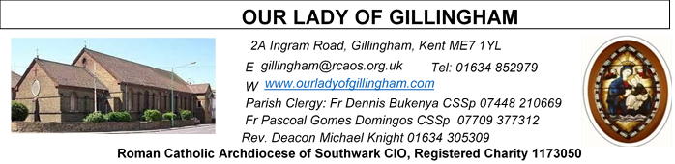
01 MARCH 2026
Second Sunday of Lent – Year A
SATURDAY
Exposition of the Blessed Sacrament & Reconciliation
10.30am – 11.30am 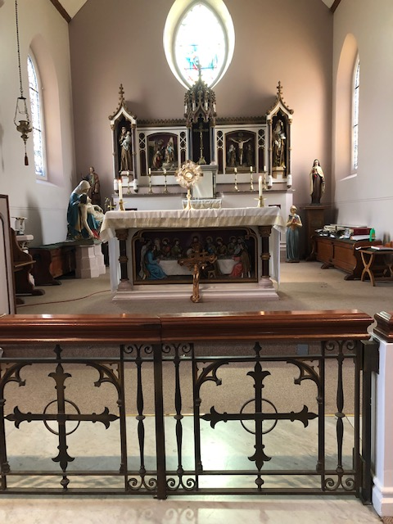
Readers Next week:
Sat  6.30pm | Sandana Family
Sun 9.30am | Ann Williams  Nicky Croft  Sharon Chinwuba
Sun 11.30am | Ellie Tetteh  Dinah Kansiime  Laarni Fajardo
Sun 6.30pm | Anastasia Ebifa  Joan Aruma

Sun  9.30am | Uhuegbu Family  Tania Jackson
Sun  11.30am | Chelsea Atoa  Kara Family
Sun  6.30pm | Frances Okafor  Daniela Ibeh  Joan Aruma

Readers this week:
Sat  6.30pm | Oliver Perez  Francisca Okeke  Juan Jupit Quilas
Sun 9.30am | Vincent Obi  Chizoba Okeke  Akhebai Tegha
Sun 11.30am | Onyehialam Sisters  Shakira Kara
Sun 6.30pm | Victoria Shosanya  Joan Aruma

Sun  9.30am | Uhuegbu Family  Tania Jackson
Sun  11.30am | Chelsea Atoa  Kara Family
Sun  6.30pm | Frances Okafor  Daniela Ibeh  Joan Aruma

Please Pray for Bridget Hollingsworth†, Pauline Ketchen†,
Jo Firth†, Mary Eason†, Clarice Moca G.Domingos†, and Ancy John Kumar† who have recently died;
Also Pray for all those whose anniversaries occur about this time including: William Hetherington, James Driscoll,
Annie Jones, Alice Marriott, Derek McManus, Edmond Hamilton, David Hunt, Annie Brennan, Phillip Flannery, Richard Smith, Emmanuel Muscat, Thomas Lynes, David Keogh, Robert Elder, Angela Singh, John Rooney and Allan Feria.
May their souls, and all the souls of the faithful departed, rest in peace

Reading 1 | Gen 12:1-4 | The call of Abraham, father of  the People of God
Psalm | Ps 32:4-5, 18-20. 22 r. 22 | May your love be upon us, O  Lord, as we place all our hope  in you.
Reading 2 | 2 Tim 1:8-10 | God calls and enlightens us.
Gospel Acclamation | Matt 17:5 | From the bright cloud the  Father's voice was heard:  'This is my Son, the Beloved.  Listen to him.'
Gospel | Matt 17:1-9 | His face shone like the sun.

FRIDAY
Exposition of the Blessed Sacrament
6.15pm – 6.55pm
Followed by Stations of the Cross at 7pm and
Holy Mass at 7.30pm

Our Parish NOTICES
Office Hours – Tuesday, Wednesday & Friday - 10.30am – 1.30pm
Collections this week:
CATEGORY | CASH (Loose) | GIFT AID | CONTACTLESS  Amount Gift Aid |  | TOTALS
Offertory | £516.49 | £94.00 | £336.00 | £31.25 | £977.74
Second Collection (Clergy Support) |  |  | £15.00 | £2.50 | £17.50
Football Parking | £275.00 |  |  |  | £275.00

Today’s Second Collection is for CAFOD Fast Day
Please use the QR code for your weekly offerings & second collections
LENTEN REFLECTION - Lord make me a good steward so that through my Lenten observance, I respond to your invitation to praying, fasting and almsgiving. Enrich me with the spirit, love, sharing and reconciliation.

PRAY FOR JO FIRTH – Please continue to pray for Jo Firth, whose Requiem Mass will take place on Tuesday 3rd March at 11.30am, followed by her burial at Woodlands Cemetery at 1pm. Josephine will be received into the Church on Monday 2nd March 2026 @ 4.15pm.

STEWARDSHIP CAMPAIGN – PROGRAMME OF PLANNED GIVING - Our parish will be carrying out a Programme of Planned Giving and Stewardship Campaign on 8th, 15th and 22nd March 2026.

KEEPING OUR CHURCH TIDY – ‘A gentle reminder’
Let us work together as a community to keep the Church tidy. We have a dedicated group of volunteers, who diligently clean the Church every week, but please do not leave newsletters, tissues, rubbish etc in the pews. If you do not wish to take the newsletter home, please return it to the back of the Church. Please also return any books or hymn books to bookcase.

DATES FOR YOUR DIARY

14th March | First Holy Communion Class (Chapters 7 & 8) at 11.45am in the McMahon Hall
21st March | First Holy Communion Class (Chapters 9 & 10) at 11.45am in the McMahon Hall
21st March | Legion of Mary “Acies” Renewal of Vows. In Church from 1pm & continuing in the McMahon Hall until 4pm.
Lenten Spiritual Programme
Mondays | Stations of the Cross at 10.30am after morning mass
Fridays | Private meditation & exposition of the Blessed Sacrament 6.15-6.55pm
Fridays | Stations of the Cross at 7pm before evening Mass
Saturdays | Exposition of Blessed Sacrament and Confession at 10.30am
AROUND THE CATHOLIC COMMUNITY
CAFOD FAMILY FAST DAY was on Friday 27th February 2026.
This Lent, live out the Gospel ‘call to love your neighbour’. By Fasting and giving what you save, you join in Christ’s compassion and help another family put food on the table. Your donation can help families around the world. Please use a CAFOD FAMILY FAST DAY envelope for your donation or donate online at cafod.org.uk/envelope or text CAFODENT to 70085 to donate £10.00
PRAY THE ROMERO ROSARY AT ST GEORGE’S CATHEDRAL. Join Archbishop John Wilson and the Cathedral clergy in praying the rosary every Friday at 5pm throughout Lent. This is a beautiful opportunity to draw closer to the Lord Jesus in prayer. Archbishop John will personally lead the devotion at the National Shrine of St Oscar Romero at St George’s Cathedral (SE1 6HR) on Friday 6th and Friday 27th March at 5pm. On all other Fridays during Lent, the Cathedral clergy will lead the rosary, followed by the Stations of the Cross at 6pm. Let the rosary connect you to the Lord Jesus this Lenten season. Find out more at: rcaos.org.uk/romerorosary
A DAY WITH MARY is taking place at Westminster Cathedral on Saturday 14 March 2026 (9.45am to 5.00pm). Further information is available at https://www.adaywithmary.org/ or https://eventcatholic.com/
MUSICAL PILGRIMAGE ON THE AUGUSTINE CAMINO JUNE 8TH-14TH 2026
Setting off from Rochester Cathedral, we will walk about 10 miles a day through the beautiful Kent countryside to Canterbury, then onto the shrine of St Augustine in Ramsgate. Each evening, Eddie Gilmore will perform a little concert in a pub en route. Contact Eddie for more details: gileag@gmail.com www.eddiegilmore.org

AMBASSADORS FOR CHRIST: A CATHOLIC APOLOGETICS RESOURCE.
The Archdiocese of Southwark has launched an exciting apologetics project to provide evidence-based answers to questions such as "Is Jesus God?" or “does prayer work?”. Ambassadors for Christ is designed to equip you with a deeper understanding of your faith, so you can confidently answer questions and be a joyful witness for the Lord Jesus and his Church. Every Monday, a new video will be posted on YouTube, along with a worksheet to enable parishes, schools, youth groups and families to use them as part of their faith formation. To watch the videos and take part in this exciting project, please visit: rcaos.org.uk/ambassadorsforchrist.

SOUTHWARK CATHOLIC YOUTH SERVICE - Pilgrimages for Young Adults Young adults (aged 18 to 35) are invited to join Archbishop John on pilgrimage to Lourdes, from 7-13 June 2026. The cost is £789, including flights and full-board accommodation on a shared basis. Please visit: www.tinyurl.com/lourdes26
Young adults (aged 18 to 35) are also invited to register interest for the World Youth Day pilgrimage to Korea in August 2027 at www.tinyurl.com/wyd2027
For information about youth activities for all ages across the Archdiocese please visit our website at www.tinyurl.com/scys1

MASS INTENTIONS FOR THE WEEK

Saturday (28th Feb) | 6.30pm | Repose of the soul of Pauline Ketchen
Sunday (1st Mar)  Second Sunday of Lent | 9.30am  11.30am  6.30pm | Repose of the souls of Stephen Cho Ndikum, Agnes Ndikum Awa and Ngefor Stellans Ndikum  Repose of the soul of Mary Nash  Pro Populo
Monday (2nd Mar) | 10.00am  10.30am  4.15pm | Repose of the souls of Beryl & Clive Brooker  Stations of the Cross  Josephine Firth received into Church
Tuesday (3rd Mar) | 10.00am  11.30am | Repose of the soul of Jo Firth  Requiem Mass of Josephine Firth
Wednesday (4th Mar) | 10.00am | Repose of the soul of Valerie Keating
Thursday (5th Mar) | 10.00am | Repose of the soul of Pauline Ketchen
First Friday (6th Mar) | 10.00am  6.15pm  7.00pm  7.30pm | Repose of the soul of Angela Singh  EXPOSITION OF THE BLESSED SACRAMENT  Stations of the Cross  Repose of the soul of Jimmy Brown
Saturday (7th Mar)  Vigil | 10.00am  10.30am  3.00pm  6.30pm | Repose of the soul of Peter Nash  EXPOSITION OF THE BLESSED SACRAMENT and RECONCILIATION  OLOG Seeds Youth Adult Mass  Spiritual Welfare of Ian Parmenter
Sunday (8th Mar)  Third Sunday of Lent | 9.30am  11.30am  6.30pm | Repose of the soul Ifunanya Lucy Nwangene  Pro Populo  Repose of the soul of Elizabeth Hooper

MASS INTENTIONS – Please ensure, when paying via Contactless, that your Intention has been entered into the diary & include the Intention date in the ‘message’ section on the Contactless device. Mass Intentions are £10.00

