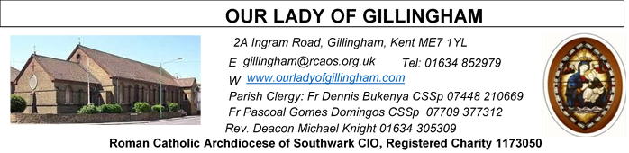
1st FEBRUARY 2026
Fourth Sunday in Ordinary Time – YEAR A
Please Pray for Jo Firth, Mary Eason, Ancy John Kumar, Luna Webster, baby Blake Moon who have recently died;
And also Pray for all those whose anniversaries occur about this time including: Teresa Varlesz, Antonio Nasillo, Harold Trowell, Melina Brattle, Marguerite Williams, Nicola Di Lisio, George Baker, Marion Edwards, Roy Woodward, Angela Savage, Mary Hewery, Archibald Tanton, Michael Hackett, Mary Mills, Rose Ward, Melvyn Andrews, Bronson Smith, Lorraine Oakes, Mary O’Donoghue, Tony Phillips, Fr. A. Porter, Margaret Perfect, Marie Hammond, Herman (Steve) Mullins, Alistair Morton, Dorothy Smith, Isobel (Daphne) Tapley, Ann Jamieson and Kevin Ketchen.
May their souls, and all the souls of the faithful departed, rest in peace

Reading 1 | Zeph 2:3; 3:12-13 | In your midst I will leave a  humble and a lowly people.
Psalm | Ps 145:7-10 r. Matt 5:3 | How happy are the poor in  spirit; theirs is the kingdom  of heaven. Or Alleluia!
Reading 2 | 1 Cor 1:  26-31 | God chose what is foolish  by human reckoning.
Gospel Acclamation | Matt 11:25 | Blessed are you, Father,  Lord of heaven and earth,  for revealing the mysteries  of the kingdom to mere  children.
 | Matt 5:12 | Rejoice and be glad: your  reward will be great in  heaven.
Gospel | Matt 5:1-12a | How happy are the poor in  spirit.

SATURDAY
Exposition of the Blessed Sacrament & Reconciliation
10.30am – 11.30am 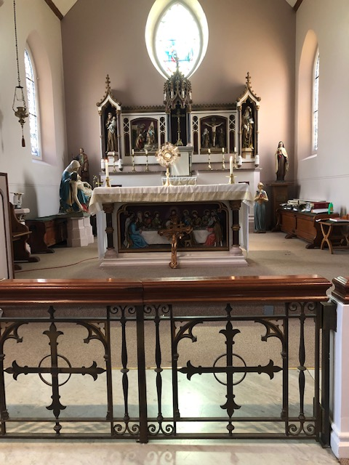
FRIDAY
Eucharistic Adoration
6.15pm – 7.20pm
Followed by Holy Mass at 7.30pm
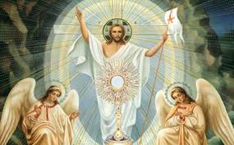

Readers this week:

Sat  6.30pm | Oliver Perez  Imelda Cervantes  Kieran Shannon
Sun 9.30am | Tania Jackson  Uhuegbu Sisters
Sun 11.30am | Kara Family  Chelsea Atoe
Sun 6.30pm | Frances Okafor  Daniella Ibeh  Joan Aruma

Sun  9.30am | Uhuegbu Family  Tania Jackson
Sun  11.30am | Chelsea Atoa  Kara Family
Sun  6.30pm | Frances Okafor  Daniela Ibeh  Joan Aruma

Our Parish NOTICES

Office Hours – Tuesday, Wednesday & Friday - 10.30am – 1.30pm
Collections this week:
CATEGORY | CASH (Loose) | GIFT AID | CONTACTLESS  Amount Gift  Aid |  | TOTALS
Offertory | £525.95 | £36.20 | £368.00 | £30.00 | £960.15
Second Collection  (St George’s Cathedral) | £133.85 | £2.00 | £105.00 | £22.50 | £263.35
Building Fund | £300.00 | - | - | - | £300.00


Please use the QR code for your weekly offerings & second collections

PRAY FOR JO FIRTH – Please continue to pray for Jo Firth, who passed away on Tuesday 20th January 2026.

LEGION OF MARY – Would you like to become a Member?
You are invited to join the Legion of Mary in our Parish. The Catholic lay faithful serving the person of Jesus Christ under the leadership of Mary, Queen and Mother. If you are interested, please speak to Deacon Michael or call 07412859763 for more information.
KNIGHTS OF ST COLUMBA – PRE LENTEN WALK
This is an annual event, walking from St Thomas of Canterbury Catholic Church, Rainham to The Friary at Aylesford Priory. This year it takes place on Saturday 14th February 2026 at 10.00am. Please meet at St Thomas of Canterbury Catholic Church from 9.45am.

KNIGHTS OF ST COLUMBA – ALMA MATER FUND
The Alma Mater fund is an initiative by the Society for the Protection of Unborn Children. It provides financial Grants to University students across the UK who are
Facing crisis pregnancies, helping them to continue pursuing their academic and personal goals. To date, the fund has provided Grants to over 90 students and
Is currently experiencing unprecedented demand. This is why the Knights have chosen to support this initiative as our National Action project until 2026. There is a poster at the back of the Church for further information & details of how to donate.
CARETAKER VACANCY – Our Lady of Gillingham STILL NEEDS YOU. Do you have strong DIY & cleaning skills; a flexible approach; problem-solving skills and an ability to work under pressure? The Caretaker position will become vacant at the end of December, and therefore we require a new person for the role, to start as soon as possible. For further information, please speak with Fr Dennis.
To apply, please send your CV to hr@rcaos.org.uk
DATES FOR YOUR DIARY

7th Feb | Filipino Mass at 12.30pm followed by a ‘Gathering’ in the McMahon Hall from 2.30pm. Everyone is welcome.
7th Feb | OLOG Seeds – Young Adult Mass @3pm
14th Feb | First Holy Communion Class ‘Chapters 3 & 4’ in the McMahon Hall at 11.45am
14th Feb | Knights of St Columba Pre Lenten Walk from St Thomas of Canterbury Catholic Church to The Friary, Aylesford Priory. Starts at 10.00am
AROUND THE CATHOLIC COMMUNITY

RACIAL JUSTICE SUNDAY – 1st February 2026
Archbishop John Wilson will celebrate Mass for Racial Justice Sunday at St George’s Cathedral on Sunday 1 February 2026, at the 10am Mass.
Racial Justice Sunday is a time for the Church to pray, reflect and take action against racism, while celebrating the diversity of our Archdiocese. Everyone is invited to take part, and those who wish may wear national or cultural dress as a sign of unity and pride. After Mass, all are welcome to gather in Amigo Hall for refreshments — a chance to meet one another, share experiences and continue the conversation about faith and inclusion. You are warmly encouraged to attend in person, but if you cannot make it you can watch the livestream through the following link: https://www.youtube.com/live/fdmGwmESSgI

AMBASSADORS FOR CHRIST: A CATHOLIC APOLOGETICS RESOURCE. The Archdiocese of Southwark has launched an exciting apologetics project to provide evidence-based answers to questions such as "Is Jesus God?" or “does prayer work?”. Ambassadors for Christ is designed to equip you with a deeper understanding of your faith, so you can confidently answer questions and be a joyful witness for the Lord Jesus and his Church. Every Monday, a new video will be posted on YouTube, along with a worksheet to enable parishes, schools, youth groups and families to use them as part of their faith formation. To watch the videos and take part in this exciting project, please visit: rcaos.org.uk/ambassadorsforchrist.
SOUTHWARK CATHOLIC YOUTH SERVICE - Pilgrimages for Young Adults Young adults (aged 18 to 35) are invited to join Archbishop John on pilgrimage to Lourdes, from 7-13 June 2026. The cost is £789, including flights and full-board accommodation on a shared basis. Please visit: www.tinyurl.com/lourdes26
Young adults (aged 18 to 35) are also invited to register interest for the World Youth Day pilgrimage to Korea in August 2027 at www.tinyurl.com/wyd2027
For information about youth activities for all ages across the Archdiocese please visit our website at www.tinyurl.com/scys1

THE GOOD COUNSEL BLACK TIE BALL will take place at 6pm on St Valentine’s Day, Saturday 14th February 2026 in Kensington, London. Live Band. Silent Auction. London’s Catholic Pro-Life Ball raising money to help save lives and change lives. Tickets £135 each. Or a table of ten for £1,300. For bookings and enquiries email GCNBall@gmail.com or telephone 07795205117
MASS INTENTIONS FOR THE WEEK

Saturday (31st January)  Vigil Mass | 10.00am  10.30am  6.30pm | Repose of the soul of Mary Mahoney  EXPOSITION OF THE BLESSED SACRAMENT and RECONCILIATION  For God’s Blessings & Grace upon the Elderly Parishioners
First Sunday (1st February) | 9.30am  11.30am  6.30pm | Repose of the soul of Jo Firth  Repose of the soul of Declan Gavin  Pro Populo
Monday (2nd February)  The Presentation of the Lord | 10.00am | Repose of the souls of George & Mary Jones
Tuesday (3rd February)  St Laurence of Canterbury | 10.00am | Repose of the soul of Mary Culhane
Wednesday (4th February) | 10.00am | Repose of the soul of Mariyamma Kuriakose
Thursday (5th February)  St Agatha | 10.00am | Repose of the soul of Rev. Fr. A Porter
Friday (6th February)  St Paul Miki & Companions | 10.00am  6.15pm  7.30pm | Birthday Thanksgiving for Francisca Okeke  ADORATION  Repose of the soul of Jo Firth
Saturday (7th February)  Vigil | 10.00am  10.30am  12.30pm  3.00pm  6.30pm | Thanksgiving for the Dinma Family  EXPOSITION OF THE BLESSED SACRAMENT and RECONCILIATION  Filipino Mass  OLOG Seeds – Young Adult Mass  Repose of the soul of Kevin Ketchen
Sunday (8th February) | 9.30am  11.30am  6.30pm | Repose of the soul of Jo Firth  Repose of the soul of Peter Martin  Pro Populo

MASS INTENTIONS – Please ensure, when paying via Contactless, that your Intention has been entered into the diary & include the Intention date in the ‘message’ section on the Contactless device. Mass Intentions are £10.00

