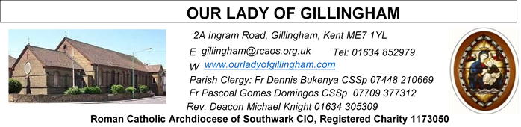
18 JANUARY 2026
Second Sunday in Ordinary Time – YEAR A
Reading 1 | Isa 49: 3, 5-6 | I will make you the light of the nations so that my salvation may reach to the ends of the earth.
Psalm | Ps 39:2. 4. 7-10 r. 8.9 | Here I am, Lord! I come to do your will.
Reading 2 | 1 Cor 1:1-3 | May God our Father and the Lord Jesus Christ send you grace and peace.
Gospel Acclamation |  | Blessing on the King who comes, in the name of the Lord!  Peace in heaven and glory in the highest heavens!
 | John 1:14.12 | The Word was made flesh and lived among us;  to all who did accept him he gave power to be come children to God.
Gospel | John 1:29-34 | Look, there is the lamb of God that takes away the sin of the world,

Readers this week:
Sat  6.30pm | Oliver Perez  Imelda Cervantes  Yolanda Danday
Sun 9.30am | Chizoba Okeke  Vincent Obi  Sharon Chinwuba
Sun 11.30am | Onyehialam Sisters
Sun 6.30pm | Anthonia Fatuase  Victoria Shosanya  Francisca Okeke

Sun  9.30am | Uhuegbu Family  Tania Jackson
Sun  11.30am | Chelsea Atoa  Kara Family
Sun  6.30pm | Frances Okafor  Daniela Ibeh  Joan Aruma

Please Pray for Mary Eason, Ancy John Kumar, Luna Webster, baby Blake Moon who have recently died;
And also Pray for all those whose anniversaries occur about this time including: Ralph Trutwein, Robert Jenkin, John Knight, Harry Hazalden, Violet Brooke, Alice Cassidy, Pearl Mathias, James, Kitney, John Cochrane, Anna McCarthy Stephen Kearney, John Fay, George Kavanagh, Lidia Watts, Mary Kinnear, Peter Szemelak and Crystal Talbot.

May their souls, and all the souls of the faithful departed, rest in peace

SATURDAY
Exposition of the Blessed Sacrament & Reconciliation
10.30am – 11.30am 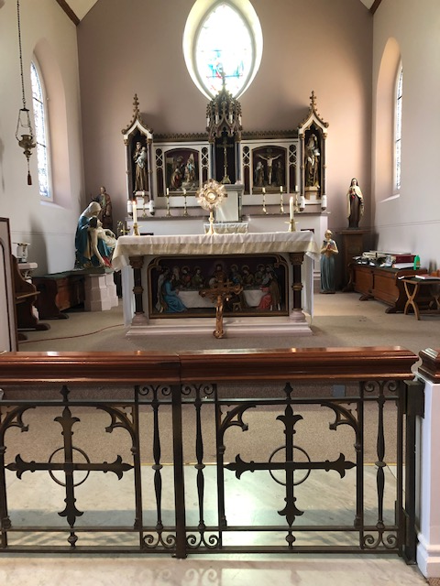
FRIDAY
Eucharistic Adoration
6.15pm – 7.20pm
Followed by Holy Mass at 7.30pm
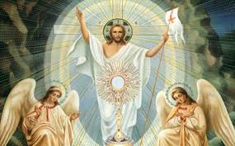
Our Parish NOTICES
Office Hours – Tuesday, Wednesday & Friday - 10.30am – 1.30pm
Collections this week:
CATEGORY | CASH (Loose) | GIFT AID | CONTACTLESS  Amount Gift  Aid |  | TOTALS
Offertory
Crib Offering
Fr Pascoal Air Ticket
Christmas Offering


Please use the QR code for your weekly offerings & second collections
FR DENNIS has arrived in Uganda. He will be away for approximately 5 weeks.

CARETAKER VACANCY – Our Lady of Gillingham STILL NEEDS YOU. Do you have strong DIY & cleaning skills; a flexible approach; problem-solving skills and an ability to work under pressure? The Caretaker position will become vacant at the end of December, and therefore we require a new person for the role, to start as soon as possible. For further information, please speak with Fr Dennis.
To apply, please send your CV to hr@rcaos.org.uk

DATES FOR YOUR DIARY

17th Jan | Marriage Preparation with Deacon Michael, McMahon Hall, 1pm-3.15pm
18th Jan | Enrolment Mass for First Holy Communion candidates, during the 9.30am Mass. All candidates must attend.
24th Jan | Filipino Mass at 12.30pm, followed by a Gathering in the McMahon Hall from 2pm till 5pm. All are welcome.
31st Jan | First Holy Communion class “Chapter 2”  McMahon Hall, 11.45am till 12.45pm
31st Jan | Marriage Preparation with Deacon Michael, McMahon Hall, 1pm-3.15pm

AROUND THE CATHOLIC COMMUNITY

ST GEORGE’S CATHEDRAL SECOND COLLECTION THIS WEEKEND
For over half a century, St George’s Cathedral has been the Mother Church of the Archdiocese of Southwark, home to 175 parishes and over 50,000 Roman Catholics. For many Catholics living and working across London and the South East of England, St George’s has been a beacon of light.
Today, St George’s Cathedral continues to attract thousands of worshippers and visitors each year. The Cathedral frequently hosts important Diocesan and national celebrations, as well as concerts and events for various Catholic charities. There is a rich musical tradition, maintaining a choir of boys and men, as well as a girls’ choir, both of which sing at Sunday Masses and on major feasts.

St George’s Cathedral is entirely reliant upon the generosity of its parishioners, volunteers and the Archdiocese of Southwark to keep its doors open. It does not receive Vatican or government funding, nor has an endowment to rely on. Your support can enable the Cathedral to remain open daily to those seeking a place of peace, prayer and worship.
- Donate Online: www.rcaos.org.uk/Cathedral
- Or Scan QR Code using telephone camera (right)
- Cash / Cheque – please use the St George’s Cathedral envelopes.
RACIAL JUSTICE SUNDAY – 1st February 2026
Archbishop John Wilson will celebrate Mass for Racial Justice Sunday at St George’s Cathedral on Sunday 1 February 2026, at the 10am Mass.
Racial Justice Sunday is a time for the Church to pray, reflect and take action against racism, while celebrating the diversity of our Archdiocese. Everyone is invited to take part, and those who wish may wear national or cultural dress as a sign of unity and pride. After Mass, all are welcome to gather in Amigo Hall for refreshments — a chance to meet one another, share experiences and continue the conversation about faith and inclusion. You are warmly encouraged to attend in person, but if you cannot make it you can watch the livestream through the following link: https://www.youtube.com/live/fdmGwmESSgI

SOUTHWARK CATHOLIC YOUTH SERVICE - Pilgrimages for Young Adults Young adults (aged 18 to 35) are invited to join Archbishop John on pilgrimage to Lourdes, from 7-13 June 2026. The cost is £789, including flights and full-board accommodation on a shared basis. Please visit: www.tinyurl.com/lourdes26
Young adults (aged 18 to 35) are also invited to register interest for the World Youth Day pilgrimage to Korea in August 2027 at www.tinyurl.com/wyd2027
For information about youth activities for all ages across the Archdiocese please visit our website at www.tinyurl.com/scys1

RETROUVAILLE - LAST CALL for online marriage programme.
Does your marriage need some TLC? Need help with communication and trust? Retrouvaille helps marriages. It can bring hope and healing to relationships.
Next date: 12th February 2026.
www.retrouvaille.org.uk Tel: 07887 296983

MASS INTENTIONS FOR THE WEEK

Saturday (24th January)  Vigil Mass | 10.00am  10.30am  6.30pm | EXPOSITION OF THE BLESSED SACRAMENT and RECONCILIATION
Sunday (25th January) | 9.30am  11.30am  6.30pm
Monday (26th January) | 10.00am
Tuesday (27th January) | 10.00am
Wednesday (28th January) | 10.00am
Thursday (29th January) | 10.00am
Friday (30th January) | 10.00am  6.15pm  7.30pm | ADORATION
Saturday (31st January)  Vigil | 10.00am  10.30am  6.30pm | EXPOSITION OF THE BLESSED SACRAMENT and RECONCILIATION
First Sunday (1st February) | 9.30am  11.30am  6.30pm

MASS INTENTIONS – Please ensure, when paying via Contactless, that your Intention has been entered into the diary & include the Intention date in the ‘message’ section on the Contactless device. Mass Intentions are £10.00

